UNITED STATES
SECURITIES AND EXCHANGE COMMISSION
WASHINGTON, D.C. 20549
FORM 8-K

CURRENT REPORT
Pursuant to Section 13 or 15(d) of the
Securities Exchange Act of 1934

Date of Report (Date of Earliest Event Reported): August 5, 2026
THE BRINK’S COMPANY
(Exact name of registrant as specified in its charter)
Virginia |  |  | 001-09148 |  |  | 54-1317776
(State or other jurisdiction of incorporation) |  |  | (Commission File Number) |  |  | (IRS Employer Identification No.)
1801 Bayberry Court
P. O. Box 18100
Richmond, VA 23226-8100
(Address and zip code of
principal executive offices)

Registrant’s telephone number, including area code: (804) 289-9600
Check the appropriate box below if the Form 8-K filing is intended to simultaneously satisfy the filing obligation of the registrant under any of the following provisions:

☐ Written communications pursuant to Rule 425 under the Securities Act (17 CFR 230.425)

☐ Soliciting material pursuant to Rule 14a-12 under the Exchange Act (17 CFR 240.14a-12)

☐ Pre-commencement communications pursuant to Rule 14d-2(b) under the Exchange Act (17 CFR 240.14d-2(b))

☐ Pre-commencement communications pursuant to Rule 13e-4(c) under the Exchange Act (17 CFR 240.13e-4(c))

Securities registered pursuant to Section 12(b) of the Act:
Title of each class |  |  | Trading Symbol(s) |  |  | Name of each exchange on which registered
Common Stock, par value $1.00 per share |  |  | BCO |  |  | New York Stock Exchange
Indicate by check mark whether the registrant is an emerging growth company as defined in Rule
405 of the Securities Act of 1933 (§230.405 of this chapter) or Rule 12b-2 of the Securities Exchange Act of 1934 (§240.12b-2 of this chapter).

Emerging growth company ☐
If an emerging growth company, indicate by check mark if the registrant has elected not to use the extended transition period for complying with any new or revised financial accounting standards provided pursuant to Section 13(a) of the Exchange Act. ☐

Item 2.02 |  |  | Results of Operations and Financial Condition.

On August 5, 2026, The Brink's Company (the “Company”) issued a press release reporting its results for the second quarter ended June 30, 2026. A copy of the release is furnished as Exhibit 99.1 to this Current Report on Form 8-K.

In accordance with General Instruction B.2 of Form 8-K, the information in this Item 2.02 of this Current Report on Form 8-K, including Exhibit 99.1, shall not be deemed “filed” for the purposes of Section 18 of the Securities Exchange Act of 1934, as amended (the “Exchange Act”), or otherwise subject to the liabilities of that section, nor shall it be deemed incorporated by reference in any filing under the Securities Act of 1933, as amended (the “Securities Act”) or the Exchange Act, except as shall be expressly set forth by specific references in such a filing.

Item 7.01 |  |  | Regulation FD Disclosure.

On August 5, 2026, the Company provided slides to accompany its earnings presentation. A copy of the slides is furnished as Exhibit 99.2 to this Current Report on Form 8-K.

In accordance with General Instruction B.2 of Form 8-K, the information in this Item 7.01 of this Current Report on Form 8-K, including Exhibit 99.2, shall not be deemed “filed” for the purposes of Section 18 of the Exchange Act, or otherwise subject to the liabilities of that section, nor shall it be deemed incorporated by reference in any filing under the Securities Act or the Exchange Act, except as shall be expressly set forth by specific references in such a filing.

Item 9.01 |  |  |  |  |  | Financial Statements and Exhibits.
(d) |  |  | Exhibits
 |  |  | 99.1 |  |  | Press Release, dated August 5, 2026, issued by The Brink's Company
 |  |  | 99.2 |  |  | Slide presentation of The Brink's Company
 |  |  | 104 |  |  | Cover Page Interactive Data File (embedded within the Inline XBRL document)

SIGNATURE
Pursuant to the requirements of the Securities Exchange Act of 1934, the registrant has duly caused this report to be signed on its behalf by the undersigned hereunto duly authorized.

THE BRINK’S COMPANY
(Registrant)
Date: August 5, 2026 |  |  | By: |  |  | /s/ Kurt B. McMaken
 |  |  |  |  |  | Kurt B. McMaken
Executive Vice President and
Chief Financial Officer

Exhibit 99.1
P R E S S R E L E A S E |  |  | 
Contact:  Investor Relations  804.289.9709 |  |  | BRINK’S CORPORATE  The Brink’s Company  1801 Bayberry Court  Richmond, VA 23226-8100 USA

Brink's Delivers Strong Second-Quarter Results
Revenue growth of 7% reflects the 14th consecutive quarter of mid-teens or greater AMS/DRS organic growth
Net Income increased 2% with Adjusted EBITDA up 11%
GAAP EPS of $1.07 increased 4% with non-GAAP EPS of $2.13 up 18%
NCR Atleos acquisition timeline accelerating behind regulatory momentum

RICHMOND, Va., August 5, 2026 – The Brink’s Company (NYSE:BCO), a leading global provider of cash and valuables management, digital retail solutions ("DRS"), and ATM managed services ("AMS"), today announced second-quarter results.
Mark Eubanks, President and CEO, said: “Our strong second quarter shows continued progress against our AMS/DRS strategy with another quarter of mid-teens or better organic revenue growth. We closed several key customer wins late in the second and early in the third quarter that support continued growth momentum into the second half of the year. The margin accretion power of AMS/DRS is evident in our profitability with record second quarter operating profit and Adjusted EBITDA margin performance. Supported by underlying operational productivity and revenue mix benefits, Adjusted EBITDA margins expanded year-over-year in every segment in the second quarter. We continue to deliver sustainable improvements in cash generation with trailing-twelve-month free cash flow up $32 million dollars to $468 million reflecting conversion of 46 percent. Combined with NCR Atleos' strong second quarter results, released earlier this morning, both companies have now delivered first-half performance ahead of expectations. With increasing visibility into our second half performance and a favorable AMS/DRS growth trajectory, we remain confident in our financial outlook and our ability to fully realize the value creation potential of the acquisition."
"With the shareholder vote now behind us, we continue to make meaningful progress towards closing the NCR Atleos acquisition. Having secured clearance in key jurisdictions, including the United States, Brazil, and India, and with all remaining regulatory reviews well underway, we have line of sight to an accelerated timeline now estimated to be early in the first quarter of 20271. Our dedicated integration management teams continue to advance detailed planning that position us to realize approximately $200 million in run-rate synergies. I remain confident this combination will deliver innovative new solutions for our customers, create opportunities for our employees, and accelerate long-term value creation for our shareholders."

____________________
1 Subject to satisfaction of customary closing conditions, including the receipt of required regulatory approvals and other conditions set forth in the merger agreement.



Second-quarter results are summarized in the following table:
(In millions, except for per share amounts) |  |  | Second-Quarter 2026 (vs. 2025)
 |  |  | GAAP |  |  |  |  |  | Change |  |  |  |  |  | Non-GAAP |  |  |  |  |  | Change |  |  |  |  |  | Constant Currency Change(b)
Revenue |  |  | $ | 1,392 |  |  |  |  | 7% |  |  |  |  |  | $ | 1,392 |  |  |  |  | 7% |  |  |  |  |  | 4%
Operating Profit |  |  | $ | 133 |  |  |  |  | —% |  |  |  |  |  | $ | 190 |  |  |  |  | 15% |  |  |  |  |  | 14%
Operating Profit Margin |  |  | 9.6 |  | % |  |  |  | (70 bps) |  |  |  |  |  | 13.6 |  | % |  |  |  | 100 bps |  |  |  |  |  | 120 bps
Net Income / Adjusted EBITDA(a) |  |  | $ | 44 |  |  |  |  | 2% |  |  |  |  |  | $ | 257 |  |  |  |  | 11% |  |  |  |  |  | 9%
EPS |  |  | $ | 1.07 |  |  |  |  | 4% |  |  |  |  |  | $ | 2.13 |  |  |  |  | 18% |  |  |  |  |  | 15%
(a)The non-GAAP financial metric, adjusted EBITDA, is presented with its corresponding GAAP metric, net income attributable to Brink's.
(b)Constant currency represents 2026 Non-GAAP results at 2025 exchange rates.

2026 Non-GAAP Framework and Q3 2026 Non-GAAP Guidance (Unaudited)
(In millions, except for percentages and per share amounts)

In 2026, management has included additional guidance to better help investors understand currency impacts on our results. Management believes organic revenue growth, adjusted EBITDA margin expansion and free cash flow conversion performance, provided in our 2026 framework, gives investors better visibility into the performance of our business. In addition to our full-year 2026 framework, we have added quarterly guidance for revenue, adjusted EBITDA and non-GAAP EPS in 2026 to clarify the expected impact of near-term currency trends and volatile economic conditions on our results. When, and if, currency volatility lessens, management may return to the previous annual guidance methodology. Revenue guidance is presented in accordance with GAAP.
 |  |  | 2026 Non-GAAP Framework
Organic Revenue Growth |  |  |  |  |  | Mid-Single Digits
AMS/DRS Organic Revenue Growth |  |  |  |  |  | Mid-to-High Teens
Adjusted EBITDA Margin Expansion |  |  |  |  |  | 30-50bps
Free Cash Flow Conversion |  |  |  |  |  | 40-45%
Q3 2026
Guidance
Revenue |  |  |  |  |  | $1,365 - $1,415
Non-GAAP Adjusted EBITDA |  |  |  |  |  | $263 - $283
Non-GAAP EPS |  |  |  |  |  | $2.23 - $2.63

The Q3 2026 non-GAAP guidance cannot be reconciled to GAAP without unreasonable effort, as we are unable to accurately forecast certain amounts that are necessary for reconciliation, including the impact of highly inflationary accounting on our Argentina operations, expenses relating to M&A transactions that may or may not occur in the quarter, and other potential non-GAAP adjusting items for which the timing and amounts are uncertain. The Q3 2026 non-GAAP guidance assumes the continuation of current economic trends and reflects management's current assumptions regarding variables that are difficult to accurately forecast, including those discussed in the Risk Factors set forth in the Company's filings with the United States Securities and Exchange Commission.

Conference Call
Brink’s will host a conference call on Wednesday, August 5, 2026, at 9:00 a.m. (EDT) to review second-quarter financial results. The conference call can be accessed by calling 888-349-0094 (in the U.S.) or 412-902-0124 (international). Participants should join at least five minutes prior to the start of the call. Participants can pre-register at https://dpregister.com/sreg/10210013/1044abca2fb to receive a direct dial-in number for the call. The call will also be accessible at https://event.choruscall.com/mediaframe/webcast.html?webcastid=tA72Sjv5. A replay of the call will be available through August 12, 2026, at (855) 669-9658 (in the U.S.) or (412) 317-0088 (international). The conference access code is 4560221. An archived version of the webcast will also be available on our website at http://investors.brinks.com.

2

The Brink’s Company and subsidiaries
(In millions, except for per share amounts) (Unaudited)

Condensed Consolidated Balance Sheets
 |  |  | December 31, 2025 |  |  |  |  |  | June 30, 2026
Assets
Current assets:
Cash and cash equivalents |  |  | $ | 1,725.9 |  |  |  |  | 1,658.2
Restricted cash |  |  | 541.0 |  |  |  |  |  | 489.7
Accounts receivable, net |  |  | 766.0 |  |  |  |  |  | 865.7
Prepaid expenses and other |  |  | 296.1 |  |  |  |  |  | 353.9
Total current assets |  |  | 3,329.0 |  |  |  |  |  | 3,367.5
Right-of-use assets, net |  |  | 388.7 |  |  |  |  |  | 391.5
Property and equipment, net |  |  | 1,130.5 |  |  |  |  |  | 1,091.3
Goodwill |  |  | 1,515.3 |  |  |  |  |  | 1,505.0
Other intangibles, net |  |  | 385.2 |  |  |  |  |  | 353.6
Deferred tax assets, net |  |  | 237.3 |  |  |  |  |  | 240.3
Other |  |  | 353.2 |  |  |  |  |  | 382.1
Total assets |  |  | $ | 7,339.2 |  |  |  |  | 7,331.3
Liabilities and Equity
Current liabilities:
Short-term borrowings |  |  | 241.1 |  |  |  |  |  | 248.8
Current maturities of long-term debt |  |  | 163.1 |  |  |  |  |  | 98.4
Accounts payable |  |  | 319.3 |  |  |  |  |  | 330.1
Accrued liabilities |  |  | 1,180.2 |  |  |  |  |  | 1,180.9
Restricted cash held for customers |  |  | 294.2 |  |  |  |  |  | 220.0
Total current liabilities |  |  | 2,197.9 |  |  |  |  |  | 2,078.2
Long-term debt |  |  | 3,810.1 |  |  |  |  |  | 3,895.1
Accrued pension costs |  |  | 147.8 |  |  |  |  |  | 149.7
Retirement benefits other than pensions |  |  | 120.4 |  |  |  |  |  | 125.0
Lease liabilities |  |  | 310.2 |  |  |  |  |  | 313.3
Deferred tax liabilities |  |  | 66.5 |  |  |  |  |  | 65.6
Other |  |  | 279.0 |  |  |  |  |  | 262.0
Total liabilities |  |  | 6,931.9 |  |  |  |  |  | 6,888.9
Equity:
The Brink's Company ("Brink's") shareholders:
Common stock, par value $1 per share:
Shares authorized: 100.0
Shares issued and outstanding: 2026 - 41.2; 2025 - 41.1 |  |  | 41.1 |  |  |  |  |  | 41.2
Capital in excess of par value |  |  | 632.1 |  |  |  |  |  | 627.5
Retained earnings |  |  | 270.1 |  |  |  |  |  | 299.4
Accumulated other comprehensive income (loss) |  |  | (665.6) |  |  |  |  |  | (657.6)
Brink's shareholders |  |  | 277.7 |  |  |  |  |  | 310.5
Noncontrolling interests |  |  | 129.6 |  |  |  |  |  | 131.9
Total equity |  |  | 407.3 |  |  |  |  |  | 442.4
Total liabilities and equity |  |  | $ | 7,339.2 |  |  |  |  | 7,331.3

3

The Brink’s Company and subsidiaries
(In millions) (Unaudited)
Condensed Consolidated Statements of Cash Flows
 |  |  | Six Months Ended June 30,
 |  |  | 2025 |  |  |  |  |  | 2026
Cash flows from operating activities:
Net income |  |  | $ | 101.3 |  |  |  |  | 82.1
Adjustments to reconcile net income to net cash provided by (used in) operating activities:
Loss from discontinued operations, net of tax |  |  | 0.2 |  |  |  |  |  | 0.1
Depreciation and amortization |  |  | 130.5 |  |  |  |  |  | 158.8
Share-based compensation expense |  |  | 13.7 |  |  |  |  |  | 15.0
Deferred income taxes |  |  | 0.1 |  |  |  |  |  | (5.2)
(Gain) loss on marketable securities, sale of property and equipment and derivatives |  |  | 17.9 |  |  |  |  |  | (3.3)
Impairment losses |  |  | 2.0 |  |  |  |  |  | 1.3
Retirement benefit funding (more) less than expense:
Pension |  |  | (1.1) |  |  |  |  |  | 2.7
Other than pension |  |  | (5.6) |  |  |  |  |  | 3.3
Unrealized foreign currency (gains) losses |  |  | (1.2) |  |  |  |  |  | 10.1
Other operating |  |  | 1.7 |  |  |  |  |  | 3.8
Changes in operating assets and liabilities, net of effects of acquisitions:
Increase in accounts receivable and income taxes receivable |  |  | (64.8) |  |  |  |  |  | (106.3)
Decrease in accounts payable, income taxes payable and accrued liabilities |  |  | (84.8) |  |  |  |  |  | (19.9)
Increase (decrease) in restricted cash held for customers |  |  | 31.3 |  |  |  |  |  | (66.3)
Increase in customer obligations |  |  | 24.0 |  |  |  |  |  | 40.5
Increase in prepaid and other current assets |  |  | (11.4) |  |  |  |  |  | (28.6)
Other |  |  | (10.0) |  |  |  |  |  | (22.9)
Net cash provided by operating activities |  |  | 143.8 |  |  |  |  |  | 65.2
Cash flows from investing activities:
Capital expenditures |  |  | (110.7) |  |  |  |  |  | (74.9)
Acquisitions, net of cash acquired |  |  | (5.3) |  |  |  |  |  | —
Marketable securities:
Purchases |  |  | (92.9) |  |  |  |  |  | (33.6)
Sales |  |  | 64.8 |  |  |  |  |  | 31.7
Cash proceeds from sale of property and equipment |  |  | 9.8 |  |  |  |  |  | 5.6
Net change in loans held for investment |  |  | 3.3 |  |  |  |  |  | 2.8
Net change in economic hedges |  |  | (17.2) |  |  |  |  |  | 3.1
Other |  |  | (9.4) |  |  |  |  |  | 1.1
Net cash used in investing activities |  |  | (157.6) |  |  |  |  |  | (64.2)
Cash flows from financing activities:
Borrowings (repayments) of debt:
Short-term borrowings |  |  | 19.8 |  |  |  |  |  | 8.6
Long-term revolving credit facilities:
Borrowings |  |  | 7,943.5 |  |  |  |  |  | 9,879.5
Repayments |  |  | (7,757.5) |  |  |  |  |  | (9,853.6)
Other long-term debt:
Borrowings |  |  | 12.2 |  |  |  |  |  | 10.6
Repayments |  |  | (77.3) |  |  |  |  |  | (53.4)
Acquisition of noncontrolling interest |  |  | (6.6) |  |  |  |  |  | —
Cash paid for acquisition related settlements and obligations |  |  | — |  |  |  |  |  | (1.1)
Debt financing costs |  |  | (1.0) |  |  |  |  |  | (22.7)
Repurchase shares of Brink's common stock |  |  | (130.0) |  |  |  |  |  | (30.2)
Dividends to:
Shareholders of Brink’s |  |  | (21.1) |  |  |  |  |  | (21.0)
Noncontrolling interests in subsidiaries |  |  | (0.7) |  |  |  |  |  | (2.2)
Proceeds from exercise of stock options |  |  | — |  |  |  |  |  | 0.2
Tax withholdings associated with share-based compensation |  |  | (17.8) |  |  |  |  |  | (18.3)
Other |  |  | (1.6) |  |  |  |  |  | (1.6)
Net cash used in financing activities |  |  | (38.1) |  |  |  |  |  | (105.2)
Effect of exchange rate changes on cash |  |  | 113.6 |  |  |  |  |  | (14.8)
Cash, cash equivalents and restricted cash:
(Decrease) increase |  |  | 61.7 |  |  |  |  |  | (119.0)
Balance at beginning of period |  |  | 1,840.4 |  |  |  |  |  | 2,266.9
Balance at end of period |  |  | $ | 1,902.1 |  |  |  |  | 2,147.9

4

Supplemental Cash Flow Information |  |  | Six Months Ended June 30,
 |  |  | 2025 |  |  |  |  |  | 2026
Cash paid for income taxes, net |  |  | $ | (56.5) |  |  |  |  | (61.3)
Cash paid for interest |  |  | (132.8) |  |  |  |  |  | (135.4)
Proceeds from lessor debt financing |  |  | 12.0 |  |  |  |  |  | 5.6

5

The Brink’s Company and subsidiaries
(In millions, except for per share amounts) (Unaudited)
Second-Quarter 2026 vs. 2025
 |  |  |  |  |  |  |  |  |  |  |  |  |  |  | Impact of |  |  |  |  |  |  |  |  |  |  |  |  |  |  |  |  |  | % Change
GAAP |  |  |  |  |  |  |  |  | Organic |  |  |  |  |  | Acquisitions / |  |  |  |  |  | Currency |  |  |  |  |  |  |  |  |  |  |  |  |  |  |  |  |  | Organic
 |  |  | 2Q'25 |  |  |  |  |  | Change(a) |  |  |  |  |  | Dispositions(b) |  |  |  |  |  | Effect(c) |  |  |  |  |  | 2Q'26 |  |  |  |  |  | Total |  |  |  |  |  | Growth(a)
Revenues:
North America |  |  | $ | 434 |  |  |  |  | 10 |  |  |  |  |  | — |  |  |  |  |  | — |  |  |  |  |  | 445 |  |  |  |  |  | 2 |  |  |  |  |  | 2
Latin America |  |  | 319 |  |  |  |  |  | 7 |  |  |  |  |  | 1 |  |  |  |  |  | 25 |  |  |  |  |  | 352 |  |  |  |  |  | 10 |  |  |  |  |  | 2
Europe |  |  | 358 |  |  |  |  |  | 8 |  |  |  |  |  | — |  |  |  |  |  | 11 |  |  |  |  |  | 377 |  |  |  |  |  | 5 |  |  |  |  |  | 2
Rest of World |  |  | 189 |  |  |  |  |  | 29 |  |  |  |  |  | — |  |  |  |  |  | 2 |  |  |  |  |  | 219 |  |  |  |  |  | 16 |  |  |  |  |  | 15
Segment revenues |  |  | $ | 1,301 |  |  |  |  | 54 |  |  |  |  |  | 1 |  |  |  |  |  | 37 |  |  |  |  |  | 1,392 |  |  |  |  |  | 7 |  |  |  |  |  | 4
Revenues |  |  | $ | 1,301 |  |  |  |  | 54 |  |  |  |  |  | 1 |  |  |  |  |  | 37 |  |  |  |  |  | 1,392 |  |  |  |  |  | 7 |  |  |  |  |  | 4
Operating profit:
North America |  |  | $ | 62 |  |  |  |  | 7 |  |  |  |  |  | — |  |  |  |  |  | — |  |  |  |  |  | 70 |  |  |  |  |  | 12 |  |  |  |  |  | 12
Latin America |  |  | 55 |  |  |  |  |  | 2 |  |  |  |  |  | — |  |  |  |  |  | 4 |  |  |  |  |  | 61 |  |  |  |  |  | 10 |  |  |  |  |  | 4
Europe |  |  | 42 |  |  |  |  |  | 8 |  |  |  |  |  | — |  |  |  |  |  | 1 |  |  |  |  |  | 52 |  |  |  |  |  | 21 |  |  |  |  |  | 18
Rest of World |  |  | 38 |  |  |  |  |  | 14 |  |  |  |  |  | — |  |  |  |  |  | — |  |  |  |  |  | 52 |  |  |  |  |  | 36 |  |  |  |  |  | 36
Segment operating profit |  |  | 198 |  |  |  |  |  | 31 |  |  |  |  |  | — |  |  |  |  |  | 5 |  |  |  |  |  | 234 |  |  |  |  |  | 18 |  |  |  |  |  | 16
Corporate expenses(d) |  |  | (34) |  |  |  |  |  | (8) |  |  |  |  |  | — |  |  |  |  |  | (3) |  |  |  |  |  | (44) |  |  |  |  |  | 31 |  |  |  |  |  | 24
Other items not allocated to segments(d) |  |  | (31) |  |  |  |  |  | (31) |  |  |  |  |  | 10 |  |  |  |  |  | (5) |  |  |  |  |  | (56) |  |  |  |  |  | 84 |  |  |  |  |  | 101
Operating profit |  |  | $ | 134 |  |  |  |  | (8) |  |  |  |  |  | 10 |  |  |  |  |  | (3) |  |  |  |  |  | 133 |  |  |  |  |  | — |  |  |  |  |  | (6)
Amounts may not add due to rounding.

(a)Organic change and organic growth are supplemental financial measures that are not required by, or presented in accordance with, GAAP, and are described in more detail on page 13.
(b)Amounts include the impact of prior year comparable period results for acquired and disposed businesses. This measure is not required by, or presented in accordance with, GAAP and is described in more detail on page 13.
(c)The amounts in the “Currency” column consist of the effects of Argentina devaluations under highly inflationary accounting and the sum of monthly currency changes. This measure is not required by, or presented in accordance with, GAAP and is described in more detail on page 13.
(d)See pages 11-12 for further information, where these items are discussed in more detail.

About The Brink’s Company
The Brink’s Company (NYSE:BCO) is a leading global provider of cash and valuables management, digital retail solutions, and ATM managed services. Our customers include financial institutions, retailers, government agencies, mints, jewelers and other commercial operations. Our network of operations in 51 countries serves customers in more than 100 countries. For more information, please visit our website at www.brinks.com or call 804-289-9709.

6

The Brink’s Company and subsidiaries
(In millions, except for per share amounts) (Unaudited)

Six Months Ended June 30, 2026 vs. 2025
 |  |  |  |  |  |  |  |  |  |  |  |  |  |  | Impact of |  |  |  |  |  |  |  |  |  |  |  |  |  |  |  |  |  | % Change
GAAP |  |  |  |  |  |  |  |  | Organic |  |  |  |  |  | Acquisitions / |  |  |  |  |  | Currency |  |  |  |  |  |  |  |  |  |  |  |  |  |  |  |  |  | Organic
 |  |  | 2025 |  |  |  |  |  | Change(a) |  |  |  |  |  | Dispositions(b) |  |  |  |  |  | Effect(c) |  |  |  |  |  | 2026 |  |  |  |  |  | Total |  |  |  |  |  | Growth(a)
Revenues:
North America |  |  | $ | 852 |  |  |  |  | 31 |  |  |  |  |  | — |  |  |  |  |  | 2 |  |  |  |  |  | 884 |  |  |  |  |  | 4 |  |  |  |  |  | 4
Latin America |  |  | 627 |  |  |  |  |  | 18 |  |  |  |  |  | 1 |  |  |  |  |  | 49 |  |  |  |  |  | 695 |  |  |  |  |  | 11 |  |  |  |  |  | 3
Europe |  |  | 677 |  |  |  |  |  | 19 |  |  |  |  |  | 1 |  |  |  |  |  | 46 |  |  |  |  |  | 743 |  |  |  |  |  | 10 |  |  |  |  |  | 3
Rest of World |  |  | 391 |  |  |  |  |  | 42 |  |  |  |  |  | — |  |  |  |  |  | 12 |  |  |  |  |  | 445 |  |  |  |  |  | 14 |  |  |  |  |  | 11
Segment revenues |  |  | $ | 2,547 |  |  |  |  | 110 |  |  |  |  |  | 2 |  |  |  |  |  | 109 |  |  |  |  |  | 2,767 |  |  |  |  |  | 9 |  |  |  |  |  | 4
Revenues |  |  | $ | 2,547 |  |  |  |  | 110 |  |  |  |  |  | 2 |  |  |  |  |  | 109 |  |  |  |  |  | 2,767 |  |  |  |  |  | 9 |  |  |  |  |  | 4
Operating profit:
North America |  |  | $ | 115 |  |  |  |  | 15 |  |  |  |  |  | — |  |  |  |  |  | — |  |  |  |  |  | 131 |  |  |  |  |  | 13 |  |  |  |  |  | 13
Latin America |  |  | 109 |  |  |  |  |  | 3 |  |  |  |  |  | — |  |  |  |  |  | 6 |  |  |  |  |  | 118 |  |  |  |  |  | 8 |  |  |  |  |  | 3
Europe |  |  | 71 |  |  |  |  |  | 15 |  |  |  |  |  | 1 |  |  |  |  |  | 5 |  |  |  |  |  | 91 |  |  |  |  |  | 30 |  |  |  |  |  | 22
Rest of World |  |  | 86 |  |  |  |  |  | 20 |  |  |  |  |  | — |  |  |  |  |  | 2 |  |  |  |  |  | 107 |  |  |  |  |  | 25 |  |  |  |  |  | 23
Segment operating profit |  |  | 380 |  |  |  |  |  | 53 |  |  |  |  |  | — |  |  |  |  |  | 13 |  |  |  |  |  | 447 |  |  |  |  |  | 17 |  |  |  |  |  | 14
Corporate expenses(d) |  |  | (65) |  |  |  |  |  | (19) |  |  |  |  |  | — |  |  |  |  |  | (4) |  |  |  |  |  | (89) |  |  |  |  |  | 36 |  |  |  |  |  | 30
Other items not allocated to segments(d) |  |  | (62) |  |  |  |  |  | (61) |  |  |  |  |  | 14 |  |  |  |  |  | (5) |  |  |  |  |  | (115) |  |  |  |  |  | 85 |  |  |  |  |  | 98
Operating profit |  |  | $ | 253 |  |  |  |  | (27) |  |  |  |  |  | 14 |  |  |  |  |  | 4 |  |  |  |  |  | 244 |  |  |  |  |  | (4) |  |  |  |  |  | (11)
Amounts may not add due to rounding.

See page 6 for footnote explanations.

7

Forward-Looking Statements
This release contains forward-looking information. Words such as "anticipate," "assume," "estimate," "expect," “target,” "project," "predict," "intend," "plan," "believe," "potential," "may," "should" and similar expressions may identify forward-looking information. Forward-looking information in this release includes, but is not limited to: statements made in Mr. Eubanks' quote; second quarter 2026 outlook, including revenue, adjusted EBITDA, and non-GAAP earnings per share (and drivers thereof); full-year 2026 guidance framework, including organic revenue growth, AMS/DRS organic revenue growth, adjusted EBITDA margin expansion, free cash flow conversion and shareholder returns (and the drivers thereof); capital allocation priorities; the impact of U.S. and global macroeconomic conditions; the impact of tariffs and foreign inflation; expected impact from deployment of technology-enabled solutions, including AMS and DRS; the effect of pending legal matters, including the Chile antitrust matter; the impacts of the operating environment in Argentina; the proposed acquisition of NCR Atleos, Inc. ("NCR Atleos"), including: the expected timing and conditions to closing (including receipt of regulatory approvals), the anticipated benefits and synergies of the transaction, the expected financing thereof and the related indebtedness expected to be incurred in connection with the transaction and the ability to service and repay such indebtedness; and strategic priorities and initiatives, including the Brink’s Business System and technology and systems investments.

Forward-looking information in this document is subject to known and unknown risks, uncertainties and contingencies, which are difficult to predict or quantify, and which could cause actual results, performance or achievements to differ materially from those that are anticipated. These risks, uncertainties and contingencies, many of which are beyond our control, include, but are not limited to: our ability to improve profitability and execute further cost and operational improvement and efficiencies in our core businesses; our ability to improve service levels and quality in our core businesses; market volatility and commodity price fluctuations; general economic issues, including supply chain disruptions, fuel price increases, new or increased international tariffs and/or trade barriers, inflation, recessionary conditions and changes in interest rates; seasonality, pricing and other competitive industry factors; investment in information technology (“IT”) and its impact on revenue and profit growth; risks associated with the usage of artificial intelligence (“AI”) technologies; our ability to maintain an effective IT infrastructure and safeguard confidential information and risks related to a failure of our IT systems and networks, including cloud-based applications, and risks associated with current and emerging technology threats, and damage from computer viruses, unauthorized access and cyber and ransomware attacks, including increasingly sophisticated cyber attacks incorporating the use of AI and other similar disruptions; our ability to effectively develop and implement solutions for our customers; risks associated with operating in foreign countries, including changing political, labor and economic conditions (including political conflict or unrest), regulatory issues (including the imposition of international sanctions, including by the U.S. government), military conflicts (including but not limited to the conflict in Israel, Iran and surrounding areas, as well as the possible expansion of such conflicts and potential geopolitical consequences), currency restrictions and devaluations, restrictions on and cost of repatriating earnings and capital, impact on the Company’s financial results as a result of jurisdictions' higher-than-expected inflation and those determined to be highly inflationary, and restrictive government actions, including nationalization; risks related to changes in control over, or economic interest in, foreign subsidiaries, including the anticipated deconsolidation of the Malaysia business, the final determination of the appropriate accounting treatment under U.S. GAAP, and the timing and magnitude of the related impact on the Company's revenue and adjusted EBITDA; labor issues, including labor shortages, negotiations with organized labor and work stoppages; pandemics, acts of terrorism, strikes or other extraordinary events that negatively affect global or regional cash commerce; anticipated cash needs in light of our current liquidity position; the strength of the U.S. dollar relative to foreign currencies and foreign currency exchange rates; our ability to identify, evaluate and complete acquisitions and other strategic transactions and to successfully integrate acquired companies; risks related to the proposed acquisition of NCR Atleos, including: the occurrence of any event, change or other circumstance that could give rise to the termination of the merger agreement; the inability to complete the proposed transaction due to the failure to obtain regulatory or shareholder approval or the failure to satisfy other conditions to closing; risks that the proposed transaction disrupts current plans and operations; the focus of management's time and attention on the transaction and other disruptions arising from the proposed transaction; the ability to recognize the anticipated benefits and synergies of the proposed transaction; the amount of the costs, fees, expenses, and charges related to the proposed transaction and financing obtained in connection with the proposed transaction; the ability to obtain regulatory approvals on the terms expected or anticipated schedule; the risk that the proposed transaction and its announcement could have an adverse effect on the ability of the Company to retain customers, retain and hire key personnel and maintain relationships with suppliers, customers and other business relationships and on operating results and business generally; the risk of litigation and/or regulatory actions related to the proposed transaction; costs related to dispositions and product or market exits; our ability to obtain appropriate insurance coverage, positions taken by insurers relative to claims and the financial condition of insurers; safety and security performance and loss experience; employee, environmental and other liabilities in connection with former coal operations, including black lung claims; the impact of the American Rescue Plan Act and Patient Protection and Affordable Care Act on legacy liabilities and ongoing operations; funding requirements, accounting treatment, and investment performance of our pension plans, the VEBA and other employee benefits; changes to estimated liabilities and assets in actuarial assumptions; the nature of hedging relationships and counterparty risk; access to the capital and credit markets; our ability to realize deferred tax assets; the impact of foreign tax credit regulations; the impact of the One Big Beautiful Bill Act; the outcome of pending and future claims, litigation, and administrative proceedings; our ability to comply with regulatory compliance obligations; public perception of our business, reputation and brand; our ability to identify, recruit and retain key employees; changes in estimates and assumptions underlying our critical accounting policies; and the promulgation and adoption of new accounting standards, new government regulations and interpretation of existing standards and regulations.
8

This list of risks, uncertainties and contingencies is not intended to be exhaustive. Additional factors that could cause our results to differ materially from those described in the forward-looking statements can be found under "Risk Factors" in Item 1A of our Annual Report on Form 10-K for the period ended December 31, 2025, and in the registration statement on Form S-4 filed in connection with the proposed acquisition of NCR Atleos, and in related disclosures in our other public filings with the Securities and Exchange Commission. All risk factors and uncertainties described herein and therein should be considered in evaluating forward-looking statements, and all of the forward-looking statements in this document are expressly qualified by the cautionary statements contained or referred to herein and therein. The actual results or developments anticipated may not be realized or, even if substantially realized, they may not have the expected consequences to or effects on the Company or our business or operations. Readers are cautioned not to rely too heavily on the forward-looking statements contained in this document. The forward-looking information included in this document is representative only as of the date of this document and The Brink's Company undertakes no obligation to update, revise or clarify any information contained in this document or forward-looking statements that may be made from time to time on our behalf, whether as a result of new information, future events or otherwise, except as required by law.

9

The Brink’s Company and subsidiaries
Segment Results: 2025 and 2026 (Unaudited)
(In millions, except for percentages)
 |  |  | Revenues
 |  |  | 2025 |  |  |  |  |  |  |  |  |  |  |  |  |  |  |  |  |  |  |  |  |  |  |  |  |  |  |  |  |  |  | 2026
 |  |  | 1Q |  |  |  |  |  | 2Q |  |  |  |  |  | 3Q |  |  |  |  |  | 4Q |  |  |  |  |  | Full Year |  |  |  |  |  |  | 1Q |  |  |  |  |  |  | 2Q |  |  |  |  |  |  |  |  | Six Months
Revenues:
North America |  |  | $ | 417.6 |  |  |  |  | 434.3 |  |  |  |  |  | 434.8 |  |  |  |  |  | 455.9 |  |  |  |  |  | 1,742.6 |  |  |  |  |  |  | $ | 439.6 |  |  |  |  |  | 444.5 |  |  |  |  |  |  |  |  | 884.1
Latin America |  |  | 307.6 |  |  |  |  |  | 319.4 |  |  |  |  |  | 326.8 |  |  |  |  |  | 335.8 |  |  |  |  |  | 1,289.6 |  |  |  |  |  |  | 343.8 |  |  |  |  |  |  | 351.6 |  |  |  |  |  |  |  |  | 695.4
Europe |  |  | 319.0 |  |  |  |  |  | 358.0 |  |  |  |  |  | 375.3 |  |  |  |  |  | 377.2 |  |  |  |  |  | 1,429.5 |  |  |  |  |  |  | 365.9 |  |  |  |  |  |  | 377.0 |  |  |  |  |  |  |  |  | 742.9
Rest of World |  |  | 202.5 |  |  |  |  |  | 188.8 |  |  |  |  |  | 198.1 |  |  |  |  |  | 210.1 |  |  |  |  |  | 799.5 |  |  |  |  |  |  | 225.8 |  |  |  |  |  |  | 219.2 |  |  |  |  |  |  |  |  | 445.0
Segment revenues |  |  | $ | 1,246.7 |  |  |  |  | 1,300.5 |  |  |  |  |  | 1,335.0 |  |  |  |  |  | 1,379.0 |  |  |  |  |  | 5,261.2 |  |  |  |  |  |  | $ | 1,375.1 |  |  |  |  |  | 1,392.3 |  |  |  |  |  |  |  |  | 2,767.4
 |  |  | Operating Profit
 |  |  | 2025 |  |  |  |  |  |  |  |  |  |  |  |  |  |  |  |  |  |  |  |  |  |  |  |  |  |  |  |  |  |  | 2026
 |  |  | 1Q |  |  |  |  |  | 2Q |  |  |  |  |  | 3Q |  |  |  |  |  | 4Q |  |  |  |  |  | Full Year |  |  |  |  |  |  | 1Q |  |  |  |  |  |  | 2Q |  |  |  |  |  |  |  |  | Six Months
Operating profit:
North America |  |  | $ | 53.1 |  |  |  |  | 62.3 |  |  |  |  |  | 56.8 |  |  |  |  |  | 74.5 |  |  |  |  |  | 246.7 |  |  |  |  |  |  | $ | 60.9 |  |  |  |  |  | 69.6 |  |  |  |  |  |  |  |  | 130.5
Latin America |  |  | 53.9 |  |  |  |  |  | 55.0 |  |  |  |  |  | 65.9 |  |  |  |  |  | 69.1 |  |  |  |  |  | 243.9 |  |  |  |  |  |  | 57.4 |  |  |  |  |  |  | 60.5 |  |  |  |  |  |  |  |  | 117.9
Europe |  |  | 28.1 |  |  |  |  |  | 42.4 |  |  |  |  |  | 49.9 |  |  |  |  |  | 56.8 |  |  |  |  |  | 177.2 |  |  |  |  |  |  | 39.9 |  |  |  |  |  |  | 51.5 |  |  |  |  |  |  |  |  | 91.4
Rest of World |  |  | 47.2 |  |  |  |  |  | 38.3 |  |  |  |  |  | 44.1 |  |  |  |  |  | 48.6 |  |  |  |  |  | 178.2 |  |  |  |  |  |  | 55.0 |  |  |  |  |  |  | 52.0 |  |  |  |  |  |  |  |  | 107.0
Segment operating profit |  |  | 182.3 |  |  |  |  |  | 198.0 |  |  |  |  |  | 216.7 |  |  |  |  |  | 249.0 |  |  |  |  |  | 846.0 |  |  |  |  |  |  | 213.2 |  |  |  |  |  |  | 233.6 |  |  |  |  |  |  |  |  | 446.8
Corporate expenses(a) |  |  | (31.7) |  |  |  |  |  | (33.5) |  |  |  |  |  | (28.5) |  |  |  |  |  | (42.4) |  |  |  |  |  | (136.1) |  |  |  |  |  |  | (44.8) |  |  |  |  |  |  | (43.9) |  |  |  |  |  |  |  |  | (88.7)
Other items not allocated to segments(a)
Reorganization and Restructuring |  |  | (0.5) |  |  |  |  |  | (0.2) |  |  |  |  |  | (0.3) |  |  |  |  |  | (0.4) |  |  |  |  |  | (1.4) |  |  |  |  |  |  | — |  |  |  |  |  |  | — |  |  |  |  |  |  |  |  | —
Acquisitions and dispositions |  |  | (18.5) |  |  |  |  |  | (25.8) |  |  |  |  |  | (17.8) |  |  |  |  |  | (16.4) |  |  |  |  |  | (78.5) |  |  |  |  |  |  | (15.6) |  |  |  |  |  |  | (15.3) |  |  |  |  |  |  |  |  | (30.9)
Argentina highly inflationary impact |  |  | (6.3) |  |  |  |  |  | 1.9 |  |  |  |  |  | (4.7) |  |  |  |  |  | (1.1) |  |  |  |  |  | (10.2) |  |  |  |  |  |  | 0.5 |  |  |  |  |  |  | (3.3) |  |  |  |  |  |  |  |  | (2.8)
NCR Atleos acquisition and transformation initiatives |  |  | (5.1) |  |  |  |  |  | (5.4) |  |  |  |  |  | (8.1) |  |  |  |  |  | (7.4) |  |  |  |  |  | (26.0) |  |  |  |  |  |  | (38.9) |  |  |  |  |  |  | (36.4) |  |  |  |  |  |  |  |  | (75.3)
Non-routine legal matters |  |  | — |  |  |  |  |  | — |  |  |  |  |  | — |  |  |  |  |  | — |  |  |  |  |  | — |  |  |  |  |  |  | (2.8) |  |  |  |  |  |  | (0.1) |  |  |  |  |  |  |  |  | (2.9)
DOJ/FinCEN investigations |  |  | (0.9) |  |  |  |  |  | (0.9) |  |  |  |  |  | (3.7) |  |  |  |  |  | (1.0) |  |  |  |  |  | (6.5) |  |  |  |  |  |  | (1.2) |  |  |  |  |  |  | (0.9) |  |  |  |  |  |  |  |  | (2.1)
Chile antitrust matter |  |  | (0.2) |  |  |  |  |  | (0.2) |  |  |  |  |  | (0.2) |  |  |  |  |  | (0.2) |  |  |  |  |  | (0.8) |  |  |  |  |  |  | (0.2) |  |  |  |  |  |  | (0.4) |  |  |  |  |  |  |  |  | (0.6)
Non-routine auto loss matter |  |  | — |  |  |  |  |  | — |  |  |  |  |  | (1.0) |  |  |  |  |  | — |  |  |  |  |  | (1.0) |  |  |  |  |  |  | — |  |  |  |  |  |  | — |  |  |  |  |  |  |  |  | —
Operating profit |  |  | $ | 119.1 |  |  |  |  | 133.9 |  |  |  |  |  | 152.4 |  |  |  |  |  | 180.1 |  |  |  |  |  | 585.5 |  |  |  |  |  |  | $ | 110.2 |  |  |  |  |  | 133.3 |  |  |  |  |  |  |  |  | 243.5
 |  |  | Operating Margin Percentage
 |  |  | 2025 |  |  |  |  |  |  |  |  |  |  |  |  |  |  |  |  |  |  |  |  |  |  |  |  |  |  |  |  |  |  | 2026
 |  |  | 1Q |  |  |  |  |  | 2Q |  |  |  |  |  | 3Q |  |  |  |  |  | 4Q |  |  |  |  |  | Full Year |  |  |  |  |  |  | 1Q |  |  |  |  |  |  | 2Q |  |  |  |  |  |  |  |  | Six Months
Operating margin percentage:
North America |  |  | 12.7 |  |  |  |  |  | 14.3 |  |  |  |  |  | 13.1 |  |  |  |  |  | 16.3 |  |  |  |  |  | 14.2 |  |  |  |  |  |  | 13.9 |  |  |  |  |  |  | 15.7 |  |  |  |  |  |  |  |  | 14.8
Latin America |  |  | 17.5 |  |  |  |  |  | 17.2 |  |  |  |  |  | 20.2 |  |  |  |  |  | 20.6 |  |  |  |  |  | 18.9 |  |  |  |  |  |  | 16.7 |  |  |  |  |  |  | 17.2 |  |  |  |  |  |  |  |  | 17.0
Europe |  |  | 8.8 |  |  |  |  |  | 11.8 |  |  |  |  |  | 13.3 |  |  |  |  |  | 15.1 |  |  |  |  |  | 12.4 |  |  |  |  |  |  | 10.9 |  |  |  |  |  |  | 13.7 |  |  |  |  |  |  |  |  | 12.3
Rest of World |  |  | 23.3 |  |  |  |  |  | 20.3 |  |  |  |  |  | 22.3 |  |  |  |  |  | 23.1 |  |  |  |  |  | 22.3 |  |  |  |  |  |  | 24.4 |  |  |  |  |  |  | 23.7 |  |  |  |  |  |  |  |  | 24.0
Segment operating margin percentage |  |  | 14.6 |  |  |  |  |  | 15.2 |  |  |  |  |  | 16.2 |  |  |  |  |  | 18.1 |  |  |  |  |  | 16.1 |  |  |  |  |  |  | 15.5 |  |  |  |  |  |  | 16.8 |  |  |  |  |  |  |  |  | 16.1
Corporate expenses and Other items not allocated to segments(a) |  |  | (5.0) |  |  |  |  |  | (4.9) |  |  |  |  |  | (4.8) |  |  |  |  |  | (5.0) |  |  |  |  |  | (5.0) |  |  |  |  |  |  | (7.5) |  |  |  |  |  |  | (7.2) |  |  |  |  |  |  |  |  | (7.3)
Total operating margin percentage |  |  | 9.6 |  |  |  |  |  | 10.3 |  |  |  |  |  | 11.4 |  |  |  |  |  | 13.1 |  |  |  |  |  | 11.1 |  |  |  |  |  |  | 8.0 |  |  |  |  |  |  | 9.6 |  |  |  |  |  |  |  |  | 8.8

(a)See explanation of items on pages 11-12.

10

The Brink’s Company and subsidiaries
Other Items Not Allocated To Segments (Unaudited)
(In millions)

Income and expenses not allocated to segments are reported either as “Corporate Expenses” or “Other Items not Allocated to Segments.”

Corporate Expenses include costs to manage the global business and perform activities required by public companies as well as other items that are considered part of the Company's operations and revenue generating activities but are not considered when the chief operating decision maker ("CODM") evaluates segment results. Examples include corporate staff compensation, corporate headquarters costs, regional management costs, share-based compensation, and currency transaction gains and losses.

Other Items not Allocated to Segments include income and expenses that are not necessary to operate our business in the ordinary course and are not considered when the CODM evaluates segment results. These include non-recurring as well as certain recurring costs and gains which are not considered to be part of the Company's operations and revenue generating activities. Each of the items in the “Other Items Not Allocated to Segments” category is excluded from non-GAAP measures.

See below for a summary of the other items not allocated to segments.

Reorganization and Restructuring
Costs associated with certain reorganization and restructuring actions were excluded from reported non-GAAP results. These items included primarily severance charges and asset impairment losses. These costs related to global restructuring initiatives, completed in prior years, mainly to mitigate the impact of external economic conditions in light of the COVID-19 pandemic. Due to the unusual nature of the underlying events that led to these actions, the charges are not considered part of the Company's operations and revenue generating activities. Management has excluded these amounts when evaluating internal performance. As such, they have not been allocated to segment or Corporate results and are excluded from non-GAAP results.

Acquisitions and dispositions
Certain acquisition and disposition items are not part of the Company's operations and revenue generating activities. These items include non-cash amortization expense for acquisition-related intangible assets, as well as integration, transaction, restructuring and certain compensation costs. All of the items are significantly impacted by the timing and nature of our acquisitions and dispositions, and many are inconsistent in amount and frequency. Management has excluded these amounts when evaluating internal performance. Therefore, we have not allocated these amounts to segment or Corporate results and have excluded these amounts from non-GAAP results.

These items are described below:

2026 Acquisitions and Dispositions
•Amortization expense for acquisition-related intangible assets was $29.3 million in the first six months of 2026.

2025 Acquisitions and Dispositions
•Amortization expense for acquisition-related intangible assets was $58.9 million in 2025.
•Restructuring costs related to acquisitions were $11.8 million in 2025.
•Net charges of $2.2 million were incurred for post-acquisition adjustments to indemnification assets related to previous business acquisitions.
•We incurred $3.8 million in integration costs in 2025.
•Transaction costs related to business acquisitions were $2.7 million in 2025.
11

Argentina highly inflationary impact Beginning in the third quarter of 2018, we designated Argentina's economy as highly inflationary for accounting purposes. As a result, Argentine peso-denominated monetary assets and liabilities are now remeasured at each balance sheet date to the currency exchange rate then in effect, with currency remeasurement gains and losses recognized in earnings. In addition, nonmonetary assets retain a higher historical basis when the currency is devalued. The higher historical basis results in incremental expense being recognized when the nonmonetary assets are consumed. In 2025, we recognized $10.2 million in pretax charges in operating profit related to highly inflationary accounting, including currency remeasurement losses of $17.0 million. In the first six months of 2026, we recognized $2.8 million in pretax charges in operating profit related to highly inflationary accounting, including currency remeasurement losses of $0.8 million. Highly inflationary adjustments also impact gains and losses on marketable securities due to the change in exchange rates. These non-cash charges are not part of the Company's operations and revenue generating activities. Management has excluded these amounts when evaluating internal performance. As such, they have not been allocated to segment or Corporate results and are excluded from non-GAAP results.

NCR Atleos acquisition and transformation initiatives On February 26, 2026, we entered into a definitive agreement to acquire NCR Atleos. The transaction is expected to close in the first quarter of 2027, subject to regulatory approval and other customary closing conditions. This acquisition represents a significant strategic step for Brink’s, expanding the scale of the combined company and supporting continued growth in our AMS and DRS offerings, which reflect an increasing portion of our business mix.

During 2023, we initiated a multi-year program intended to accelerate growth and drive margin expansion through transformation of our business model. The program is designed to help us standardize and streamline our commercial and operational systems and processes, as well as back-office functions, including finance and information technology. The efforts will drive continuous improvement and achieve operational excellence.

Accordingly, we incurred $26.0 million of expense in 2025, which primarily included third-party professional services, project management charges, and severance. During the first six months of 2026, we incurred $75.3 million of related costs, including severance costs; fees to attorneys, accountants and other professional advisors related to the NCR Atleos acquisition; as well as third-party professional services. Because these expenses are associated with discrete transformation initiatives, they are not reflective of our ongoing operating cost structure and are not indicative of our core operating expenses or normal activities. Accordingly, management has excluded these amounts when evaluating internal performance. As such, they have not been allocated to segment or Corporate results and are excluded from non-GAAP results.

Non-routine legal matters In the first six months of 2026, we recognized $2.9 million of probable losses and related legal costs in connection with non-routine legal matters. These costs relate to fact-specific matters that management does not believe are indicative of the Company's underlying operational performance for the period. Additionally, the nature of these amounts and the underlying claims are such that they are not reasonably likely to recur based on the Company's historical experience within two years, nor were there similar charges for such matters within the prior two years. Management has excluded these amounts when evaluating internal operating performance, and accordingly, these amounts have not been allocated to segment or Corporate results and are excluded from non-GAAP results.

DOJ/FinCEN investigations During 2025, we accrued $6.5 million in connection with the U.S. Department of Justice ("DOJ") and U.S. Department of the Treasury's Financial Crimes Enforcement Network ("FinCEN") investigations, which represents third-party legal costs associated with these matters, including upfront expenses that are directly attributable to establishing compliance programs. In the first six months of 2026, we accrued $2.1 million in connection with the DOJ and FinCEN investigations, which represents third-party legal costs associated with these matters. In the first quarter of 2025, we reached resolutions with both the DOJ and FinCEN. These costs are not considered part of the Company's operations and revenue generating activities. Additionally, the nature of these amounts and the underlying investigations are such that they are not reasonably likely to recur within two years, nor were there similar charges within the prior two years. Management has excluded these amounts when evaluating internal performance. Therefore, these amounts have not been allocated to segment or Corporate results and are excluded from non-GAAP results.

Chile antitrust matter We recognized an estimated loss of $9.5 million in the third quarter of 2021 and recognized additional amounts in subsequent years (which were primarily related to changes in currency rates). Overall, these charges related to a potential fine associated with an investigation by the Chilean Fiscalía Nacional Económica or "FNE" (the Chilean antitrust agency). The investigation is related to potential anti-competitive practices among competitors in the cash logistics industry in Chile. These costs are not considered part of the Company's operations and revenue generating activities. Additionally, the nature of these amounts, including the estimated loss and associated third-party costs, is such that they are not reasonably likely to recur within two years, nor were there similar charges within the prior two years of the underlying event. Management has excluded these amounts when evaluating internal performance. Therefore, these amounts have not been allocated to segment or Corporate results and are excluded from non-GAAP results.

Non-routine auto loss matter In 2023, a Brink’s employee was involved in a motor vehicle accident with unique circumstances that resulted in the death of a third party and, in connection with the ensuing litigation, Brink’s recognized a $10.0 million charge. Due to the unusual nature of the matter, including the unique circumstances of the claim, potential magnitude of remedy, and variation from our ordinary-course litigation strategy, we consider the litigation as separate and distinct from routine legal matters. Management does not believe that similar litigation will likely recur within the next two years, and there have been no similar matters within the prior two years. Management has excluded these amounts when evaluating internal performance. Therefore, they have not been allocated to segment or Corporate results and are excluded from non-GAAP results.

12

The Brink’s Company and subsidiaries
Non-GAAP Measures and Reconciliations to GAAP Measures (Unaudited)
(In millions, except for percentages and per share amounts)

Non-GAAP measures described below and included in this press release are financial measures that are not required by or presented in accordance with GAAP. The purpose of the disclosure of these non-GAAP measures is to report financial information from the primary operations of our business by excluding the effects of certain income and expenses that do not reflect the ordinary earnings of our operations.

These non-GAAP financial measures are intended to provide investors with a supplemental comparison of our operating results and trends for the periods presented. Our management believes these measures are also useful to investors as such measures allow investors to evaluate our performance using the same metrics that our management uses to evaluate past performance and prospects for future performance. The reconciliations in the tables below include adjustments that we do not consider reflective of our operating performance as they result from events and circumstances that are not a part of our core business. Additionally, certain non-GAAP results, including non-GAAP operating profit and free cash flow before dividends, are utilized as performance measures in certain management incentive compensation plans.

Non-GAAP results should not be considered as an alternative to results determined in accordance with GAAP and should be read in conjunction with their GAAP counterparts. Non-GAAP financial measures may not be comparable to non-GAAP financial measures presented by other companies.

The items excluded from non-GAAP measures are considered by us to be nonrecurring, infrequent or unusual costs and gains as well as other items not considered part of our operations and revenue generating activities. Non-recurring and infrequent items are items that are not reasonably expected to recur in the following two years.

In addition to the rationale described above, we believe the following non-GAAP metrics are helpful to investors in assessing results of operations consistent with how our management evaluates performance:
•Non-GAAP operating profit and Non-GAAP operating profit margin: Non-GAAP operating profit equals GAAP operating profit excluding Other Items not Allocated to Segments. Non-GAAP operating margin equals non-GAAP operating profit divided by revenues.
•Non-GAAP income from continuing operations attributable to Brink's: This measure equals GAAP income from continuing operations attributable to Brink's excluding Other Items not Allocated to Segments as well as certain retirement plan expenses/gains, taxes on return of capital, impairment of certain debt securities, and unusual adjustments to deferred tax asset valuation allowances.
•Earnings Before Interest Expense, Income Taxes, Depreciation and Amortization ("EBITDA") and Adjusted EBITDA: EBITDA is calculated by starting with net income attributable to Brink's and adding back the amounts for interest expense, income taxes, depreciation and amortization. Adjusted EBITDA equals EBITDA excluding the applicable impacts of Other Items not Allocated to Segments as well as certain retirement plan expenses/gains, taxes on return of capital, impairment of certain debt securities, unusual adjustments to deferred tax asset valuation allowances, income tax rate adjustments, share-based compensation and marketable securities (gain) loss.
•Non-GAAP diluted EPS from continuing operations attributable to Brink's common shareholders: This measure equals non-GAAP income from continuing operations attributable to Brink's divided by diluted shares.
•Organic change and organic growth: Organic change represents the change in revenues or operating profit between the current and prior period excluding the effect of acquisitions and dispositions for one year after the transaction and changes in currency exchange rates. Organic growth is the percentage change of organic growth versus the prior year amount.
•Impact of acquisitions/dispositions: This measure represents the impact of acquisitions or dispositions without a full year of reported results in either comparable period.
•Currency effect: This measure consists of the effects of Argentina devaluations under highly inflationary accounting and the sum of monthly currency changes. Monthly currency changes represent the accumulation throughout the year of the impact on current period results of changes in foreign currency rates from the prior year period.
•Non-GAAP pre-tax income, Non-GAAP income tax and Non-GAAP effective income tax rate: Non-GAAP pre-tax income and non-GAAP income tax equal their GAAP counterparts excluding the applicable impacts of Other Items not Allocated to Segments as well as certain retirement plan expenses/gains. Non-GAAP effective income tax rate equals non-GAAP income tax divided by non-GAAP pre-tax income.

In addition to the rationale described above, we believe the following non-GAAP metrics are helpful in assessing cash flow and financial leverage consistent with how our management evaluates performance:
•Free cash flow before dividends: Free cash flow before dividends is a non-GAAP financial measure that represents management’s calculation of cash flows that are available for capital and investing activities such as paying dividends, share repurchases, debt, acquisition and other investments. We define free cash flow before dividends as net cash provided by (used in) operating activities, adjusted to exclude certain operating activities related to cash that is not available for corporate purposes, including the impact of cash flows from restricted cash held for customers, as well as cash received and processed in certain of our secure cash management services operations. The resulting amount is further adjusted to include the impact of cash flows related to property and equipment used to operate our business, including capital expenditures, cash proceeds from the sale of property and equipment, as well as lessor debt financing. Free cash flow before dividends also excludes the cash impact of transaction costs related to the NCR Atleos acquisition.

13

Reconciliations of Non-GAAP to GAAP Measures

Non-GAAP measures are reconciled to comparable GAAP measures in the tables below. Amounts reported for prior periods have been updated in this press release to present information consistently for all periods presented. Most of the reconciling adjustments are described in Other Items Not Allocated to Segments above on pages 11-12. Additional reconciling items include the following:

Retirement plans We incur costs, such as interest expense and amortization of actuarial gains and losses, associated with certain retirement plans that have been frozen to new entrants. Furthermore, we also incur non-cash settlement charges and curtailment gains related to all of our retirement plans. These costs and gains are not considered to be part of the Company's operations and revenue generating activities. Management has excluded these amounts when evaluating internal performance. Therefore, they are excluded from non-GAAP results.

Valuation allowance on tax credits Gains and charges related to major tax law changes are not considered to be part of the Company's operations and revenue generating activities. As a result of the One Big Beautiful Bill Act, we increased a valuation allowance on deferred tax assets and recorded a significant income tax expense in the third quarter of 2025. Management has excluded these amounts when evaluating internal performance. Therefore, they are excluded from non-GAAP results.

Tax on return of capital As a result of lifted foreign exchange controls and the official and unofficial foreign exchange rates convergence in Argentina, we were able to make an unusual and infrequent return of capital. Due to Argentinian tax law, a withholding tax was imposed on the return of capital. This withholding tax is not considered to be part of the Company’s operations and revenue generating activities. Management has excluded this amount when evaluating internal performance. Therefore, it is excluded from non-GAAP results.

Change in restricted cash held for customers Restricted cash held for customers is not available for general corporate purposes such as payroll, vendor invoice payments, debt repayment, or capital expenditures. Because the cash is not available to support the Company's operations and revenue generating activities, management excludes the changes in the restricted cash held for customers balance when assessing cash flows from operations. We believe that the exclusion of the change in restricted cash held for customers from our non-GAAP operating cash flows measure is helpful to users of the financial statements as it presents this financial measure consistent with how management assesses this liquidity measure.

Change in certain customer obligations The title to cash received and processed in certain of our secure cash management services operations transfers to us for a short period of time. The cash is generally credited to customers’ accounts the following day and is thus not available for general corporate purposes. Because the cash is not available to support our operations and revenue generating activities, management excludes the changes in this specific cash balance when assessing cash flows from operations. We believe that the exclusion of the change in this cash balance from our non-GAAP operating cash flows measure is helpful to the users of our financial statements as it presents this financial measure consistent with how our management assesses this liquidity measure.

NCR Atleos acquisition cash flows This represents the cash outflows during the period related to NCR Atleos acquisition-related transaction costs, such as fees to attorneys, accountants and other professional advisors.

Non-GAAP Results Reconciled to GAAP
 |  |  | Six months ended June 30, 2025 |  |  |  |  |  |  |  |  |  |  |  |  |  |  |  |  |  | Six months ended June 30, 2026
 |  |  | Pre-tax income(a) |  |  |  |  |  | Income tax |  |  |  |  |  | Effective income tax rate(a) |  |  |  |  |  | Pre-tax income(a) |  |  |  |  |  | Income tax |  |  |  |  |  | Effective income tax rate(a)
GAAP |  |  | $ | 144.3 |  |  |  |  | 42.8 |  |  |  |  |  | 29.7 |  | % |  |  |  | $ | 113.7 |  |  |  |  | 31.5 |  |  |  |  |  | 27.7 |  | %
Reorganization and Restructuring(c) |  |  | 0.7 |  |  |  |  |  | 0.1 |  |  |  |  |  |  |  |  |  |  |  | — |  |  |  |  |  | —
Acquisitions and dispositions(c) |  |  | 46.5 |  |  |  |  |  | 13.5 |  |  |  |  |  |  |  |  |  |  |  | 30.5 |  |  |  |  |  | 6.4
Argentina highly inflationary impact(c) |  |  | 9.1 |  |  |  |  |  | 0.1 |  |  |  |  |  |  |  |  |  |  |  | 4.4 |  |  |  |  |  | —
NCR Atleos acquisition and transformation initiatives(c) |  |  | 10.5 |  |  |  |  |  | 0.2 |  |  |  |  |  |  |  |  |  |  |  | 75.3 |  |  |  |  |  | 11.6
Non-routine legal matters(c) |  |  | — |  |  |  |  |  | — |  |  |  |  |  |  |  |  |  |  |  | 2.9 |  |  |  |  |  | 0.7
DOJ/FinCEN investigations(c) |  |  | 1.8 |  |  |  |  |  | — |  |  |  |  |  |  |  |  |  |  |  | 2.1 |  |  |  |  |  | 0.5
Chile antitrust matter(c) |  |  | 0.4 |  |  |  |  |  | 0.1 |  |  |  |  |  |  |  |  |  |  |  | 0.6 |  |  |  |  |  | 0.2
Retirement plans(b) |  |  | (3.1) |  |  |  |  |  | (0.7) |  |  |  |  |  |  |  |  |  |  |  | 2.7 |  |  |  |  |  | 0.6
Income tax rate adjustment(d) |  |  | — |  |  |  |  |  | 1.7 |  |  |  |  |  |  |  |  |  |  |  | — |  |  |  |  |  | 11.9
Non-GAAP |  |  | $ | 210.2 |  |  |  |  | 57.8 |  |  |  |  |  | 27.5 |  | % |  |  |  | $ | 232.2 |  |  |  |  | 63.4 |  |  |  |  |  | 27.3 |  | %

Amounts may not add due to rounding.

(a)From continuing operations.
(b)See "Reconciliations of Non-GAAP to GAAP Measures" on page 14 for details.
(c)See “Other Items Not Allocated To Segments” on pages 11-12 for details.
(d)Non-GAAP income from continuing operations and non-GAAP EPS have been adjusted to reflect an effective income tax rate in each interim period equal to the full-year non-GAAP effective income tax rate. The full-year non-GAAP effective tax rate is estimated at 27.3% for 2026 and was 27.5% for 2025.

14

The Brink’s Company and subsidiaries
Non-GAAP Results Reconciled to GAAP (Unaudited) - continued
(In millions, except for percentages and per share amounts)
 |  |  | 2025 |  |  |  |  |  |  |  |  |  |  |  |  |  |  |  |  |  |  |  |  |  |  |  |  |  |  |  |  |  | 2026
 |  |  | 1Q |  |  |  |  |  | 2Q |  |  |  |  |  | 3Q |  |  |  |  |  | 4Q |  |  |  |  |  | Full Year |  |  |  |  |  | 1Q |  |  |  |  |  | 2Q |  |  |  |  |  |  |  | Six Months
Operating profit (loss):
GAAP |  |  | $ | 119.1 |  |  |  |  | 133.9 |  |  |  |  |  | 152.4 |  |  |  |  |  | 180.1 |  |  |  |  |  | 585.5 |  |  |  |  |  | $ | 110.2 |  |  |  |  | 133.3 |  |  |  |  |  |  |  | 243.5
Reorganization and Restructuring(a) |  |  | 0.5 |  |  |  |  |  | 0.2 |  |  |  |  |  | 0.3 |  |  |  |  |  | 0.4 |  |  |  |  |  | 1.4 |  |  |  |  |  | — |  |  |  |  |  | — |  |  |  |  |  |  |  | —
Acquisitions and dispositions(a) |  |  | 18.5 |  |  |  |  |  | 25.8 |  |  |  |  |  | 17.8 |  |  |  |  |  | 16.4 |  |  |  |  |  | 78.5 |  |  |  |  |  | 15.6 |  |  |  |  |  | 15.3 |  |  |  |  |  |  |  | 30.9
Argentina highly inflationary impact(a) |  |  | 6.3 |  |  |  |  |  | (1.9) |  |  |  |  |  | 4.7 |  |  |  |  |  | 1.1 |  |  |  |  |  | 10.2 |  |  |  |  |  | (0.5) |  |  |  |  |  | 3.3 |  |  |  |  |  |  |  | 2.8
NCR Atleos acquisition and transformation initiatives(a) |  |  | 5.1 |  |  |  |  |  | 5.4 |  |  |  |  |  | 8.1 |  |  |  |  |  | 7.4 |  |  |  |  |  | 26.0 |  |  |  |  |  | 38.9 |  |  |  |  |  | 36.4 |  |  |  |  |  |  |  | 75.3
Non-routine legal matters(a) |  |  | — |  |  |  |  |  | — |  |  |  |  |  | — |  |  |  |  |  | — |  |  |  |  |  | — |  |  |  |  |  | 2.8 |  |  |  |  |  | 0.1 |  |  |  |  |  |  |  | 2.9
DOJ/FinCEN investigations(a) |  |  | 0.9 |  |  |  |  |  | 0.9 |  |  |  |  |  | 3.7 |  |  |  |  |  | 1.0 |  |  |  |  |  | 6.5 |  |  |  |  |  | 1.2 |  |  |  |  |  | 0.9 |  |  |  |  |  |  |  | 2.1
Chile antitrust matter(a) |  |  | 0.2 |  |  |  |  |  | 0.2 |  |  |  |  |  | 0.2 |  |  |  |  |  | 0.2 |  |  |  |  |  | 0.8 |  |  |  |  |  | 0.2 |  |  |  |  |  | 0.4 |  |  |  |  |  |  |  | 0.6
Non-routine auto loss matter(a) |  |  | — |  |  |  |  |  | — |  |  |  |  |  | 1.0 |  |  |  |  |  | — |  |  |  |  |  | 1.0 |  |  |  |  |  | — |  |  |  |  |  | — |  |  |  |  |  |  |  | —
Non-GAAP |  |  | $ | 150.6 |  |  |  |  | 164.5 |  |  |  |  |  | 188.2 |  |  |  |  |  | 206.6 |  |  |  |  |  | 709.9 |  |  |  |  |  | $ | 168.4 |  |  |  |  | 189.7 |  |  |  |  |  |  |  | 358.1
Income (loss) from continuing operations attributable to Brink's:
GAAP |  |  | $ | 51.6 |  |  |  |  | 43.9 |  |  |  |  |  | 36.2 |  |  |  |  |  | 68.4 |  |  |  |  |  | 200.1 |  |  |  |  |  | $ | 32.1 |  |  |  |  | 44.5 |  |  |  |  |  |  |  | 76.6
Reorganization and Restructuring(a) |  |  | 0.4 |  |  |  |  |  | 0.2 |  |  |  |  |  | 0.3 |  |  |  |  |  | 0.3 |  |  |  |  |  | 1.2 |  |  |  |  |  | — |  |  |  |  |  | — |  |  |  |  |  |  |  | —
Acquisitions and dispositions(a) |  |  | 17.5 |  |  |  |  |  | 15.0 |  |  |  |  |  | 15.6 |  |  |  |  |  | 16.5 |  |  |  |  |  | 64.6 |  |  |  |  |  | 11.6 |  |  |  |  |  | 12.0 |  |  |  |  |  |  |  | 23.6
Argentina highly inflationary impact(a) |  |  | 7.2 |  |  |  |  |  | 1.8 |  |  |  |  |  | 5.6 |  |  |  |  |  | 12.2 |  |  |  |  |  | 26.8 |  |  |  |  |  | 1.0 |  |  |  |  |  | 3.4 |  |  |  |  |  |  |  | 4.4
NCR Atleos acquisition and transformation initiatives(a) |  |  | 5.0 |  |  |  |  |  | 5.3 |  |  |  |  |  | 7.8 |  |  |  |  |  | 7.1 |  |  |  |  |  | 25.2 |  |  |  |  |  | 34.1 |  |  |  |  |  | 29.6 |  |  |  |  |  |  |  | 63.7
Non-routine legal matters(a) |  |  | — |  |  |  |  |  | — |  |  |  |  |  | — |  |  |  |  |  | — |  |  |  |  |  | — |  |  |  |  |  | 2.1 |  |  |  |  |  | 0.1 |  |  |  |  |  |  |  | 2.2
DOJ/FinCEN investigations(a) |  |  | 0.9 |  |  |  |  |  | 0.9 |  |  |  |  |  | 3.7 |  |  |  |  |  | 0.9 |  |  |  |  |  | 6.4 |  |  |  |  |  | 0.9 |  |  |  |  |  | 0.7 |  |  |  |  |  |  |  | 1.6
Chile antitrust matter(a) |  |  | 0.2 |  |  |  |  |  | 0.1 |  |  |  |  |  | 0.2 |  |  |  |  |  | 0.1 |  |  |  |  |  | 0.6 |  |  |  |  |  | 0.1 |  |  |  |  |  | 0.3 |  |  |  |  |  |  |  | 0.4
Non-routine auto loss matter(a) |  |  | — |  |  |  |  |  | — |  |  |  |  |  | 1.0 |  |  |  |  |  | — |  |  |  |  |  | 1.0 |  |  |  |  |  | — |  |  |  |  |  | — |  |  |  |  |  |  |  | —
Argentina debt securities impairment(f) |  |  | — |  |  |  |  |  | — |  |  |  |  |  | — |  |  |  |  |  | 1.0 |  |  |  |  |  | 1.0 |  |  |  |  |  | — |  |  |  |  |  | — |  |  |  |  |  |  |  | —
Retirement plans(b) |  |  | (1.2) |  |  |  |  |  | (1.2) |  |  |  |  |  | (1.2) |  |  |  |  |  | (1.1) |  |  |  |  |  | (4.7) |  |  |  |  |  | 1.1 |  |  |  |  |  | 1.0 |  |  |  |  |  |  |  | 2.1
Tax on return of capital(b) |  |  | — |  |  |  |  |  | — |  |  |  |  |  | — |  |  |  |  |  | 5.4 |  |  |  |  |  | 5.4 |  |  |  |  |  | — |  |  |  |  |  | — |  |  |  |  |  |  |  | —
Valuation allowance on tax credits(b) |  |  | — |  |  |  |  |  | — |  |  |  |  |  | 16.5 |  |  |  |  |  | (2.1) |  |  |  |  |  | 14.4 |  |  |  |  |  | — |  |  |  |  |  | — |  |  |  |  |  |  |  | —
Income tax rate adjustment(c) |  |  | (11.0) |  |  |  |  |  | 10.7 |  |  |  |  |  | 2.1 |  |  |  |  |  | (1.8) |  |  |  |  |  | — |  |  |  |  |  | (8.0) |  |  |  |  |  | (3.4) |  |  |  |  |  |  |  | (11.4)
Non-GAAP |  |  | $ | 70.6 |  |  |  |  | 76.7 |  |  |  |  |  | 87.8 |  |  |  |  |  | 106.9 |  |  |  |  |  | 342.0 |  |  |  |  |  | $ | 75.0 |  |  |  |  | 88.2 |  |  |  |  |  |  |  | 163.2
Adjusted EBITDA:
Net income attributable to Brink's |  |  | $ | 51.6 |  |  |  |  | 43.7 |  |  |  |  |  | 36.3 |  |  |  |  |  | 68.1 |  |  |  |  |  | 199.7 |  |  |  |  |  | $ | 32.1 |  |  |  |  | 44.4 |  |  |  |  |  |  |  | 76.5
Interest expense |  |  | 57.5 |  |  |  |  |  | 60.9 |  |  |  |  |  | 63.4 |  |  |  |  |  | 63.7 |  |  |  |  |  | 245.5 |  |  |  |  |  | 63.5 |  |  |  |  |  | 62.9 |  |  |  |  |  |  |  | 126.4
Income tax provision |  |  | 15.6 |  |  |  |  |  | 27.2 |  |  |  |  |  | 53.0 |  |  |  |  |  | 47.5 |  |  |  |  |  | 143.3 |  |  |  |  |  | 11.0 |  |  |  |  |  | 20.5 |  |  |  |  |  |  |  | 31.5
Depreciation and amortization |  |  | 70.7 |  |  |  |  |  | 59.8 |  |  |  |  |  | 78.2 |  |  |  |  |  | 82.1 |  |  |  |  |  | 290.8 |  |  |  |  |  | 79.7 |  |  |  |  |  | 79.1 |  |  |  |  |  |  |  | 158.8
EBITDA |  |  | $ | 195.4 |  |  |  |  | 191.6 |  |  |  |  |  | 230.9 |  |  |  |  |  | 261.4 |  |  |  |  |  | 879.3 |  |  |  |  |  | $ | 186.3 |  |  |  |  | 206.9 |  |  |  |  |  |  |  | 393.2
Discontinued operations |  |  | — |  |  |  |  |  | 0.2 |  |  |  |  |  | (0.1) |  |  |  |  |  | 0.3 |  |  |  |  |  | 0.4 |  |  |  |  |  | — |  |  |  |  |  | 0.1 |  |  |  |  |  |  |  | 0.1
Reorganization and Restructuring(a) |  |  | 0.5 |  |  |  |  |  | 0.2 |  |  |  |  |  | 0.3 |  |  |  |  |  | 0.4 |  |  |  |  |  | 1.4 |  |  |  |  |  | — |  |  |  |  |  | — |  |  |  |  |  |  |  | —
Acquisitions and dispositions(a) |  |  | 4.5 |  |  |  |  |  | 12.3 |  |  |  |  |  | 2.3 |  |  |  |  |  | 1.2 |  |  |  |  |  | 20.3 |  |  |  |  |  | 0.1 |  |  |  |  |  | 0.6 |  |  |  |  |  |  |  | 0.7
Argentina highly inflationary impact(a) |  |  | 5.2 |  |  |  |  |  | 14.4 |  |  |  |  |  | 3.8 |  |  |  |  |  | 7.1 |  |  |  |  |  | 30.5 |  |  |  |  |  | 0.1 |  |  |  |  |  | 2.4 |  |  |  |  |  |  |  | 2.5
NCR Atleos acquisition and transformation initiatives(a) |  |  | 5.1 |  |  |  |  |  | 5.4 |  |  |  |  |  | 8.1 |  |  |  |  |  | 7.4 |  |  |  |  |  | 26.0 |  |  |  |  |  | 38.9 |  |  |  |  |  | 36.4 |  |  |  |  |  |  |  | 75.3
Non-routine legal matters(a) |  |  | — |  |  |  |  |  | — |  |  |  |  |  | — |  |  |  |  |  | — |  |  |  |  |  | — |  |  |  |  |  | 2.8 |  |  |  |  |  | 0.1 |  |  |  |  |  |  |  | 2.9
DOJ/FinCEN investigations(a) |  |  | 0.9 |  |  |  |  |  | 0.9 |  |  |  |  |  | 3.7 |  |  |  |  |  | 1.0 |  |  |  |  |  | 6.5 |  |  |  |  |  | 1.2 |  |  |  |  |  | 0.9 |  |  |  |  |  |  |  | 2.1
Chile antitrust matter(a) |  |  | 0.2 |  |  |  |  |  | 0.2 |  |  |  |  |  | 0.2 |  |  |  |  |  | 0.2 |  |  |  |  |  | 0.8 |  |  |  |  |  | 0.2 |  |  |  |  |  | 0.4 |  |  |  |  |  |  |  | 0.6
Non-routine auto loss matter(a) |  |  | — |  |  |  |  |  | — |  |  |  |  |  | 1.0 |  |  |  |  |  | — |  |  |  |  |  | 1.0 |  |  |  |  |  | — |  |  |  |  |  | — |  |  |  |  |  |  |  | —
Argentina debt securities impairment(f) |  |  | — |  |  |  |  |  | — |  |  |  |  |  | — |  |  |  |  |  | 1.5 |  |  |  |  |  | 1.5 |  |  |  |  |  | — |  |  |  |  |  | — |  |  |  |  |  |  |  | —
Retirement plans(b) |  |  | (1.7) |  |  |  |  |  | (1.4) |  |  |  |  |  | (1.6) |  |  |  |  |  | (1.7) |  |  |  |  |  | (6.4) |  |  |  |  |  | 1.5 |  |  |  |  |  | 1.2 |  |  |  |  |  |  |  | 2.7
Income tax rate adjustment(c) |  |  | — |  |  |  |  |  | 1.4 |  |  |  |  |  | (1.4) |  |  |  |  |  | — |  |  |  |  |  | — |  |  |  |  |  | 0.3 |  |  |  |  |  | 0.2 |  |  |  |  |  |  |  | 0.5
Share-based compensation(d) |  |  | 5.7 |  |  |  |  |  | 8.1 |  |  |  |  |  | 4.9 |  |  |  |  |  | 7.3 |  |  |  |  |  | 26.0 |  |  |  |  |  | 7.1 |  |  |  |  |  | 7.7 |  |  |  |  |  |  |  | 14.8
Marketable securities (gain) loss(e) |  |  | (0.8) |  |  |  |  |  | (1.3) |  |  |  |  |  | 1.2 |  |  |  |  |  | (9.3) |  |  |  |  |  | (10.2) |  |  |  |  |  | (1.0) |  |  |  |  |  | 0.3 |  |  |  |  |  |  |  | (0.7)
Adjusted EBITDA |  |  | $ | 215.0 |  |  |  |  | 232.0 |  |  |  |  |  | 253.3 |  |  |  |  |  | 276.8 |  |  |  |  |  | 977.1 |  |  |  |  |  | $ | 237.5 |  |  |  |  | 257.2 |  |  |  |  |  |  |  | 494.7
15

 |  |  | 2025 |  |  |  |  |  |  |  |  |  |  |  |  |  |  |  |  |  |  |  |  |  |  |  |  |  |  |  |  |  | 2026
 |  |  | 1Q |  |  |  |  |  | 2Q |  |  |  |  |  | 3Q |  |  |  |  |  | 4Q |  |  |  |  |  | Full Year |  |  |  |  |  | 1Q |  |  |  |  |  | 2Q |  |  |  |  |  |  |  | Six Months
EPS:
GAAP |  |  | $ | 1.19 |  |  |  |  | 1.03 |  |  |  |  |  | 0.86 |  |  |  |  |  | 1.62 |  |  |  |  |  | 4.70 |  |  |  |  |  | $ | 0.77 |  |  |  |  | 1.07 |  |  |  |  |  |  |  | 1.84
Reorganization and Restructuring costs(a) |  |  | 0.01 |  |  |  |  |  | — |  |  |  |  |  | 0.01 |  |  |  |  |  | 0.01 |  |  |  |  |  | 0.03 |  |  |  |  |  | — |  |  |  |  |  | — |  |  |  |  |  |  |  | —
Acquisitions and dispositions(a) |  |  | 0.40 |  |  |  |  |  | 0.36 |  |  |  |  |  | 0.37 |  |  |  |  |  | 0.39 |  |  |  |  |  | 1.52 |  |  |  |  |  | 0.28 |  |  |  |  |  | 0.29 |  |  |  |  |  |  |  | 0.57
Argentina highly inflationary impact(a) |  |  | 0.17 |  |  |  |  |  | 0.05 |  |  |  |  |  | 0.13 |  |  |  |  |  | 0.29 |  |  |  |  |  | 0.63 |  |  |  |  |  | 0.02 |  |  |  |  |  | 0.09 |  |  |  |  |  |  |  | 0.11
NCR Atleos acquisition and transformation initiatives(a) |  |  | 0.11 |  |  |  |  |  | 0.13 |  |  |  |  |  | 0.19 |  |  |  |  |  | 0.17 |  |  |  |  |  | 0.59 |  |  |  |  |  | 0.82 |  |  |  |  |  | 0.71 |  |  |  |  |  |  |  | 1.53
Non-routine legal matters(a) |  |  | — |  |  |  |  |  | — |  |  |  |  |  | — |  |  |  |  |  | — |  |  |  |  |  | — |  |  |  |  |  | 0.05 |  |  |  |  |  | — |  |  |  |  |  |  |  | 0.05
DOJ/FinCEN investigations(a) |  |  | 0.02 |  |  |  |  |  | 0.02 |  |  |  |  |  | 0.09 |  |  |  |  |  | 0.02 |  |  |  |  |  | 0.15 |  |  |  |  |  | 0.02 |  |  |  |  |  | 0.02 |  |  |  |  |  |  |  | 0.04
Chile antitrust matter(a) |  |  | — |  |  |  |  |  | — |  |  |  |  |  | 0.01 |  |  |  |  |  | — |  |  |  |  |  | 0.01 |  |  |  |  |  | — |  |  |  |  |  | 0.01 |  |  |  |  |  |  |  | 0.01
Non-routine auto loss matter(a) |  |  | — |  |  |  |  |  | — |  |  |  |  |  | 0.02 |  |  |  |  |  | — |  |  |  |  |  | 0.02 |  |  |  |  |  | — |  |  |  |  |  | — |  |  |  |  |  |  |  | —
Argentina debt securities impairment(f) |  |  | — |  |  |  |  |  | — |  |  |  |  |  | — |  |  |  |  |  | 0.02 |  |  |  |  |  | 0.02 |  |  |  |  |  | — |  |  |  |  |  | — |  |  |  |  |  |  |  | —
Retirement plans(b) |  |  | (0.02) |  |  |  |  |  | (0.03) |  |  |  |  |  | (0.03) |  |  |  |  |  | (0.03) |  |  |  |  |  | (0.11) |  |  |  |  |  | 0.03 |  |  |  |  |  | 0.02 |  |  |  |  |  |  |  | 0.05
Tax on return of capital(b) |  |  | — |  |  |  |  |  | — |  |  |  |  |  | — |  |  |  |  |  | 0.13 |  |  |  |  |  | 0.13 |  |  |  |  |  | — |  |  |  |  |  | — |  |  |  |  |  |  |  | —
Valuation allowance on tax credits(b) |  |  | — |  |  |  |  |  | — |  |  |  |  |  | 0.39 |  |  |  |  |  | (0.05) |  |  |  |  |  | 0.34 |  |  |  |  |  | — |  |  |  |  |  | — |  |  |  |  |  |  |  | —
Income tax rate adjustment(c) |  |  | (0.25) |  |  |  |  |  | 0.25 |  |  |  |  |  | 0.05 |  |  |  |  |  | (0.04) |  |  |  |  |  | — |  |  |  |  |  | (0.19) |  |  |  |  |  | (0.08) |  |  |  |  |  |  |  | (0.27)
Non-GAAP |  |  | $ | 1.62 |  |  |  |  | 1.81 |  |  |  |  |  | 2.09 |  |  |  |  |  | 2.54 |  |  |  |  |  | 8.05 |  |  |  |  |  | $ | 1.81 |  |  |  |  | 2.13 |  |  |  |  |  |  |  | 3.93

Amounts may not add due to rounding.

(a)See “Other Items Not Allocated To Segments” on pages 11-12 for details.
(b)See "Reconciliations of Non-GAAP to GAAP Measures" on page 14 for details.
(c)Non-GAAP income from continuing operations and non-GAAP EPS have been adjusted to reflect an effective income tax rate in each interim period equal to the full-year non-GAAP effective income tax rate. The full-year non-GAAP effective tax rate is estimated at 27.3% for 2026 and was 27.5% for 2025.
(d)Due to the impact of transformation-related equity awards, there was a $0.2 million non-GAAP adjustment to share-based compensation in the second quarter of 2026. There is no difference between GAAP and non-GAAP share-based compensation amounts for the other periods presented.
(e)Due to the impact of Argentina highly inflationary accounting, there was a $1.0 million non-GAAP adjustment for a loss in the first quarter of 2025, a $3.7 million non-GAAP adjustment for a loss in the second quarter of 2025, a $0.9 million non-GAAP adjustment for a loss in the third quarter of 2025, a $6.9 million non-GAAP adjustment for a loss in the fourth quarter of 2025, and a $1.6 million non-GAAP adjustment for a loss in the first quarter of 2026. In the second quarter of 2026, there were no non-GAAP adjustments for marketable securities gains or losses due to Argentina highly inflationary accounting.
(f)Related to the impairment of specific debt securities in Argentina in 2025.

 |  |  | Full Year |  |  |  |  |  | Six Months  Ended June 30,
 |  |  | 2025 |  |  |  |  |  | 2025 |  |  |  |  |  | 2026
Cash flows provided from operating activities - GAAP |  |  | $ | 639.5 |  |  |  |  | $ | 143.8 |  |  |  |  | $ | 65.2
(Increase) decrease in restricted cash held for customers(a) |  |  | (46.1) |  |  |  |  |  | (31.3) |  |  |  |  |  | 66.3
Increase in certain customer obligations(a) |  |  | (16.5) |  |  |  |  |  | (24.0) |  |  |  |  |  | (40.5)
Capital expenditures |  |  | (203.1) |  |  |  |  |  | (110.7) |  |  |  |  |  | (74.9)
Cash proceeds from sale of property and equipment |  |  | 18.5 |  |  |  |  |  | 9.8 |  |  |  |  |  | 5.6
Proceeds from lessor debt financing |  |  | 43.2 |  |  |  |  |  | 12.0 |  |  |  |  |  | 5.6
Subtotal |  |  | $ | 435.5 |  |  |  |  | (0.4) |  |  |  |  |  | 27.3
NCR Atleos acquisition cash flows(a) |  |  | — |  |  |  |  |  | — |  |  |  |  |  | 4.7
Free cash flow before dividends(a) |  |  | $ | 435.5 |  |  |  |  | (0.4) |  |  |  |  |  | 32.0

(a)Free cash flow before dividends is a supplemental financial measure that is not required by, or presented in accordance with, GAAP. See page 13 for further information on this non-GAAP measure, and see page 14 for descriptions of the adjustments.


16
© The Brink’s Company 2026 | Confidential. For internal use only. Do not duplicate or distribute. | 1 Second Quarter 2026 Earnings August 5, 2026 Exhibit 99.2

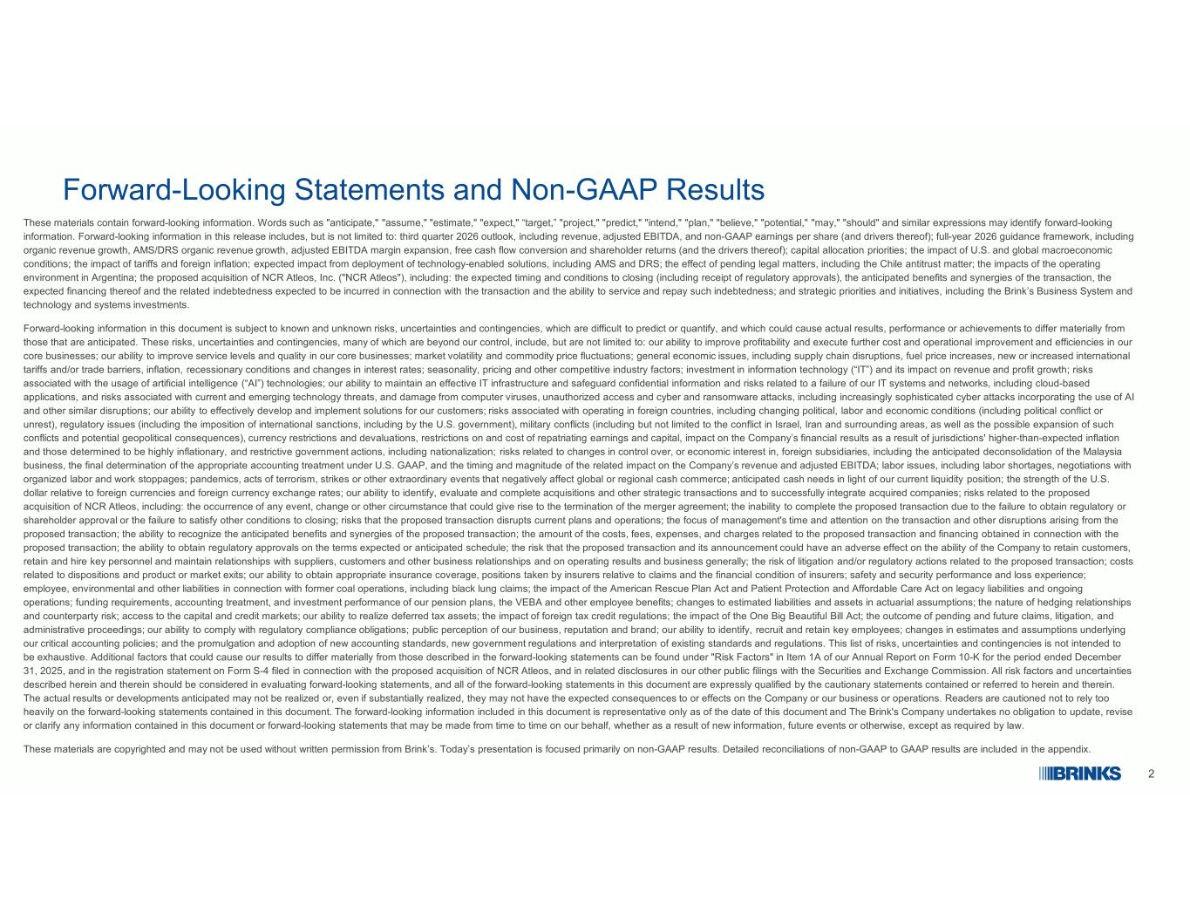
2 Forward-Looking Statements and Non-GAAP Results These materials contain forward-looking information. Words such as "anticipate," "assume," "estimate," "expect," “target,” "project," "predict," "intend," "plan," "believe," "potential," "may," "should" and similar expressions may identify forward-looking information. Forward-looking information in this release includes, but is not limited to: third quarter 2026 outlook, including revenue, adjusted EBITDA, and non-GAAP earnings per share (and drivers thereof); full-year 2026 guidance framework, including organic revenue growth, AMS/DRS organic revenue growth, adjusted EBITDA margin expansion, free cash flow conversion and shareholder returns (and the drivers thereof); capital allocation priorities; the impact of U.S. and global macroeconomic conditions; the impact of tariffs and foreign inflation; expected impact from deployment of technology-enabled solutions, including AMS and DRS; the effect of pending legal matters, including the Chile antitrust matter; the impacts of the operating environment in Argentina; the proposed acquisition of NCR Atleos, Inc. ("NCR Atleos"), including: the expected timing and conditions to closing (including receipt of regulatory approvals), the anticipated benefits and synergies of the transaction, the expected financing thereof and the related indebtedness expected to be incurred in connection with the transaction and the ability to service and repay such indebtedness; and strategic priorities and initiatives, including the Brink’s Business System and technology and systems investments. Forward-looking information in this document is subject to known and unknown risks, uncertainties and contingencies, which are difficult to predict or quantify, and which could cause actual results, performance or achievements to differ materially from those that are anticipated. These risks, uncertainties and contingencies, many of which are beyond our control, include, but are not limited to: our ability to improve profitability and execute further cost and operational improvement and efficiencies in our core businesses; our ability to improve service levels and quality in our core businesses; market volatility and commodity price fluctuations; general economic issues, including supply chain disruptions, fuel price increases, new or increased international tariffs and/or trade barriers, inflation, recessionary conditions and changes in interest rates; seasonality, pricing and other competitive industry factors; investment in information technology (“IT”) and its impact on revenue and profit growth; risks associated with the usage of artificial intelligence (“AI”) technologies; our ability to maintain an effective IT infrastructure and safeguard confidential information and risks related to a failure of our IT systems and networks, including cloud-based applications, and risks associated with current and emerging technology threats, and damage from computer viruses, unauthorized access and cyber and ransomware attacks, including increasingly sophisticated cyber attacks incorporating the use of AI and other similar disruptions; our ability to effectively develop and implement solutions for our customers; risks associated with operating in foreign countries, including changing political, labor and economic conditions (including political conflict or unrest), regulatory issues (including the imposition of international sanctions, including by the U.S. government), military conflicts (including but not limited to the conflict in Israel, Iran and surrounding areas, as well as the possible expansion of such conflicts and potential geopolitical consequences), currency restrictions and devaluations, restrictions on and cost of repatriating earnings and capital, impact on the Company’s financial results as a result of jurisdictions' higher-than-expected inflation and those determined to be highly inflationary, and restrictive government actions, including nationalization; risks related to changes in control over, or economic interest in, foreign subsidiaries, including the anticipated deconsolidation of the Malaysia business, the final determination of the appropriate accounting treatment under U.S. GAAP, and the timing and magnitude of the related impact on the Company’s revenue and adjusted EBITDA; labor issues, including labor shortages, negotiations with organized labor and work stoppages; pandemics, acts of terrorism, strikes or other extraordinary events that negatively affect global or regional cash commerce; anticipated cash needs in light of our current liquidity position; the strength of the U.S. dollar relative to foreign currencies and foreign currency exchange rates; our ability to identify, evaluate and complete acquisitions and other strategic transactions and to successfully integrate acquired companies; risks related to the proposed acquisition of NCR Atleos, including: the occurrence of any event, change or other circumstance that could give rise to the termination of the merger agreement; the inability to complete the proposed transaction due to the failure to obtain regulatory or shareholder approval or the failure to satisfy other conditions to closing; risks that the proposed transaction disrupts current plans and operations; the focus of management's time and attention on the transaction and other disruptions arising from the proposed transaction; the ability to recognize the anticipated benefits and synergies of the proposed transaction; the amount of the costs, fees, expenses, and charges related to the proposed transaction and financing obtained in connection with the proposed transaction; the ability to obtain regulatory approvals on the terms expected or anticipated schedule; the risk that the proposed transaction and its announcement could have an adverse effect on the ability of the Company to retain customers, retain and hire key personnel and maintain relationships with suppliers, customers and other business relationships and on operating results and business generally; the risk of litigation and/or regulatory actions related to the proposed transaction; costs related to dispositions and product or market exits; our ability to obtain appropriate insurance coverage, positions taken by insurers relative to claims and the financial condition of insurers; safety and security performance and loss experience; employee, environmental and other liabilities in connection with former coal operations, including black lung claims; the impact of the American Rescue Plan Act and Patient Protection and Affordable Care Act on legacy liabilities and ongoing operations; funding requirements, accounting treatment, and investment performance of our pension plans, the VEBA and other employee benefits; changes to estimated liabilities and assets in actuarial assumptions; the nature of hedging relationships and counterparty risk; access to the capital and credit markets; our ability to realize deferred tax assets; the impact of foreign tax credit regulations; the impact of the One Big Beautiful Bill Act; the outcome of pending and future claims, litigation, and administrative proceedings; our ability to comply with regulatory compliance obligations; public perception of our business, reputation and brand; our ability to identify, recruit and retain key employees; changes in estimates and assumptions underlying our critical accounting policies; and the promulgation and adoption of new accounting standards, new government regulations and interpretation of existing standards and regulations. This list of risks, uncertainties and contingencies is not intended to be exhaustive. Additional factors that could cause our results to differ materially from those described in the forward-looking statements can be found under "Risk Factors" in Item 1A of our Annual Report on Form 10-K for the period ended December 31, 2025, and in the registration statement on Form S-4 filed in connection with the proposed acquisition of NCR Atleos, and in related disclosures in our other public filings with the Securities and Exchange Commission. All risk factors and uncertainties described herein and therein should be considered in evaluating forward-looking statements, and all of the forward-looking statements in this document are expressly qualified by the cautionary statements contained or referred to herein and therein. The actual results or developments anticipated may not be realized or, even if substantially realized, they may not have the expected consequences to or effects on the Company or our business or operations. Readers are cautioned not to rely too heavily on the forward-looking statements contained in this document. The forward-looking information included in this document is representative only as of the date of this document and The Brink's Company undertakes no obligation to update, revise or clarify any information contained in this document or forward-looking statements that may be made from time to time on our behalf, whether as a result of new information, future events or otherwise, except as required by law. These materials are copyrighted and may not be used without written permission from Brink’s. Today’s presentation is focused primarily on non-GAAP results. Detailed reconciliations of non-GAAP to GAAP results are included in the appendix.

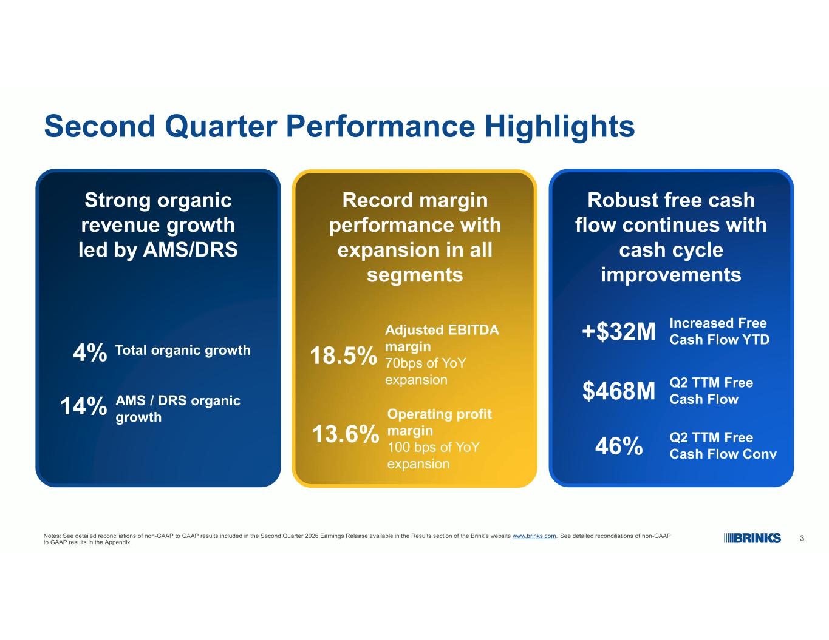
3 Second Quarter Performance Highlights Strong organic revenue growth led by AMS/DRS 4% Total organic growth 14% AMS / DRS organic growth Record margin performance with expansion in all segments 18.5% Adjusted EBITDA margin 70bps of YoY expansion 13.6% Operating profit margin 100 bps of YoY expansion Robust free cash flow continues with cash cycle improvements +$32M Increased Free Cash Flow YTD Notes: See detailed reconciliations of non-GAAP to GAAP results included in the Second Quarter 2026 Earnings Release available in the Results section of the Brink’s website www.brinks.com. See detailed reconciliations of non-GAAP to GAAP results in the Appendix. 46% Q2 TTM Free Cash Flow Conv $468M Q2 TTM Free Cash Flow

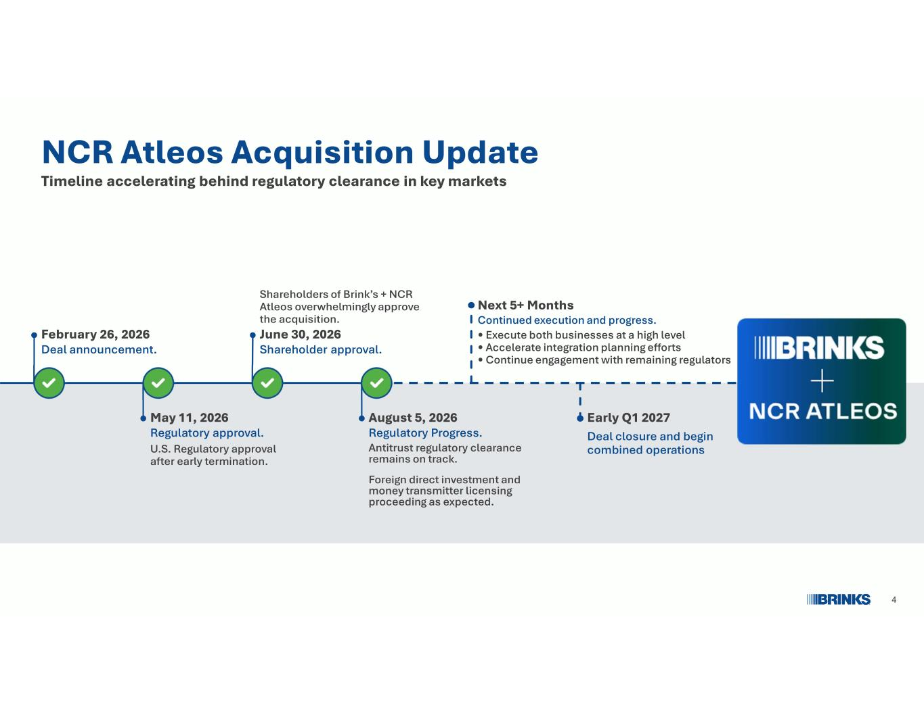
4 NCR Atleos Acquisition Update Timeline accelerating behind regulatory clearance in key markets U.S. Regulatory approval after early termination. May 11, 2026 Regulatory approval. February 26, 2026 Deal announcement. Shareholders of Brink’s + NCR Atleos overwhelmingly approve the acquisition. June 30, 2026 Shareholder approval. Antitrust regulatory clearance remains on track. Foreign direct investment and money transmitter licensing proceeding as expected. August 5, 2026 Regulatory Progress. • Execute both businesses at a high level • Accelerate integration planning efforts • Continue engagement with remaining regulators Next 5+ Months Continued execution and progress. Deal closure and begin combined operations Early Q1 2027

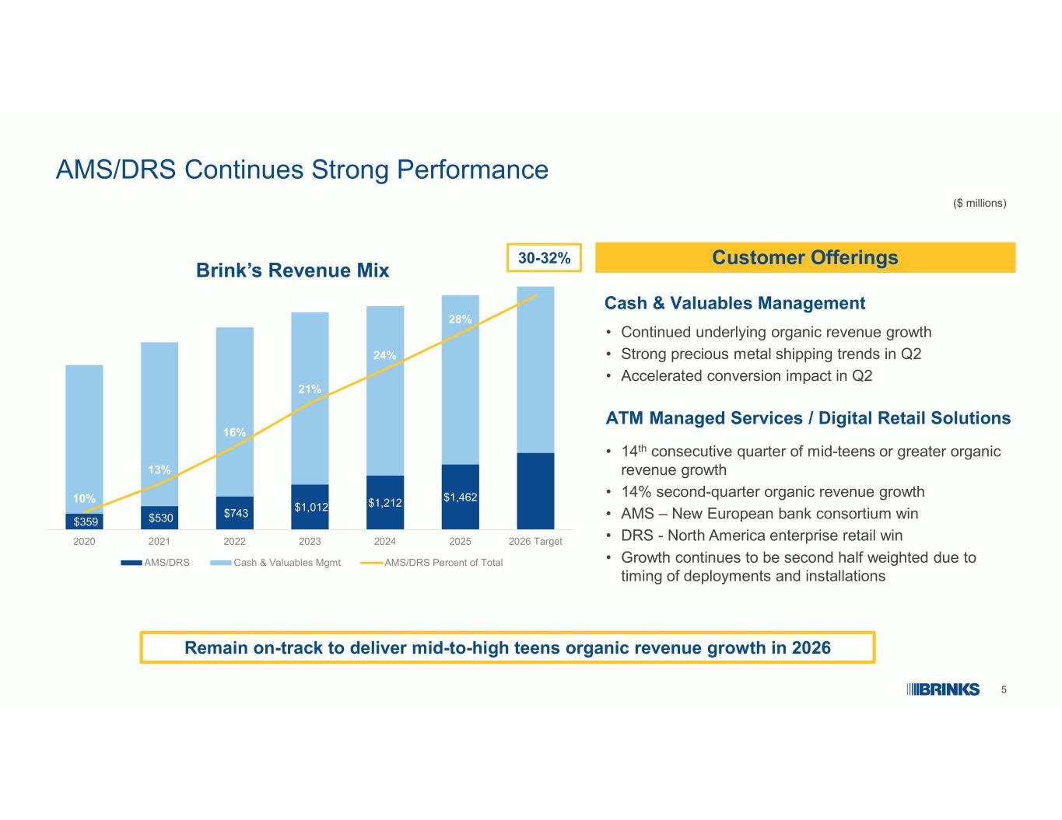
5 $359 $530 $743 $1,012 $1,212 $1,462 10% 13% 16% 21% 24% 28% 31.6% 2020 2021 2022 2023 2024 2025 2026 Target AMS/DRS Cash & Valuables Mgmt AMS/DRS Percent of Total AMS/DRS Continues Strong Performance • Continued underlying organic revenue growth • Strong precious metal shipping trends in Q2 • Accelerated conversion impact in Q2 Cash & Valuables Management • 14th consecutive quarter of mid-teens or greater organic revenue growth • 14% second-quarter organic revenue growth • AMS – New European bank consortium win • DRS - North America enterprise retail win • Growth continues to be second half weighted due to timing of deployments and installations ATM Managed Services / Digital Retail Solutions Customer Offerings Brink’s Revenue Mix Remain on-track to deliver mid-to-high teens organic revenue growth in 2026 ($ millions) 30-32%

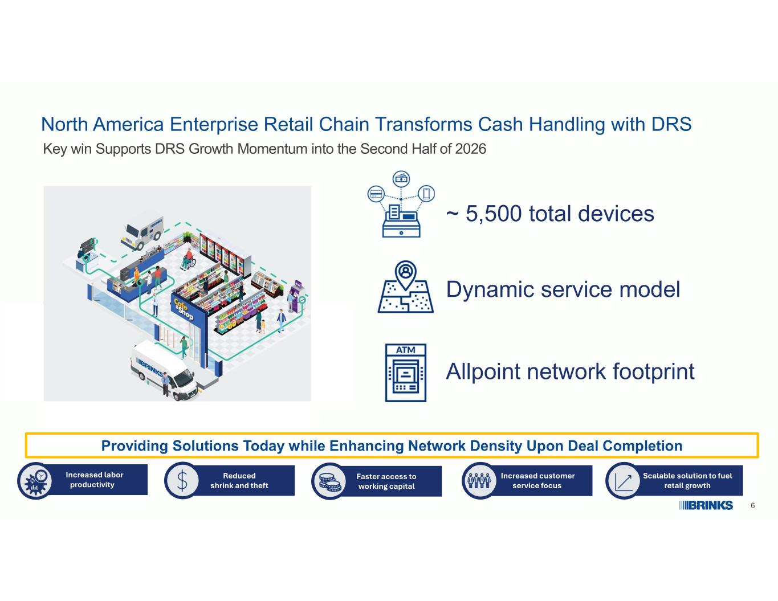
6 Dynamic service model ~ 5,500 total devices Allpoint network footprint Providing Solutions Today while Enhancing Network Density Upon Deal Completion Increased labor productivity Reduced shrink and theft Faster access to working capital Scalable solution to fuel retail growth Increased customer service focus North America Enterprise Retail Chain Transforms Cash Handling with DRS Key win Supports DRS Growth Momentum into the Second Half of 2026

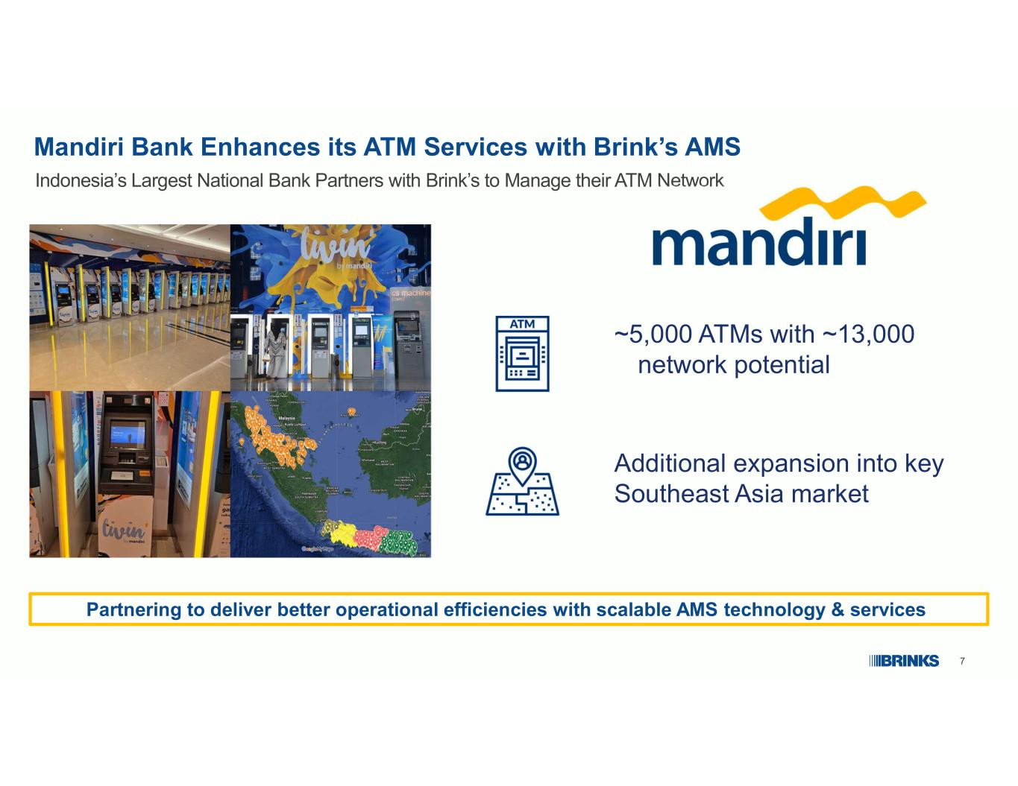
7 Mandiri Bank Enhances its ATM Services with Brink’s AMS Indonesia’s Largest National Bank Partners with Brink’s to Manage their ATM Network ~5,000 ATMs with ~13,000 network potential Partnering to deliver better operational efficiencies with scalable AMS technology & services Additional expansion into key Southeast Asia market

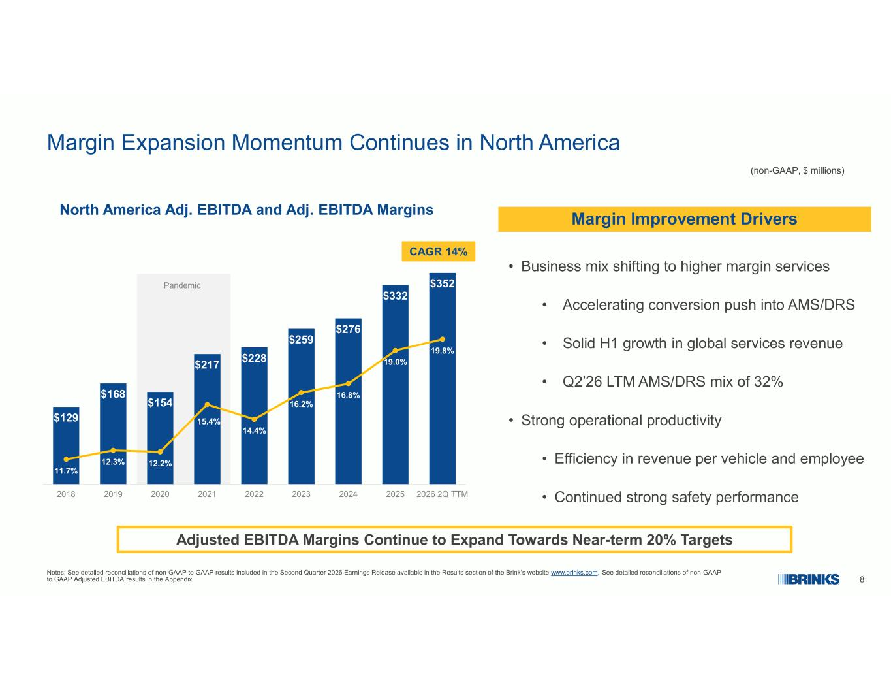
8 $129 $168 $154 $217 $228 $259 $276 $332 $352 11.7% 12.3% 12.2% 15.4% 14.4% 16.2% 16.8% 19.0% 19.8% 2018 2019 2020 2021 2022 2023 2024 2025 2026 2Q TTM Pandemic Margin Expansion Momentum Continues in North America North America Adj. EBITDA and Adj. EBITDA Margins Adjusted EBITDA Margins Continue to Expand Towards Near-term 20% Targets CAGR 14% • Business mix shifting to higher margin services • Accelerating conversion push into AMS/DRS • Solid H1 growth in global services revenue • Q2’26 LTM AMS/DRS mix of 32% • Strong operational productivity • Efficiency in revenue per vehicle and employee • Continued strong safety performance (non-GAAP, $ millions) Notes: See detailed reconciliations of non-GAAP to GAAP results included in the Second Quarter 2026 Earnings Release available in the Results section of the Brink’s website www.brinks.com. See detailed reconciliations of non-GAAP to GAAP Adjusted EBITDA results in the Appendix Margin Improvement Drivers

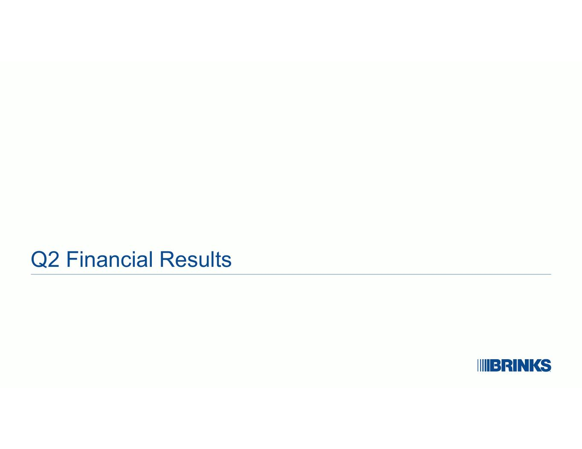
Q2 Financial Results

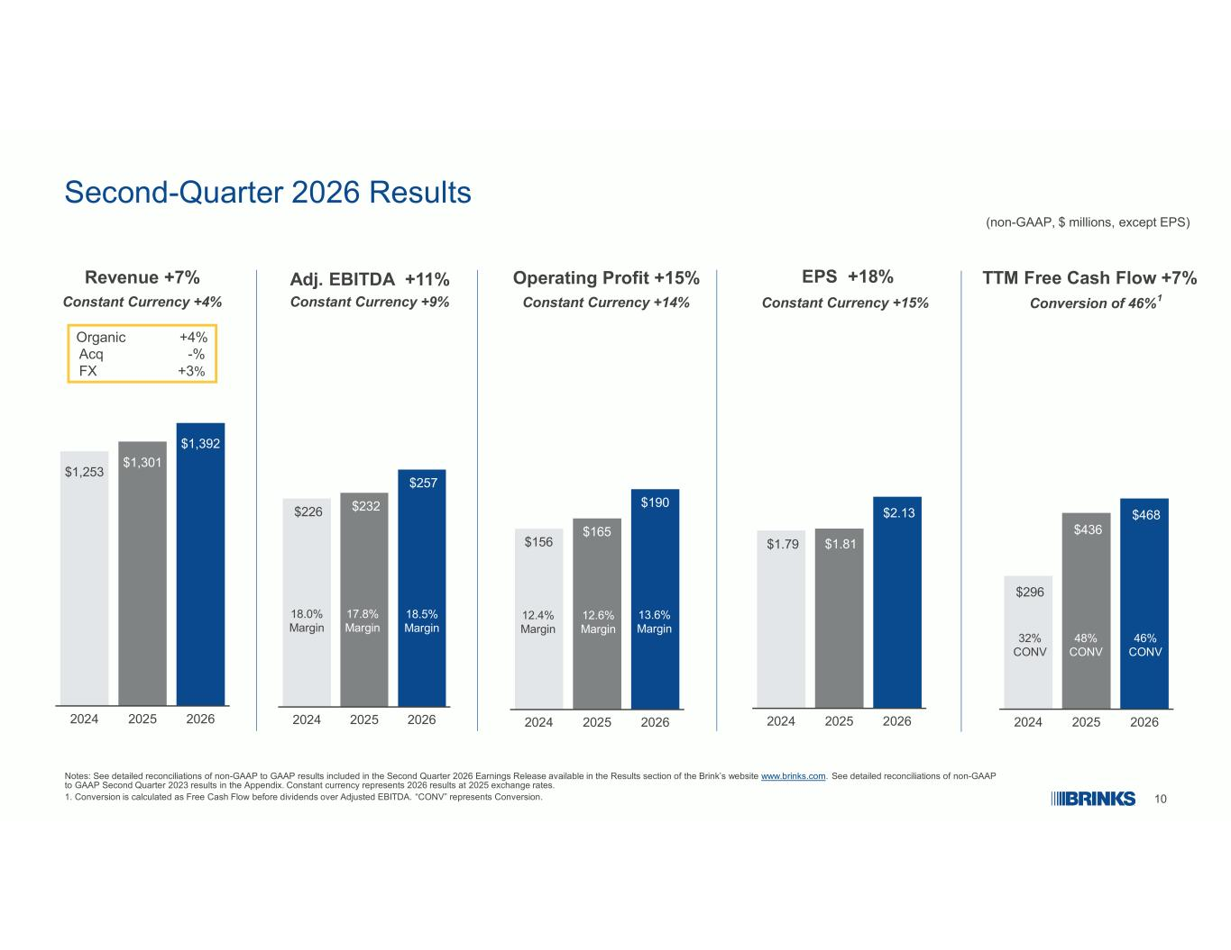
10 Second-Quarter 2026 Results (non-GAAP, $ millions, except EPS) Notes: See detailed reconciliations of non-GAAP to GAAP results included in the Second Quarter 2026 Earnings Release available in the Results section of the Brink’s website www.brinks.com. See detailed reconciliations of non-GAAP to GAAP Second Quarter 2023 results in the Appendix. Constant currency represents 2026 results at 2025 exchange rates. 1. Conversion is calculated as Free Cash Flow before dividends over Adjusted EBITDA. “CONV” represents Conversion. Revenue +7% Organic +4% Acq -% FX +3% Adj. EBITDA +11% $1,253 $1,301 $1,392 2024 2025 2026 Constant Currency +4% Constant Currency +9% EPS +18% Constant Currency +15% $1.79 $1.81 $2.13 2024 2025 2026 $226 $232 $257 2024 2025 2026 18.5% Margin 17.8% Margin 18.0% Margin $156 $165 $190 2024 2025 2026 Operating Profit +15% Constant Currency +14% 12.4% Margin 12.6% Margin 13.6% Margin TTM Free Cash Flow +7% Conversion of 46%1 $296 $436 $468 2024 2025 2026 46% CONV 48% CONV 32% CONV

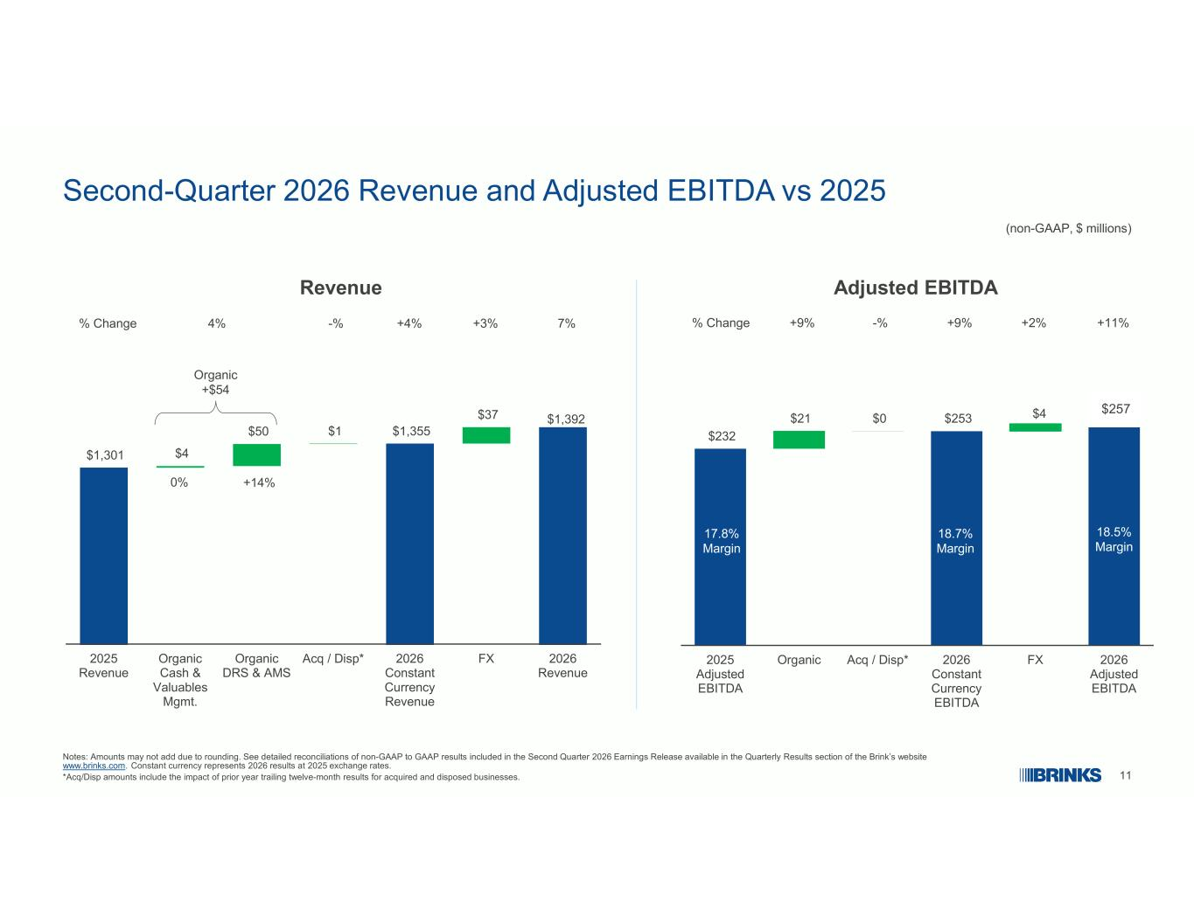
11 Second-Quarter 2026 Revenue and Adjusted EBITDA vs 2025 (non-GAAP, $ millions) Revenue $1,301 $4 $50 $1 $1,355 $37 $1,392 2025 Revenue Organic Cash & Valuables Mgmt. Organic DRS & AMS Acq / Disp* 2026 Constant Currency Revenue FX 2026 Revenue Notes: Amounts may not add due to rounding. See detailed reconciliations of non-GAAP to GAAP results included in the Second Quarter 2026 Earnings Release available in the Quarterly Results section of the Brink’s website www.brinks.com. Constant currency represents 2026 results at 2025 exchange rates. *Acq/Disp amounts include the impact of prior year trailing twelve-month results for acquired and disposed businesses. % Change +3%4% -% 7%+4% Organic +$54 0% +14% $257 $232 $21 $0 $253 $4 2025 Adjusted EBITDA Organic Acq / Disp* 2026 Constant Currency EBITDA FX 2026 Adjusted EBITDA Adjusted EBITDA 17.8% Margin 18.5% Margin % Change +9% +9% +2% +11% 18.7% Margin -%

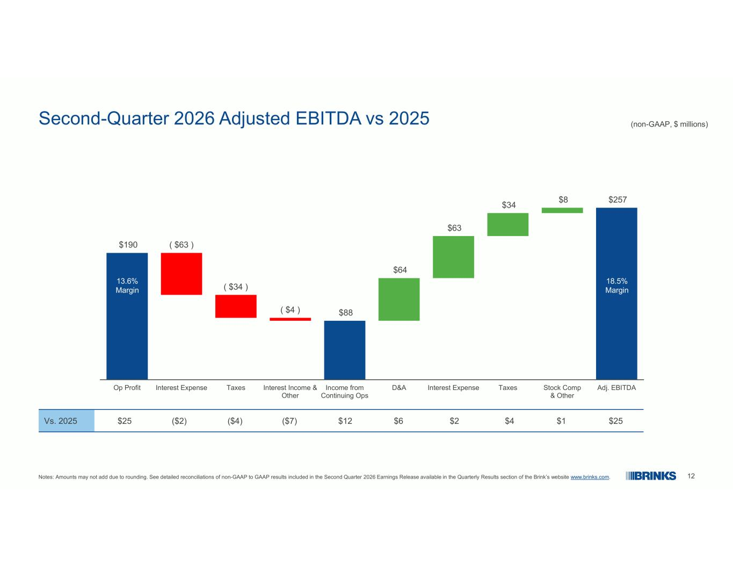
12 $190 ( $63 ) ( $34 ) ( $4 ) $88 $64 $63 $34 $8 $257 Op Profit Interest Expense Taxes Interest Income & Other Income from Continuing Ops D&A Interest Expense Taxes Stock Comp & Other Adj. EBITDA Second-Quarter 2026 Adjusted EBITDA vs 2025 (non-GAAP, $ millions) 18.5% Margin 13.6% Margin Notes: Amounts may not add due to rounding. See detailed reconciliations of non-GAAP to GAAP results included in the Second Quarter 2026 Earnings Release available in the Quarterly Results section of the Brink’s website www.brinks.com. $25$1$4$2$6$12($7)($4)($2)$25Vs. 2025

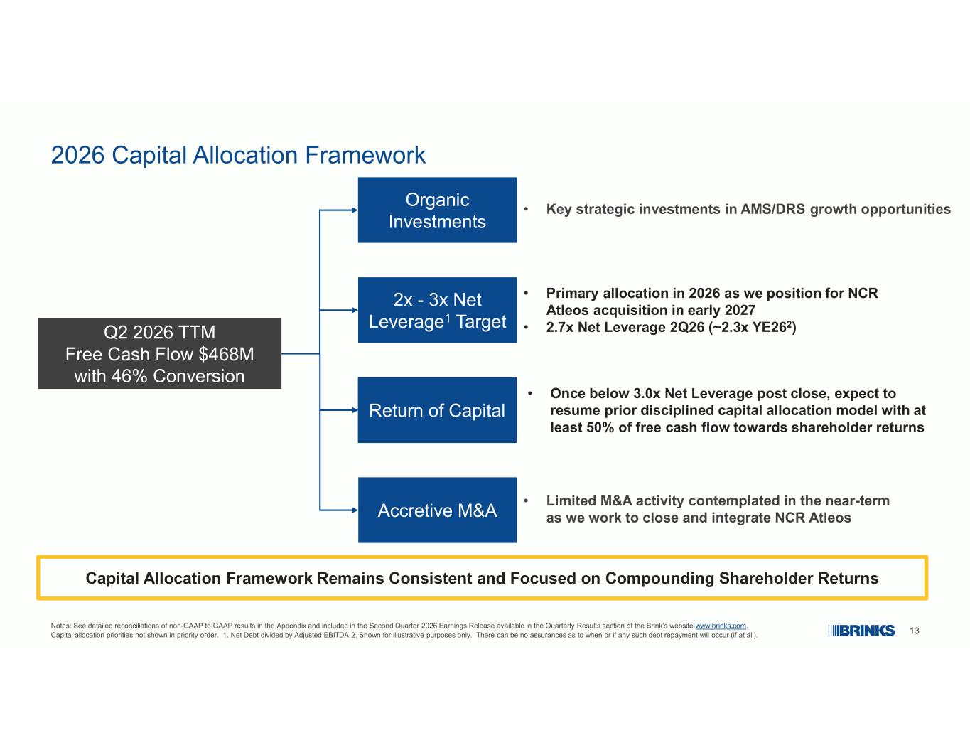
13 2026 Capital Allocation Framework Notes: See detailed reconciliations of non-GAAP to GAAP results in the Appendix and included in the Second Quarter 2026 Earnings Release available in the Quarterly Results section of the Brink’s website www.brinks.com. Capital allocation priorities not shown in priority order. 1. Net Debt divided by Adjusted EBITDA 2. Shown for illustrative purposes only. There can be no assurances as to when or if any such debt repayment will occur (if at all). Q2 2026 TTM Free Cash Flow $468M with 46% Conversion • Limited M&A activity contemplated in the near-term as we work to close and integrate NCR Atleos 2x - 3x Net Leverage1 Target Accretive M&A Return of Capital Organic Investments • Once below 3.0x Net Leverage post close, expect to resume prior disciplined capital allocation model with at least 50% of free cash flow towards shareholder returns • Primary allocation in 2026 as we position for NCR Atleos acquisition in early 2027 • 2.7x Net Leverage 2Q26 (~2.3x YE262) • Key strategic investments in AMS/DRS growth opportunities Capital Allocation Framework Remains Consistent and Focused on Compounding Shareholder Returns

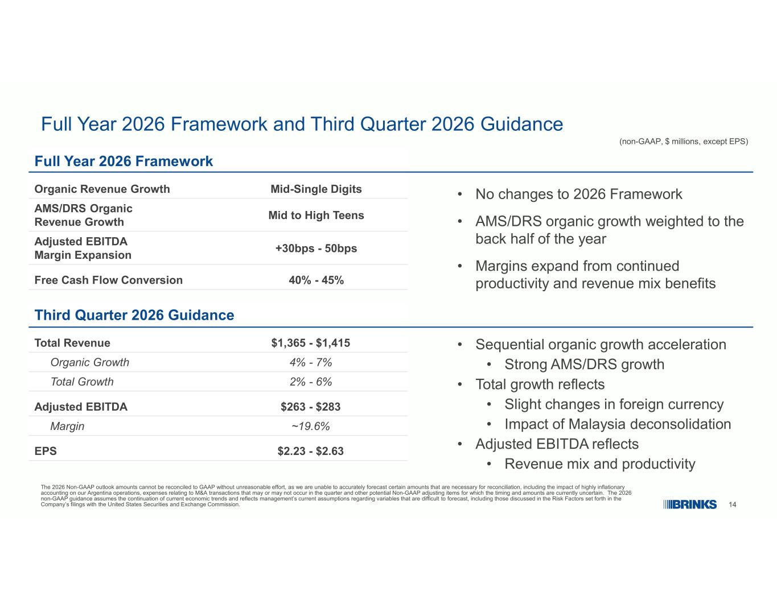
14 Full Year 2026 Framework and Third Quarter 2026 Guidance (non-GAAP, $ millions, except EPS) The 2026 Non-GAAP outlook amounts cannot be reconciled to GAAP without unreasonable effort, as we are unable to accurately forecast certain amounts that are necessary for reconciliation, including the impact of highly inflationary accounting on our Argentina operations, expenses relating to M&A transactions that may or may not occur in the quarter and other potential Non-GAAP adjusting items for which the timing and amounts are currently uncertain. The 2026 non-GAAP guidance assumes the continuation of current economic trends and reflects management’s current assumptions regarding variables that are difficult to forecast, including those discussed in the Risk Factors set forth in the Company’s filings with the United States Securities and Exchange Commission. Full Year 2026 Framework Mid-Single DigitsOrganic Revenue Growth Mid to High Teens AMS/DRS Organic Revenue Growth +30bps - 50bps Adjusted EBITDA Margin Expansion 40% - 45%Free Cash Flow Conversion Third Quarter 2026 Guidance $1,365 - $1,415Total Revenue 4% - 7%Organic Growth 2% - 6%Total Growth $263 - $283Adjusted EBITDA ~19.6%Margin $2.23 - $2.63EPS • Sequential organic growth acceleration • Strong AMS/DRS growth • Total growth reflects • Slight changes in foreign currency • Impact of Malaysia deconsolidation • Adjusted EBITDA reflects • Revenue mix and productivity • No changes to 2026 Framework • AMS/DRS organic growth weighted to the back half of the year • Margins expand from continued productivity and revenue mix benefits

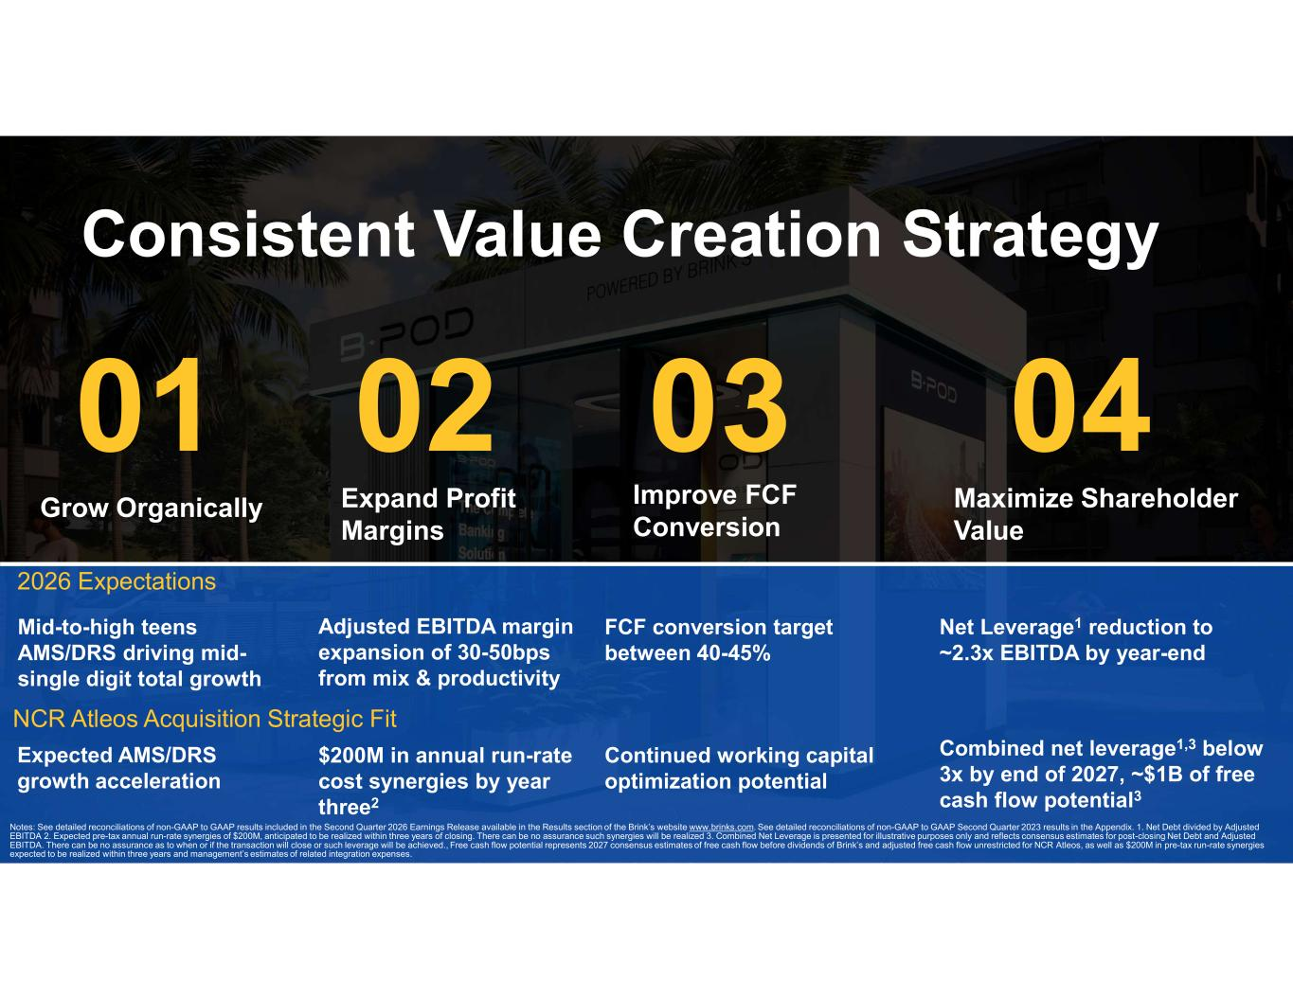
15 Consistent Value Creation Strategy Grow Organically Expand Profit Margins Improve FCF Conversion Maximize Shareholder Value Mid-to-high teens AMS/DRS driving mid- single digit total growth FCF conversion target between 40-45% Combined net leverage1,3 below 3x by end of 2027, ~$1B of free cash flow potential3 Expected AMS/DRS growth acceleration NCR Atleos Acquisition Strategic Fit Adjusted EBITDA margin expansion of 30-50bps from mix & productivity $200M in annual run-rate cost synergies by year three2 Continued working capital optimization potential Net Leverage1 reduction to ~2.3x EBITDA by year-end 2026 Expectations Notes: See detailed reconciliations of non-GAAP to GAAP results included in the Second Quarter 2026 Earnings Release available in the Results section of the Brink’s website www.brinks.com. See detailed reconciliations of non-GAAP to GAAP Second Quarter 2023 results in the Appendix. 1. Net Debt divided by Adjusted EBITDA 2. Expected pre-tax annual run-rate synergies of $200M, anticipated to be realized within three years of closing. There can be no assurance such synergies will be realized 3. Combined Net Leverage is presented for illustrative purposes only and reflects consensus estimates for post-closing Net Debt and Adjusted EBITDA. There can be no assurance as to when or if the transaction will close or such leverage will be achieved., Free cash flow potential represents 2027 consensus estimates of free cash flow before dividends of Brink’s and adjusted free cash flow unrestricted for NCR Atleos, as well as $200M in pre-tax run-rate synergies expected to be realized within three years and management’s estimates of related integration expenses.

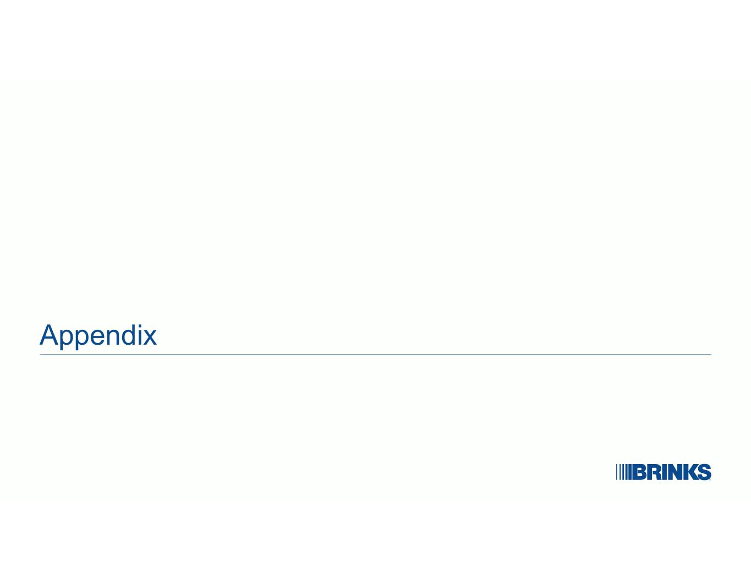
Appendix

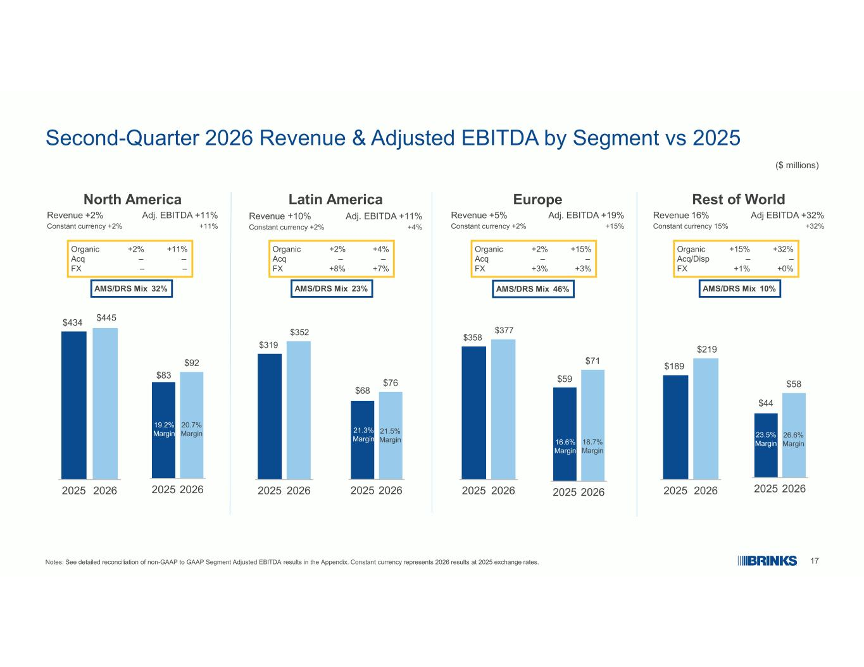
17 Second-Quarter 2026 Revenue & Adjusted EBITDA by Segment vs 2025 ($ millions) Notes: See detailed reconciliation of non-GAAP to GAAP Segment Adjusted EBITDA results in the Appendix. Constant currency represents 2026 results at 2025 exchange rates. $434 $445 2025 2026 $83 $92 2025 2026 19.2% Margin 20.7% Margin $319 $352 2025 2026 $68 $76 2025 2026 21.3% Margin 21.5% Margin $189 $219 2025 2026 $44 $58 2025 2026 23.5% Margin 26.6% Margin Latin America Adj. EBITDA +11%Revenue +10% +4%Constant currency +2% North America Adj. EBITDA +11%Revenue +2% +11%Constant currency +2% Europe Adj. EBITDA +19%Revenue +5% +15%Constant currency +2% Rest of World Adj EBITDA +32%Revenue 16% +32%Constant currency 15% Organic +2% +11% Acq – – FX – – Organic +2% +4% Acq – – FX +8% +7% Organic +2% +15% Acq – – FX +3% +3% Organic +15% +32% Acq/Disp – – FX +1% +0% $358 $377 2025 2026 $59 $71 2025 2026 18.7% Margin 16.6% Margin AMS/DRS Mix 32% AMS/DRS Mix 23% AMS/DRS Mix 46% AMS/DRS Mix 10%

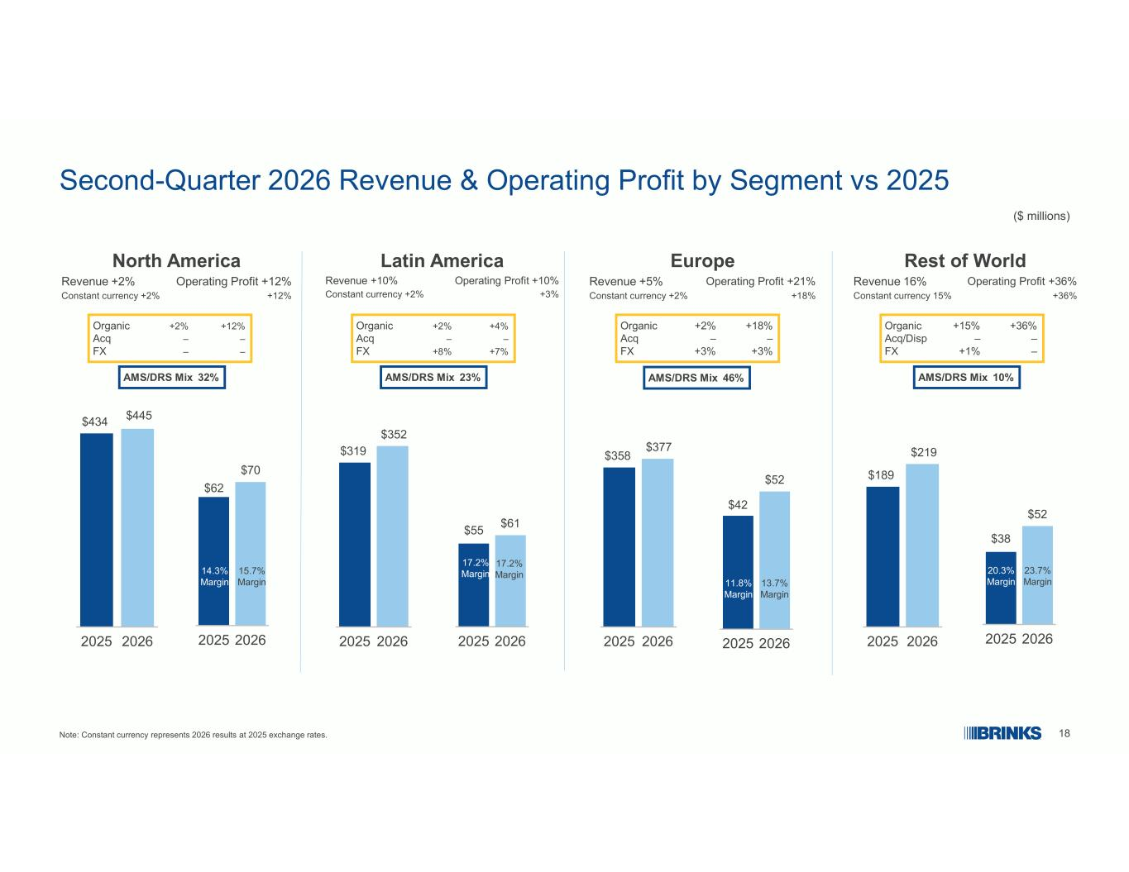
18 Second-Quarter 2026 Revenue & Operating Profit by Segment vs 2025 ($ millions) Note: Constant currency represents 2026 results at 2025 exchange rates. $434 $445 2025 2026 $62 $70 2025 2026 14.3% Margin 15.7% Margin $319 $352 2025 2026 $55 $61 2025 2026 17.2% Margin 17.2% Margin $189 $219 2025 2026 $38 $52 2025 2026 20.3% Margin 23.7% Margin Latin America Operating Profit +10%Revenue +10% +3%Constant currency +2% North America Operating Profit +12%Revenue +2% +12%Constant currency +2% Europe Operating Profit +21%Revenue +5% +18% Constant currency +2% Rest of World Operating Profit +36%Revenue 16% +36%Constant currency 15% Organic +2% +12% Acq – – FX – – Organic +2% +4% Acq – – FX +8% +7% Organic +2% +18% Acq – – FX +3% +3% Organic +15% +36% Acq/Disp – – FX +1% – $358 $377 2025 2026 $42 $52 2025 2026 13.7% Margin 11.8% Margin AMS/DRS Mix 32% AMS/DRS Mix 23% AMS/DRS Mix 46% AMS/DRS Mix 10%

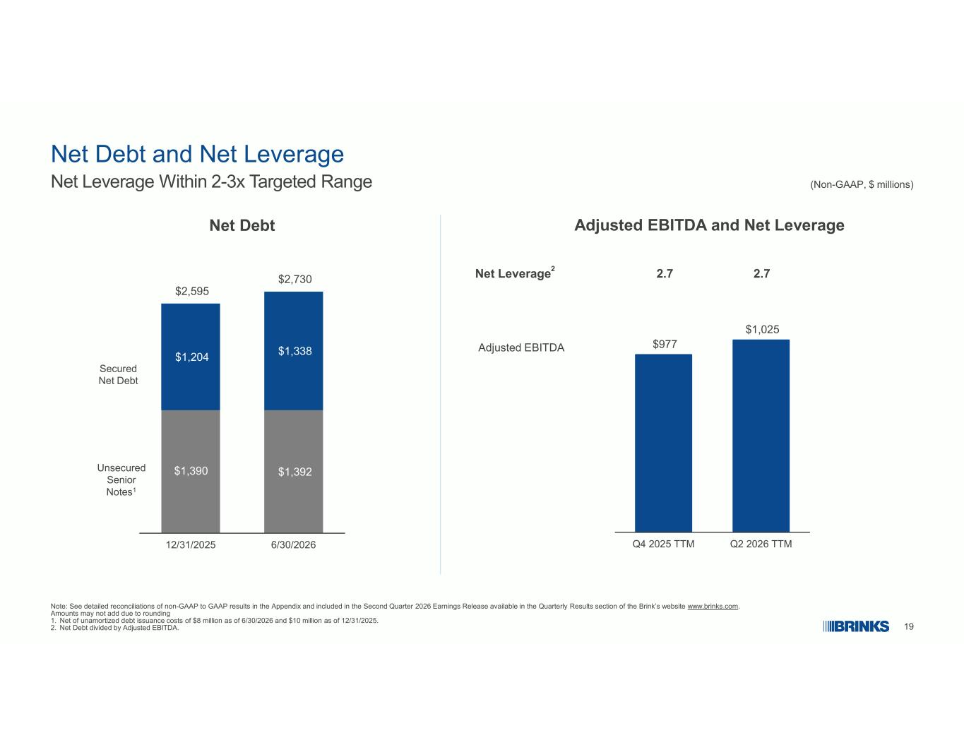
19 Net Debt and Net Leverage Note: See detailed reconciliations of non-GAAP to GAAP results in the Appendix and included in the Second Quarter 2026 Earnings Release available in the Quarterly Results section of the Brink’s website www.brinks.com. Amounts may not add due to rounding 1. Net of unamortized debt issuance costs of $8 million as of 6/30/2026 and $10 million as of 12/31/2025. 2. Net Debt divided by Adjusted EBITDA. (Non-GAAP, $ millions)Net Leverage Within 2-3x Targeted Range $977 $1,025 Q4 2025 TTM Q2 2026 TTM Net Debt Adjusted EBITDA and Net Leverage Adjusted EBITDA $1,390 $1,392 $1,204 $1,338 $2,595 $2,730 12/31/2025 6/30/2026 Unsecured Senior Notes1 Secured Net Debt 2.72.7Net Leverage2

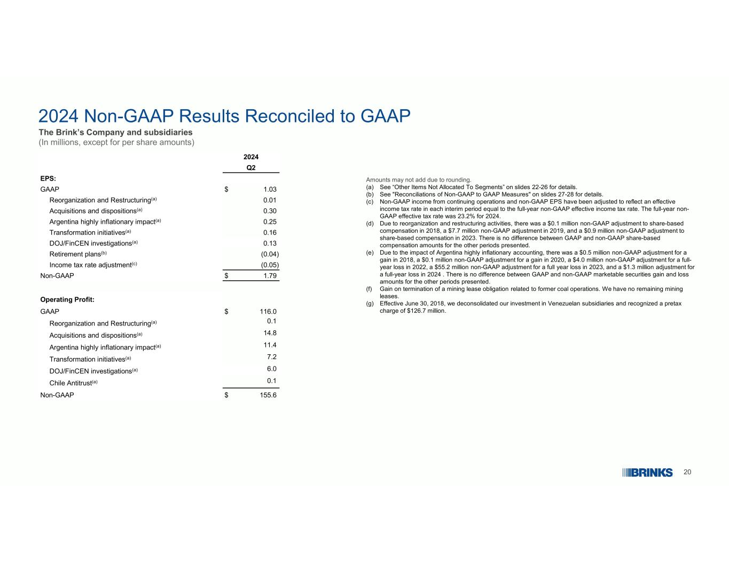
20 2024 Non-GAAP Results Reconciled to GAAP The Brink’s Company and subsidiaries (In millions, except for per share amounts) Amounts may not add due to rounding. (a) See “Other Items Not Allocated To Segments” on slides 22-26 for details. (b) See "Reconciliations of Non-GAAP to GAAP Measures" on slides 27-28 for details. (c) Non-GAAP income from continuing operations and non-GAAP EPS have been adjusted to reflect an effective income tax rate in each interim period equal to the full-year non-GAAP effective income tax rate. The full-year non- GAAP effective tax rate was 23.2% for 2024. (d) Due to reorganization and restructuring activities, there was a $0.1 million non-GAAP adjustment to share-based compensation in 2018, a $7.7 million non-GAAP adjustment in 2019, and a $0.9 million non-GAAP adjustment to share-based compensation in 2023. There is no difference between GAAP and non-GAAP share-based compensation amounts for the other periods presented. (e) Due to the impact of Argentina highly inflationary accounting, there was a $0.5 million non-GAAP adjustment for a gain in 2018, a $0.1 million non-GAAP adjustment for a gain in 2020, a $4.0 million non-GAAP adjustment for a full- year loss in 2022, a $55.2 million non-GAAP adjustment for a full year loss in 2023, and a $1.3 million adjustment for a full-year loss in 2024 . There is no difference between GAAP and non-GAAP marketable securities gain and loss amounts for the other periods presented. (f) Gain on termination of a mining lease obligation related to former coal operations. We have no remaining mining leases. (g) Effective June 30, 2018, we deconsolidated our investment in Venezuelan subsidiaries and recognized a pretax charge of $126.7 million. 2024 Q2 EPS: $ 1.03GAAP 0.01Reorganization and Restructuring(a) 0.30Acquisitions and dispositions(a) 0.25Argentina highly inflationary impact(a) 0.16Transformation initiatives(a) 0.13DOJ/FinCEN investigations(a) (0.04)Retirement plans(b) (0.05)Income tax rate adjustment(c) $ 1.79Non-GAAP Operating Profit: $ 116.0GAAP 0.1Reorganization and Restructuring(a) 14.8Acquisitions and dispositions(a) 11.4Argentina highly inflationary impact(a) 7.2Transformation initiatives(a) 6.0DOJ/FinCEN investigations(a) 0.1Chile Antitrust(a) $ 155.6Non-GAAP

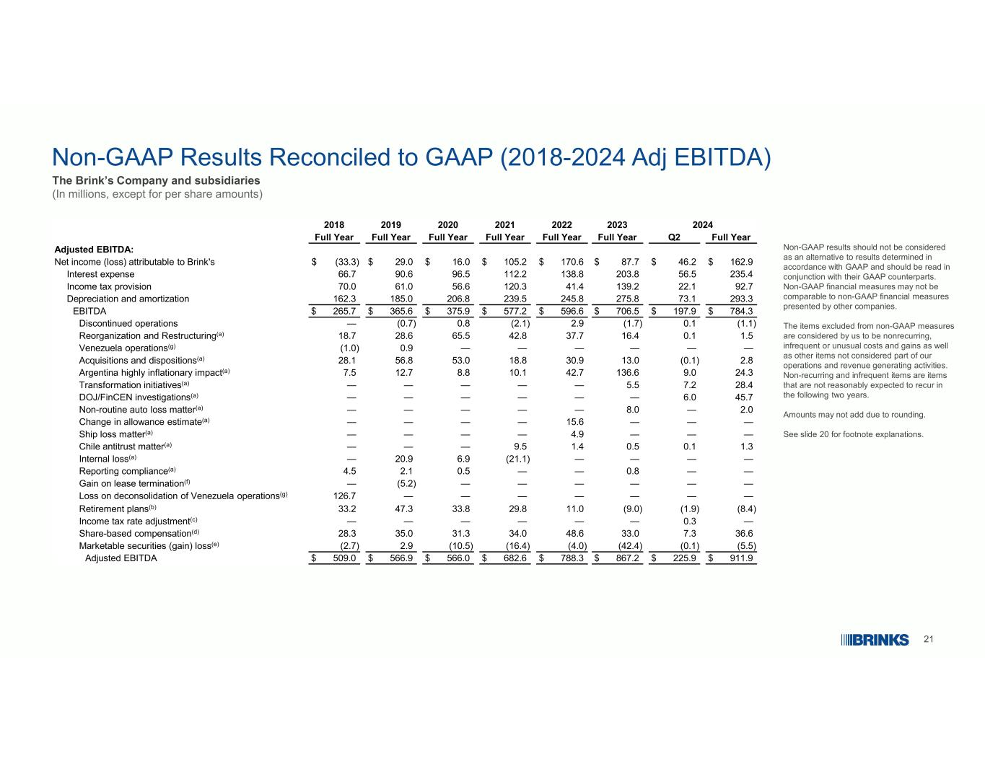
21 Non-GAAP Results Reconciled to GAAP (2018-2024 Adj EBITDA) The Brink’s Company and subsidiaries (In millions, except for per share amounts) Non-GAAP results should not be considered as an alternative to results determined in accordance with GAAP and should be read in conjunction with their GAAP counterparts. Non-GAAP financial measures may not be comparable to non-GAAP financial measures presented by other companies. The items excluded from non-GAAP measures are considered by us to be nonrecurring, infrequent or unusual costs and gains as well as other items not considered part of our operations and revenue generating activities. Non-recurring and infrequent items are items that are not reasonably expected to recur in the following two years. Amounts may not add due to rounding. See slide 20 for footnote explanations. 2024202320222021202020192018 Full YearQ2Full YearFull YearFull YearFull YearFull YearFull Year Adjusted EBITDA: $ 162.9$ 46.2$ 87.7$ 170.6$ 105.2$ 16.0$ 29.0$ (33.3)Net income (loss) attributable to Brink's 235.456.5203.8138.8112.296.590.666.7Interest expense 92.722.1139.241.4120.356.661.070.0Income tax provision 293.373.1275.8245.8239.5206.8185.0162.3Depreciation and amortization $ 784.3$ 197.9$ 706.5$ 596.6$ 577.2$ 375.9$ 365.6$ 265.7EBITDA (1.1)0.1(1.7)2.9(2.1)0.8(0.7)—Discontinued operations 1.50.116.437.742.865.528.618.7Reorganization and Restructuring(a) ——————0.9(1.0)Venezuela operations(g) 2.8(0.1)13.030.918.853.056.828.1Acquisitions and dispositions(a) 24.39.0136.642.710.18.812.77.5Argentina highly inflationary impact(a) 28.47.25.5—————Transformation initiatives(a) 45.76.0——————DOJ/FinCEN investigations(a) 2.0—8.0—————Non-routine auto loss matter(a) ———15.6————Change in allowance estimate(a) ———4.9————Ship loss matter(a) 1.30.10.51.49.5———Chile antitrust matter(a) ————(21.1)6.920.9—Internal loss(a) ——0.8——0.52.14.5Reporting compliance(a) ——————(5.2)—Gain on lease termination(f) ———————126.7Loss on deconsolidation of Venezuela operations(g) (8.4)(1.9)(9.0)11.029.833.847.333.2Retirement plans(b) —0.3——————Income tax rate adjustment(c) 36.67.333.048.634.031.335.028.3Share-based compensation(d) (5.5)(0.1)(42.4)(4.0)(16.4)(10.5)2.9(2.7)Marketable securities (gain) loss(e) $ 911.9$ 225.9$ 867.2$ 788.3$ 682.6$ 566.0$ 566.9$ 509.0Adjusted EBITDA

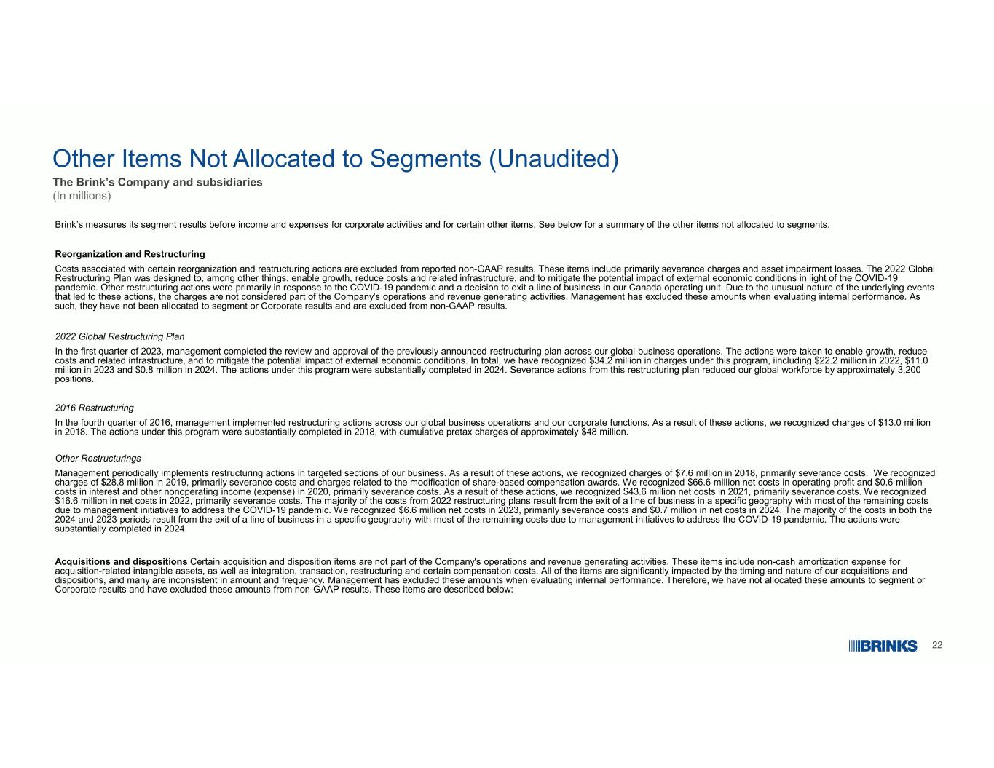
22 Other Items Not Allocated to Segments (Unaudited) The Brink’s Company and subsidiaries (In millions) Brink’s measures its segment results before income and expenses for corporate activities and for certain other items. See below for a summary of the other items not allocated to segments. Reorganization and Restructuring Costs associated with certain reorganization and restructuring actions are excluded from reported non-GAAP results. These items include primarily severance charges and asset impairment losses. The 2022 Global Restructuring Plan was designed to, among other things, enable growth, reduce costs and related infrastructure, and to mitigate the potential impact of external economic conditions in light of the COVID-19 pandemic. Other restructuring actions were primarily in response to the COVID-19 pandemic and a decision to exit a line of business in our Canada operating unit. Due to the unusual nature of the underlying events that led to these actions, the charges are not considered part of the Company's operations and revenue generating activities. Management has excluded these amounts when evaluating internal performance. As such, they have not been allocated to segment or Corporate results and are excluded from non-GAAP results. 2022 Global Restructuring Plan In the first quarter of 2023, management completed the review and approval of the previously announced restructuring plan across our global business operations. The actions were taken to enable growth, reduce costs and related infrastructure, and to mitigate the potential impact of external economic conditions. In total, we have recognized $34.2 million in charges under this program, iincluding $22.2 million in 2022, $11.0 million in 2023 and $0.8 million in 2024. The actions under this program were substantially completed in 2024. Severance actions from this restructuring plan reduced our global workforce by approximately 3,200 positions. 2016 Restructuring In the fourth quarter of 2016, management implemented restructuring actions across our global business operations and our corporate functions. As a result of these actions, we recognized charges of $13.0 million in 2018. The actions under this program were substantially completed in 2018, with cumulative pretax charges of approximately $48 million. Other Restructurings Management periodically implements restructuring actions in targeted sections of our business. As a result of these actions, we recognized charges of $7.6 million in 2018, primarily severance costs. We recognized charges of $28.8 million in 2019, primarily severance costs and charges related to the modification of share-based compensation awards. We recognized $66.6 million net costs in operating profit and $0.6 million costs in interest and other nonoperating income (expense) in 2020, primarily severance costs. As a result of these actions, we recognized $43.6 million net costs in 2021, primarily severance costs. We recognized $16.6 million in net costs in 2022, primarily severance costs. The majority of the costs from 2022 restructuring plans result from the exit of a line of business in a specific geography with most of the remaining costs due to management initiatives to address the COVID-19 pandemic. We recognized $6.6 million net costs in 2023, primarily severance costs and $0.7 million in net costs in 2024. The majority of the costs in both the 2024 and 2023 periods result from the exit of a line of business in a specific geography with most of the remaining costs due to management initiatives to address the COVID-19 pandemic. The actions were substantially completed in 2024. Acquisitions and dispositions Certain acquisition and disposition items are not part of the Company's operations and revenue generating activities. These items include non-cash amortization expense for acquisition-related intangible assets, as well as integration, transaction, restructuring and certain compensation costs. All of the items are significantly impacted by the timing and nature of our acquisitions and dispositions, and many are inconsistent in amount and frequency. Management has excluded these amounts when evaluating internal performance. Therefore, we have not allocated these amounts to segment or Corporate results and have excluded these amounts from non-GAAP results. These items are described below:

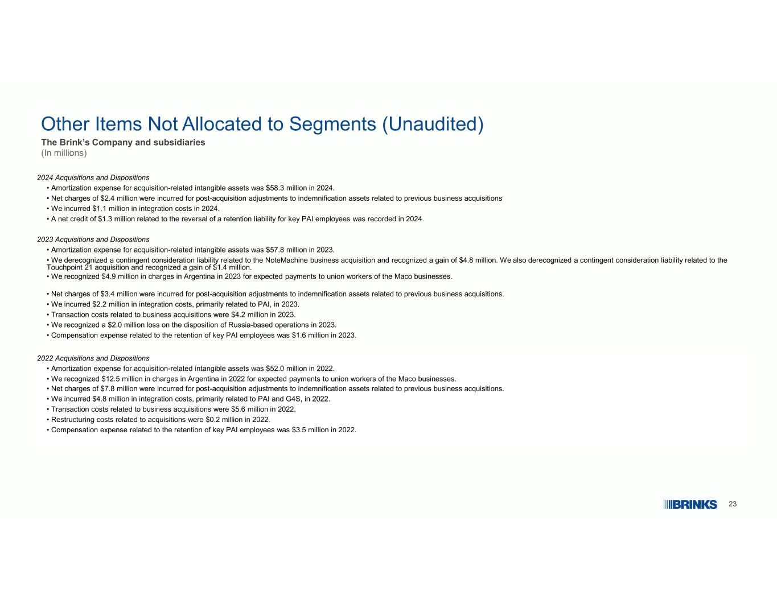
23 Other Items Not Allocated to Segments (Unaudited) The Brink’s Company and subsidiaries (In millions) 2024 Acquisitions and Dispositions • Amortization expense for acquisition-related intangible assets was $58.3 million in 2024. • Net charges of $2.4 million were incurred for post-acquisition adjustments to indemnification assets related to previous business acquisitions • We incurred $1.1 million in integration costs in 2024. • A net credit of $1.3 million related to the reversal of a retention liability for key PAI employees was recorded in 2024. 2023 Acquisitions and Dispositions • Amortization expense for acquisition-related intangible assets was $57.8 million in 2023. • We derecognized a contingent consideration liability related to the NoteMachine business acquisition and recognized a gain of $4.8 million. We also derecognized a contingent consideration liability related to the Touchpoint 21 acquisition and recognized a gain of $1.4 million. • We recognized $4.9 million in charges in Argentina in 2023 for expected payments to union workers of the Maco businesses. • Net charges of $3.4 million were incurred for post-acquisition adjustments to indemnification assets related to previous business acquisitions. • We incurred $2.2 million in integration costs, primarily related to PAI, in 2023. • Transaction costs related to business acquisitions were $4.2 million in 2023. • We recognized a $2.0 million loss on the disposition of Russia-based operations in 2023. • Compensation expense related to the retention of key PAI employees was $1.6 million in 2023. 2022 Acquisitions and Dispositions • Amortization expense for acquisition-related intangible assets was $52.0 million in 2022. • We recognized $12.5 million in charges in Argentina in 2022 for expected payments to union workers of the Maco businesses. • Net charges of $7.8 million were incurred for post-acquisition adjustments to indemnification assets related to previous business acquisitions. • We incurred $4.8 million in integration costs, primarily related to PAI and G4S, in 2022. • Transaction costs related to business acquisitions were $5.6 million in 2022. • Restructuring costs related to acquisitions were $0.2 million in 2022. • Compensation expense related to the retention of key PAI employees was $3.5 million in 2022.

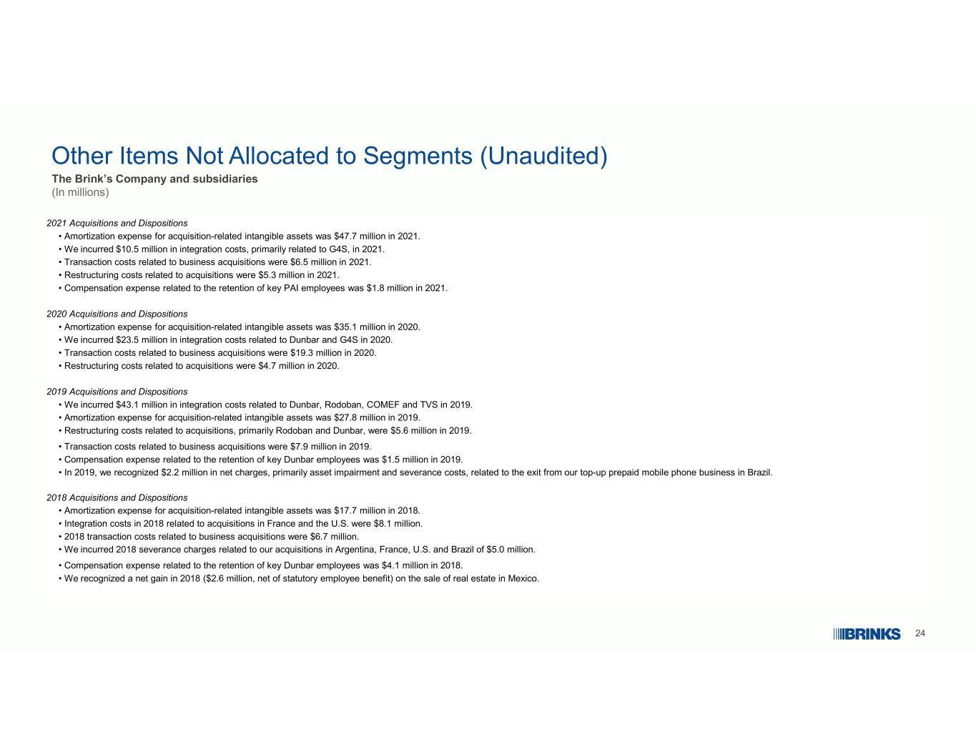
24 Other Items Not Allocated to Segments (Unaudited) The Brink’s Company and subsidiaries (In millions) 2021 Acquisitions and Dispositions • Amortization expense for acquisition-related intangible assets was $47.7 million in 2021. • We incurred $10.5 million in integration costs, primarily related to G4S, in 2021. • Transaction costs related to business acquisitions were $6.5 million in 2021. • Restructuring costs related to acquisitions were $5.3 million in 2021. • Compensation expense related to the retention of key PAI employees was $1.8 million in 2021. 2020 Acquisitions and Dispositions • Amortization expense for acquisition-related intangible assets was $35.1 million in 2020. • We incurred $23.5 million in integration costs related to Dunbar and G4S in 2020. • Transaction costs related to business acquisitions were $19.3 million in 2020. • Restructuring costs related to acquisitions were $4.7 million in 2020. 2019 Acquisitions and Dispositions • We incurred $43.1 million in integration costs related to Dunbar, Rodoban, COMEF and TVS in 2019. • Amortization expense for acquisition-related intangible assets was $27.8 million in 2019. • Restructuring costs related to acquisitions, primarily Rodoban and Dunbar, were $5.6 million in 2019. • Transaction costs related to business acquisitions were $7.9 million in 2019. • Compensation expense related to the retention of key Dunbar employees was $1.5 million in 2019. • In 2019, we recognized $2.2 million in net charges, primarily asset impairment and severance costs, related to the exit from our top-up prepaid mobile phone business in Brazil. 2018 Acquisitions and Dispositions • Amortization expense for acquisition-related intangible assets was $17.7 million in 2018. • Integration costs in 2018 related to acquisitions in France and the U.S. were $8.1 million. • 2018 transaction costs related to business acquisitions were $6.7 million. • We incurred 2018 severance charges related to our acquisitions in Argentina, France, U.S. and Brazil of $5.0 million. • Compensation expense related to the retention of key Dunbar employees was $4.1 million in 2018. • We recognized a net gain in 2018 ($2.6 million, net of statutory employee benefit) on the sale of real estate in Mexico.

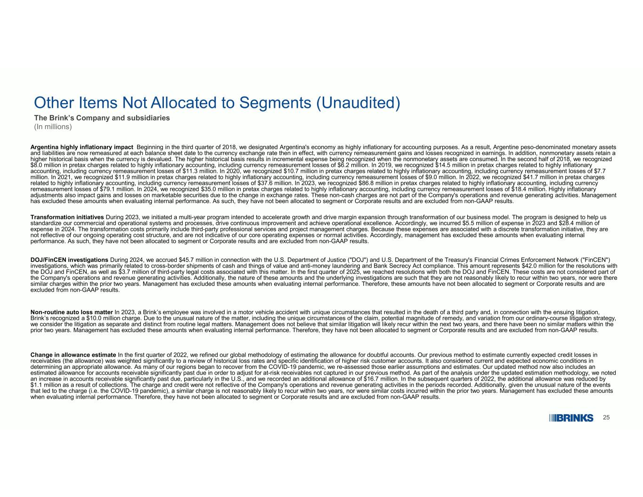
25 Other Items Not Allocated to Segments (Unaudited) The Brink’s Company and subsidiaries (In millions) Argentina highly inflationary impact Beginning in the third quarter of 2018, we designated Argentina's economy as highly inflationary for accounting purposes. As a result, Argentine peso-denominated monetary assets and liabilities are now remeasured at each balance sheet date to the currency exchange rate then in effect, with currency remeasurement gains and losses recognized in earnings. In addition, nonmonetary assets retain a higher historical basis when the currency is devalued. The higher historical basis results in incremental expense being recognized when the nonmonetary assets are consumed. In the second half of 2018, we recognized $8.0 million in pretax charges related to highly inflationary accounting, including currency remeasurement losses of $6.2 million. In 2019, we recognized $14.5 million in pretax charges related to highly inflationary accounting, including currency remeasurement losses of $11.3 million. In 2020, we recognized $10.7 million in pretax charges related to highly inflationary accounting, including currency remeasurement losses of $7.7 million. In 2021, we recognized $11.9 million in pretax charges related to highly inflationary accounting, including currency remeasurement losses of $9.0 million. In 2022, we recognized $41.7 million in pretax charges related to highly inflationary accounting, including currency remeasurement losses of $37.6 million. In 2023, we recognized $86.8 million in pretax charges related to highly inflationary accounting, including currency remeasurement losses of $79.1 million. In 2024, we recognized $35.0 million in pretax charges related to highly inflationary accounting, including currency remeasurement losses of $18.4 million. Highly inflationary adjustments also impact gains and losses on marketable securities due to the change in exchange rates. These non-cash charges are not part of the Company's operations and revenue generating activities. Management has excluded these amounts when evaluating internal performance. As such, they have not been allocated to segment or Corporate results and are excluded from non-GAAP results. Transformation initiatives During 2023, we initiated a multi-year program intended to accelerate growth and drive margin expansion through transformation of our business model. The program is designed to help us standardize our commercial and operational systems and processes, drive continuous improvement and achieve operational excellence. Accordingly, we incurred $5.5 million of expense in 2023 and $28.4 million of expense in 2024. The transformation costs primarily include third-party professional services and project management charges. Because these expenses are associated with a discrete transformation initiative, they are not reflective of our ongoing operating cost structure, and are not indicative of our core operating expenses or normal activities. Accordingly, management has excluded these amounts when evaluating internal performance. As such, they have not been allocated to segment or Corporate results and are excluded from non-GAAP results. DOJ/FinCEN investigations During 2024, we accrued $45.7 million in connection with the U.S. Department of Justice ("DOJ") and U.S. Department of the Treasury's Financial Crimes Enforcement Network ("FinCEN") investigations, which was primarily related to cross-border shipments of cash and things of value and anti-money laundering and Bank Secrecy Act compliance. This amount represents $42.0 million for the resolutions with the DOJ and FinCEN, as well as $3.7 million of third-party legal costs associated with this matter. In the first quarter of 2025, we reached resolutions with both the DOJ and FinCEN. These costs are not considered part of the Company's operations and revenue generating activities. Additionally, the nature of these amounts and the underlying investigations are such that they are not reasonably likely to recur within two years, nor were there similar charges within the prior two years. Management has excluded these amounts when evaluating internal performance. Therefore, these amounts have not been allocated to segment or Corporate results and are excluded from non-GAAP results. Non-routine auto loss matter In 2023, a Brink’s employee was involved in a motor vehicle accident with unique circumstances that resulted in the death of a third party and, in connection with the ensuing litigation, Brink’s recognized a $10.0 million charge. Due to the unusual nature of the matter, including the unique circumstances of the claim, potential magnitude of remedy, and variation from our ordinary-course litigation strategy, we consider the litigation as separate and distinct from routine legal matters. Management does not believe that similar litigation will likely recur within the next two years, and there have been no similar matters within the prior two years. Management has excluded these amounts when evaluating internal performance. Therefore, they have not been allocated to segment or Corporate results and are excluded from non-GAAP results. Change in allowance estimate In the first quarter of 2022, we refined our global methodology of estimating the allowance for doubtful accounts. Our previous method to estimate currently expected credit losses in receivables (the allowance) was weighted significantly to a review of historical loss rates and specific identification of higher risk customer accounts. It also considered current and expected economic conditions in determining an appropriate allowance. As many of our regions began to recover from the COVID-19 pandemic, we re-assessed those earlier assumptions and estimates. Our updated method now also includes an estimated allowance for accounts receivable significantly past due in order to adjust for at-risk receivables not captured in our previous method. As part of the analysis under the updated estimation methodology, we noted an increase in accounts receivable significantly past due, particularly in the U.S., and we recorded an additional allowance of $16.7 million. In the subsequent quarters of 2022, the additional allowance was reduced by $1.1 million as a result of collections. The charge and credit were not reflective of the Company's operations and revenue generating activities in the periods recorded. Additionally, given the unusual nature of the events that led to the charge (i.e. the COVID-19 pandemic), a similar charge is not reasonably likely to recur within two years, nor were similar costs incurred within the prior two years. Management has excluded these amounts when evaluating internal performance. Therefore, they have not been allocated to segment or Corporate results and are excluded from non-GAAP results.

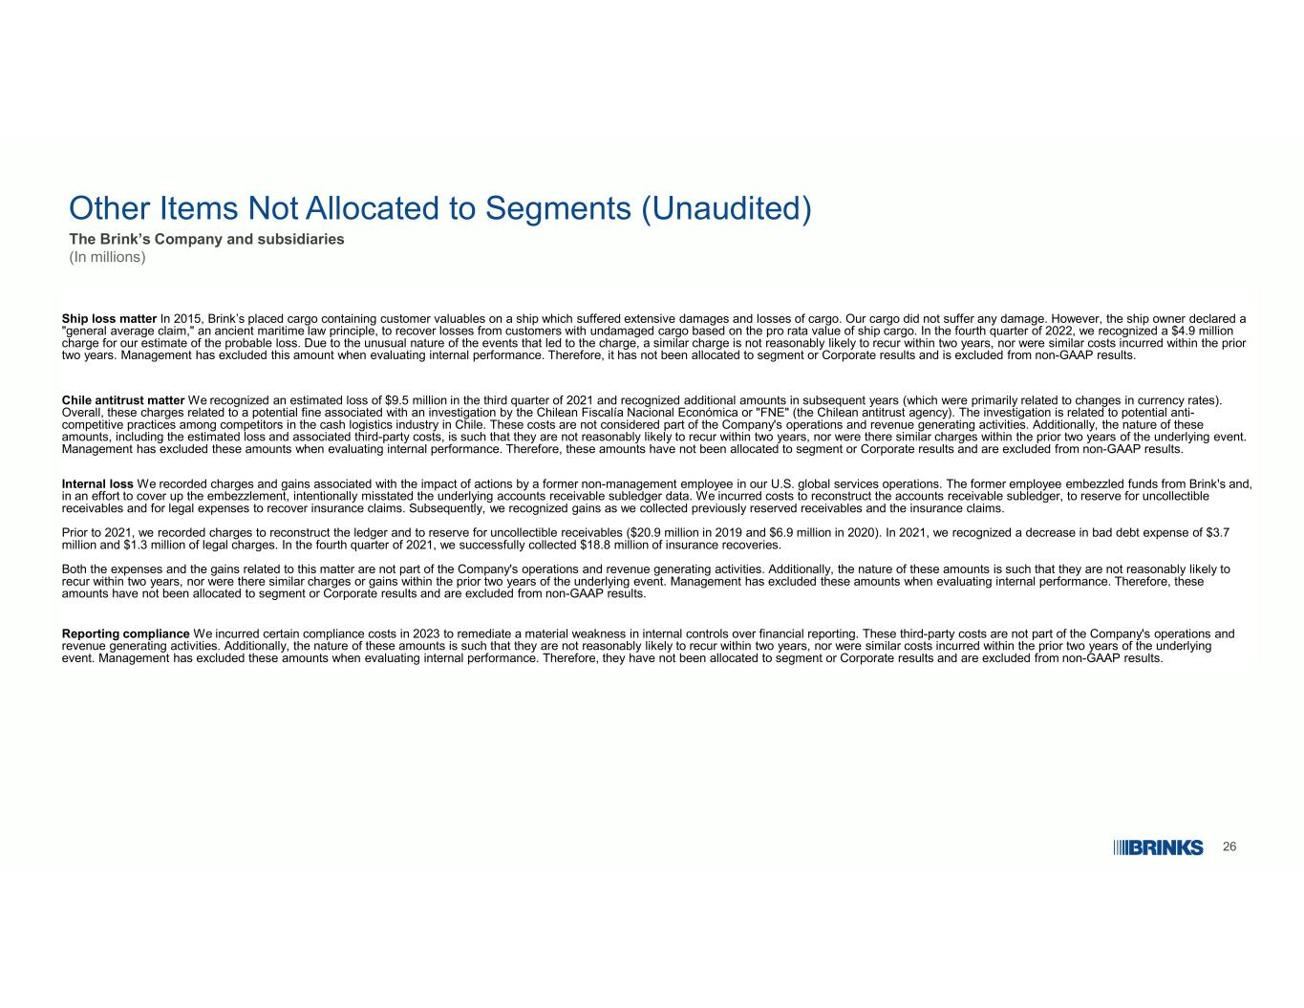
26 Other Items Not Allocated to Segments (Unaudited) The Brink’s Company and subsidiaries (In millions) Ship loss matter In 2015, Brink’s placed cargo containing customer valuables on a ship which suffered extensive damages and losses of cargo. Our cargo did not suffer any damage. However, the ship owner declared a "general average claim," an ancient maritime law principle, to recover losses from customers with undamaged cargo based on the pro rata value of ship cargo. In the fourth quarter of 2022, we recognized a $4.9 million charge for our estimate of the probable loss. Due to the unusual nature of the events that led to the charge, a similar charge is not reasonably likely to recur within two years, nor were similar costs incurred within the prior two years. Management has excluded this amount when evaluating internal performance. Therefore, it has not been allocated to segment or Corporate results and is excluded from non-GAAP results. Chile antitrust matter We recognized an estimated loss of $9.5 million in the third quarter of 2021 and recognized additional amounts in subsequent years (which were primarily related to changes in currency rates). Overall, these charges related to a potential fine associated with an investigation by the Chilean Fiscalía Nacional Económica or "FNE" (the Chilean antitrust agency). The investigation is related to potential anti- competitive practices among competitors in the cash logistics industry in Chile. These costs are not considered part of the Company's operations and revenue generating activities. Additionally, the nature of these amounts, including the estimated loss and associated third-party costs, is such that they are not reasonably likely to recur within two years, nor were there similar charges within the prior two years of the underlying event. Management has excluded these amounts when evaluating internal performance. Therefore, these amounts have not been allocated to segment or Corporate results and are excluded from non-GAAP results. Internal loss We recorded charges and gains associated with the impact of actions by a former non-management employee in our U.S. global services operations. The former employee embezzled funds from Brink's and, in an effort to cover up the embezzlement, intentionally misstated the underlying accounts receivable subledger data. We incurred costs to reconstruct the accounts receivable subledger, to reserve for uncollectible receivables and for legal expenses to recover insurance claims. Subsequently, we recognized gains as we collected previously reserved receivables and the insurance claims. Prior to 2021, we recorded charges to reconstruct the ledger and to reserve for uncollectible receivables ($20.9 million in 2019 and $6.9 million in 2020). In 2021, we recognized a decrease in bad debt expense of $3.7 million and $1.3 million of legal charges. In the fourth quarter of 2021, we successfully collected $18.8 million of insurance recoveries. Both the expenses and the gains related to this matter are not part of the Company's operations and revenue generating activities. Additionally, the nature of these amounts is such that they are not reasonably likely to recur within two years, nor were there similar charges or gains within the prior two years of the underlying event. Management has excluded these amounts when evaluating internal performance. Therefore, these amounts have not been allocated to segment or Corporate results and are excluded from non-GAAP results. Reporting compliance We incurred certain compliance costs in 2023 to remediate a material weakness in internal controls over financial reporting. These third-party costs are not part of the Company's operations and revenue generating activities. Additionally, the nature of these amounts is such that they are not reasonably likely to recur within two years, nor were similar costs incurred within the prior two years of the underlying event. Management has excluded these amounts when evaluating internal performance. Therefore, they have not been allocated to segment or Corporate results and are excluded from non-GAAP results.

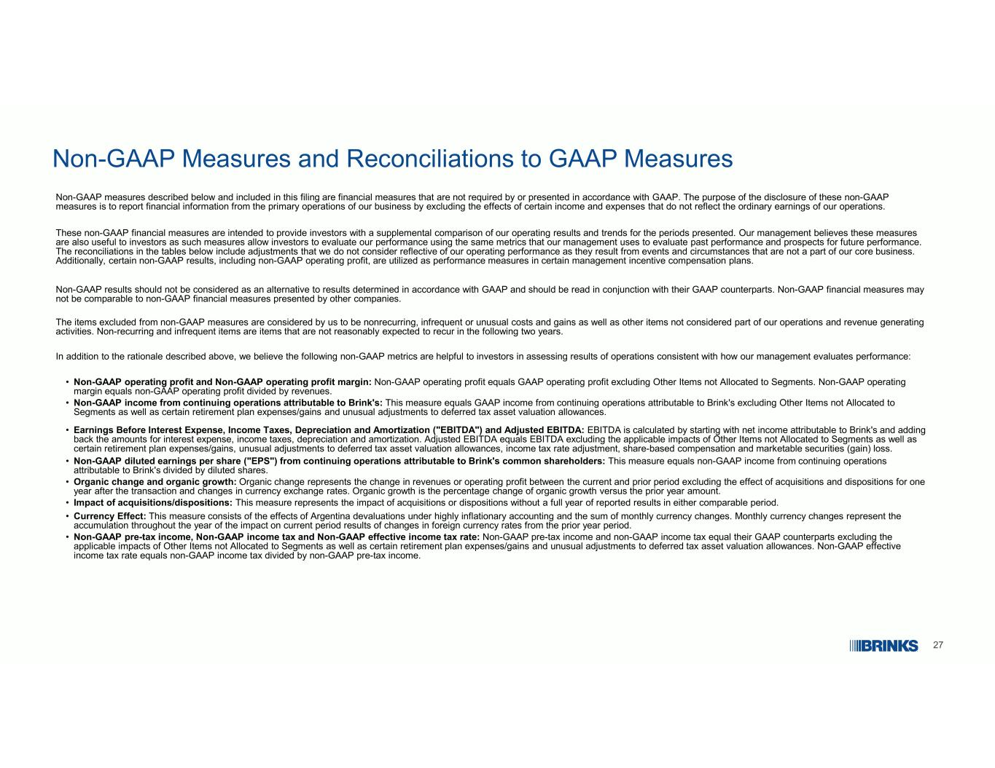
27 Non-GAAP Measures and Reconciliations to GAAP Measures Non-GAAP measures described below and included in this filing are financial measures that are not required by or presented in accordance with GAAP. The purpose of the disclosure of these non-GAAP measures is to report financial information from the primary operations of our business by excluding the effects of certain income and expenses that do not reflect the ordinary earnings of our operations. These non-GAAP financial measures are intended to provide investors with a supplemental comparison of our operating results and trends for the periods presented. Our management believes these measures are also useful to investors as such measures allow investors to evaluate our performance using the same metrics that our management uses to evaluate past performance and prospects for future performance. The reconciliations in the tables below include adjustments that we do not consider reflective of our operating performance as they result from events and circumstances that are not a part of our core business. Additionally, certain non-GAAP results, including non-GAAP operating profit, are utilized as performance measures in certain management incentive compensation plans. Non-GAAP results should not be considered as an alternative to results determined in accordance with GAAP and should be read in conjunction with their GAAP counterparts. Non-GAAP financial measures may not be comparable to non-GAAP financial measures presented by other companies. The items excluded from non-GAAP measures are considered by us to be nonrecurring, infrequent or unusual costs and gains as well as other items not considered part of our operations and revenue generating activities. Non-recurring and infrequent items are items that are not reasonably expected to recur in the following two years. In addition to the rationale described above, we believe the following non-GAAP metrics are helpful to investors in assessing results of operations consistent with how our management evaluates performance: Non-GAAP operating profit and Non-GAAP operating profit margin: Non-GAAP operating profit equals GAAP operating profit excluding Other Items not Allocated to Segments. Non-GAAP operating margin equals non-GAAP operating profit divided by revenues. • Non-GAAP income from continuing operations attributable to Brink's: This measure equals GAAP income from continuing operations attributable to Brink's excluding Other Items not Allocated to Segments as well as certain retirement plan expenses/gains and unusual adjustments to deferred tax asset valuation allowances. • Earnings Before Interest Expense, Income Taxes, Depreciation and Amortization ("EBITDA") and Adjusted EBITDA: EBITDA is calculated by starting with net income attributable to Brink's and adding back the amounts for interest expense, income taxes, depreciation and amortization. Adjusted EBITDA equals EBITDA excluding the applicable impacts of Other Items not Allocated to Segments as well as certain retirement plan expenses/gains, unusual adjustments to deferred tax asset valuation allowances, income tax rate adjustment, share-based compensation and marketable securities (gain) loss. • Non-GAAP diluted earnings per share ("EPS") from continuing operations attributable to Brink's common shareholders: This measure equals non-GAAP income from continuing operations attributable to Brink's divided by diluted shares. • Organic change and organic growth: Organic change represents the change in revenues or operating profit between the current and prior period excluding the effect of acquisitions and dispositions for one year after the transaction and changes in currency exchange rates. Organic growth is the percentage change of organic growth versus the prior year amount. • Impact of acquisitions/dispositions: This measure represents the impact of acquisitions or dispositions without a full year of reported results in either comparable period.• Currency Effect: This measure consists of the effects of Argentina devaluations under highly inflationary accounting and the sum of monthly currency changes. Monthly currency changes represent the accumulation throughout the year of the impact on current period results of changes in foreign currency rates from the prior year period. • Non-GAAP pre-tax income, Non-GAAP income tax and Non-GAAP effective income tax rate: Non-GAAP pre-tax income and non-GAAP income tax equal their GAAP counterparts excluding the applicable impacts of Other Items not Allocated to Segments as well as certain retirement plan expenses/gains and unusual adjustments to deferred tax asset valuation allowances. Non-GAAP effective income tax rate equals non-GAAP income tax divided by non-GAAP pre-tax income. •

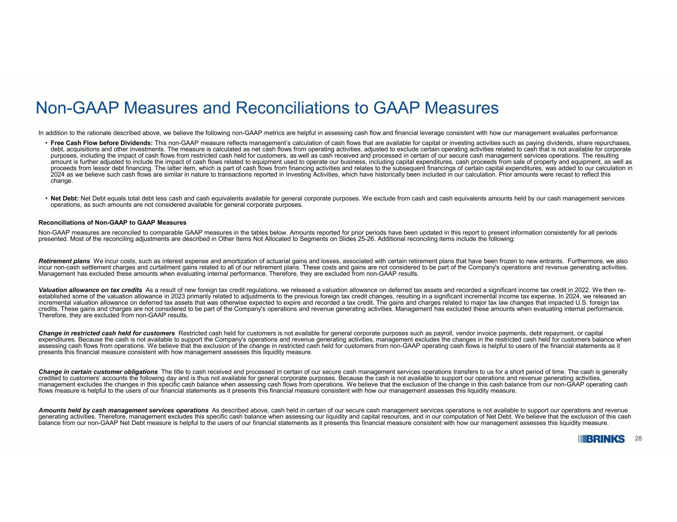
28 Non-GAAP Measures and Reconciliations to GAAP Measures In addition to the rationale described above, we believe the following non-GAAP metrics are helpful in assessing cash flow and financial leverage consistent with how our management evaluates performance: Free Cash Flow before Dividends: This non-GAAP measure reflects management’s calculation of cash flows that are available for capital or investing activities such as paying dividends, share repurchases, debt, acquisitions and other investments. The measure is calculated as net cash flows from operating activities, adjusted to exclude certain operating activities related to cash that is not available for corporate purposes, including the impact of cash flows from restricted cash held for customers, as well as cash received and processed in certain of our secure cash management services operations. The resulting amount is further adjusted to include the impact of cash flows related to equipment used to operate our business, including capital expenditures, cash proceeds from sale of property and equipment, as well as proceeds from lessor debt financing. The latter item, which is part of cash flows from financing activities and relates to the subsequent financings of certain capital expenditures, was added to our calculation in 2024 as we believe such cash flows are similar in nature to transactions reported in Investing Activities, which have historically been included in our calculation. Prior amounts were recast to reflect this change. • Net Debt: Net Debt equals total debt less cash and cash equivalents available for general corporate purposes. We exclude from cash and cash equivalents amounts held by our cash management services operations, as such amounts are not considered available for general corporate purposes. • Reconciliations of Non-GAAP to GAAP Measures Non-GAAP measures are reconciled to comparable GAAP measures in the tables below. Amounts reported for prior periods have been updated in this report to present information consistently for all periods presented. Most of the reconciling adjustments are described in Other Items Not Allocated to Segments on Slides 25-26. Additional reconciling items include the following: Retirement plans We incur costs, such as interest expense and amortization of actuarial gains and losses, associated with certain retirement plans that have been frozen to new entrants. Furthermore, we also incur non-cash settlement charges and curtailment gains related to all of our retirement plans. These costs and gains are not considered to be part of the Company's operations and revenue generating activities. Management has excluded these amounts when evaluating internal performance. Therefore, they are excluded from non-GAAP results. Valuation allowance on tax credits As a result of new foreign tax credit regulations, we released a valuation allowance on deferred tax assets and recorded a significant income tax credit in 2022. We then re- established some of the valuation allowance in 2023 primarily related to adjustments to the previous foreign tax credit changes, resulting in a significant incremental income tax expense. In 2024, we released an incremental valuation allowance on deferred tax assets that was otherwise expected to expire and recorded a tax credit. The gains and charges related to major tax law changes that impacted U.S. foreign tax credits. These gains and charges are not considered to be part of the Company's operations and revenue generating activities. Management has excluded these amounts when evaluating internal performance. Therefore, they are excluded from non-GAAP results. Change in restricted cash held for customers Restricted cash held for customers is not available for general corporate purposes such as payroll, vendor invoice payments, debt repayment, or capital expenditures. Because the cash is not available to support the Company's operations and revenue generating activities, management excludes the changes in the restricted cash held for customers balance when assessing cash flows from operations. We believe that the exclusion of the change in restricted cash held for customers from non-GAAP operating cash flows is helpful to users of the financial statements as it presents this financial measure consistent with how management assesses this liquidity measure. Change in certain customer obligations The title to cash received and processed in certain of our secure cash management services operations transfers to us for a short period of time. The cash is generally credited to customers’ accounts the following day and is thus not available for general corporate purposes. Because the cash is not available to support our operations and revenue generating activities, management excludes the changes in this specific cash balance when assessing cash flows from operations. We believe that the exclusion of the change in this cash balance from our non-GAAP operating cash flows measure is helpful to the users of our financial statements as it presents this financial measure consistent with how our management assesses this liquidity measure. Amounts held by cash management services operations As described above, cash held in certain of our secure cash management services operations is not available to support our operations and revenue generating activities. Therefore, management excludes this specific cash balance when assessing our liquidity and capital resources, and in our computation of Net Debt. We believe that the exclusion of this cash balance from our non-GAAP Net Debt measure is helpful to the users of our financial statements as it presents this financial measure consistent with how our management assesses this liquidity measure.

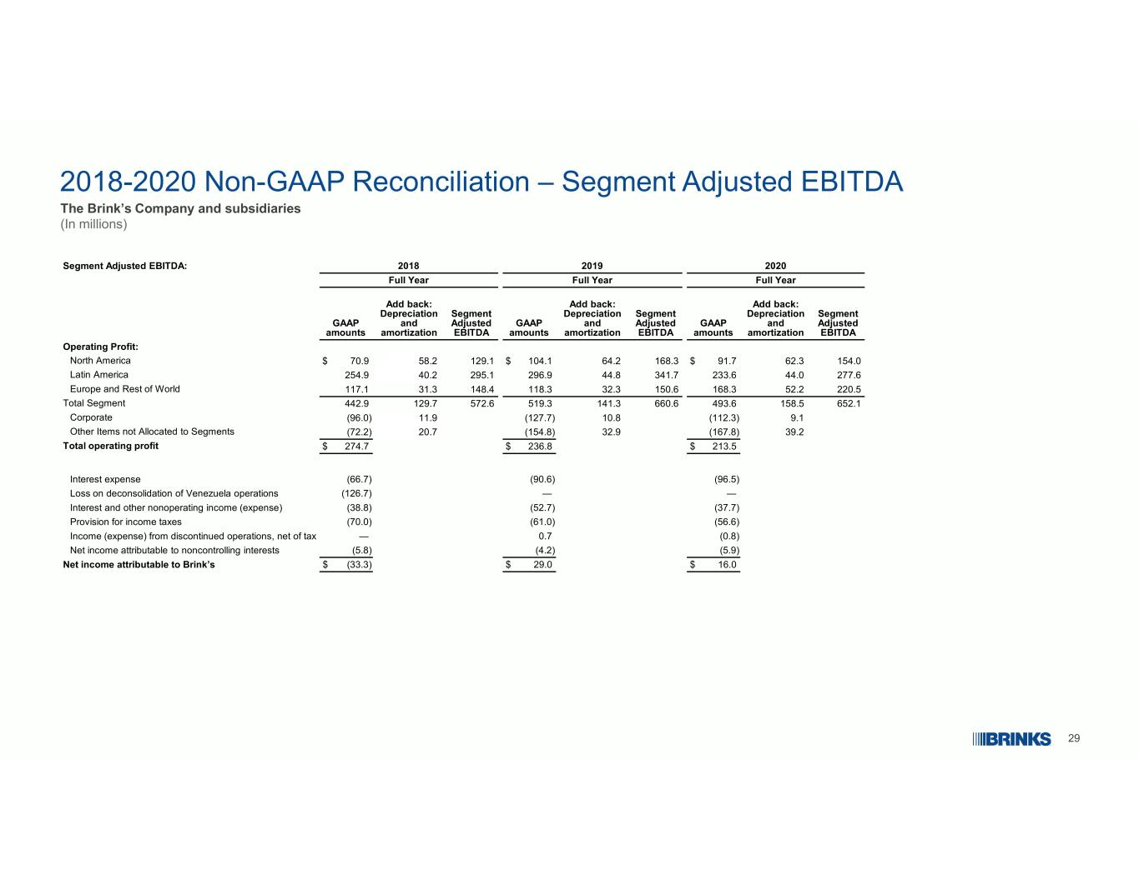
29 2018-2020 Non-GAAP Reconciliation – Segment Adjusted EBITDA The Brink’s Company and subsidiaries (In millions) 202020192018Segment Adjusted EBITDA: Full YearFull YearFull Year Segment Adjusted EBITDA Add back: Depreciation and amortization GAAP amounts Segment Adjusted EBITDA Add back: Depreciation and amortization GAAP amounts Segment Adjusted EBITDA Add back: Depreciation and amortization GAAP amounts Operating Profit: 154.062.3$ 91.7168.364.2$ 104.1129.158.2$ 70.9North America 277.644.0233.6341.744.8296.9295.140.2254.9Latin America 220.552.2168.3150.632.3118.3148.431.3117.1Europe and Rest of World 652.1158.5493.6660.6141.3519.3572.6129.7442.9Total Segment 9.1(112.3)10.8(127.7)11.9(96.0)Corporate 39.2(167.8)32.9(154.8)20.7(72.2)Other Items not Allocated to Segments $ 213.5$ 236.8$ 274.7Total operating profit (96.5)(90.6)(66.7)Interest expense ——(126.7)Loss on deconsolidation of Venezuela operations (37.7)(52.7)(38.8)Interest and other nonoperating income (expense) (56.6)(61.0)(70.0)Provision for income taxes (0.8)0.7—Income (expense) from discontinued operations, net of tax (5.9)(4.2)(5.8)Net income attributable to noncontrolling interests $ 16.0$ 29.0$ (33.3)Net income attributable to Brink’s

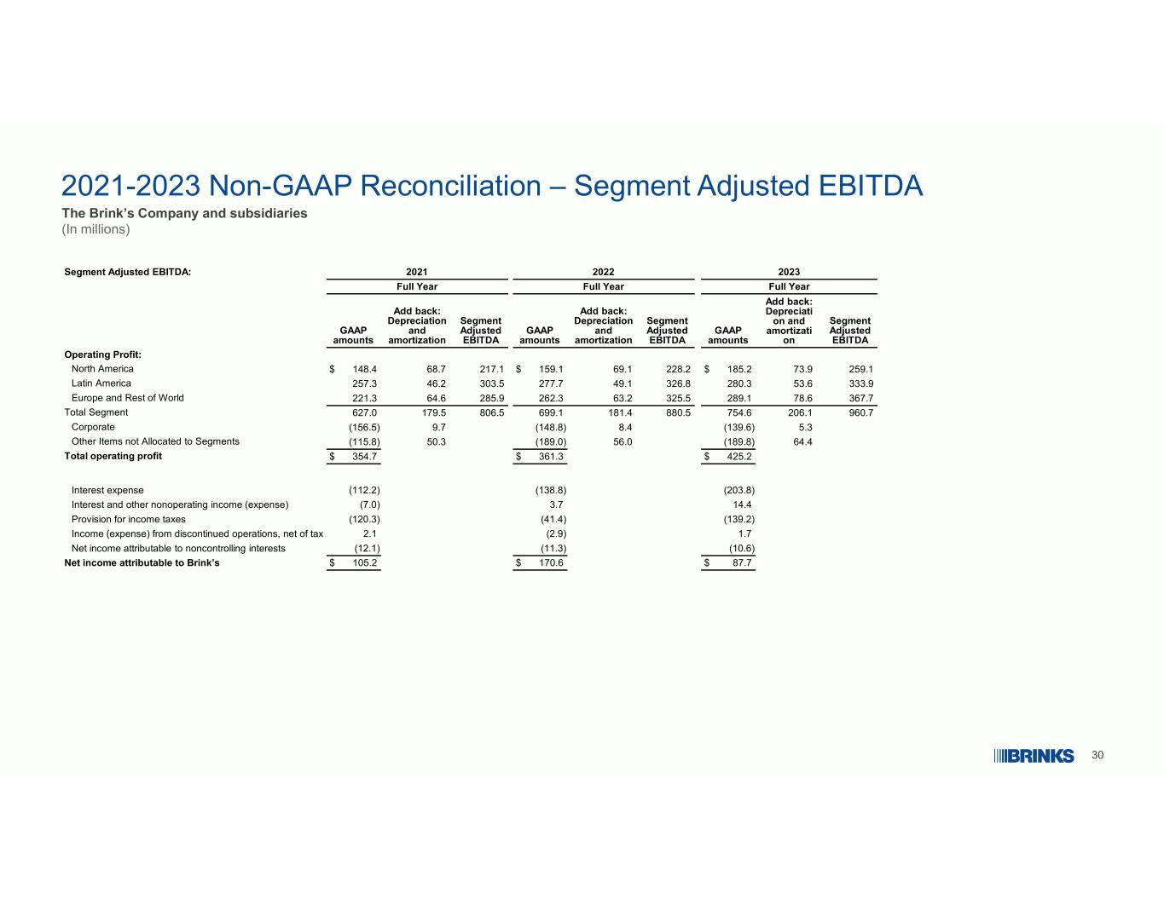
30 2021-2023 Non-GAAP Reconciliation – Segment Adjusted EBITDA The Brink’s Company and subsidiaries (In millions) 202320222021Segment Adjusted EBITDA: Full YearFull YearFull Year Segment Adjusted EBITDA Add back: Depreciati on and amortizati on GAAP amounts Segment Adjusted EBITDA Add back: Depreciation and amortization GAAP amounts Segment Adjusted EBITDA Add back: Depreciation and amortization GAAP amounts Operating Profit: 259.173.9$ 185.2228.269.1$ 159.1217.168.7$ 148.4North America 333.953.6280.3326.849.1277.7303.546.2257.3Latin America 367.778.6289.1325.563.2262.3285.964.6221.3Europe and Rest of World 960.7206.1754.6880.5181.4699.1806.5179.5627.0Total Segment 5.3(139.6)8.4(148.8)9.7(156.5)Corporate 64.4(189.8)56.0(189.0)50.3(115.8)Other Items not Allocated to Segments $ 425.2$ 361.3$ 354.7Total operating profit (203.8)(138.8)(112.2)Interest expense 14.43.7(7.0)Interest and other nonoperating income (expense) (139.2)(41.4)(120.3)Provision for income taxes 1.7(2.9)2.1Income (expense) from discontinued operations, net of tax (10.6)(11.3)(12.1)Net income attributable to noncontrolling interests $ 87.7$ 170.6$ 105.2Net income attributable to Brink’s

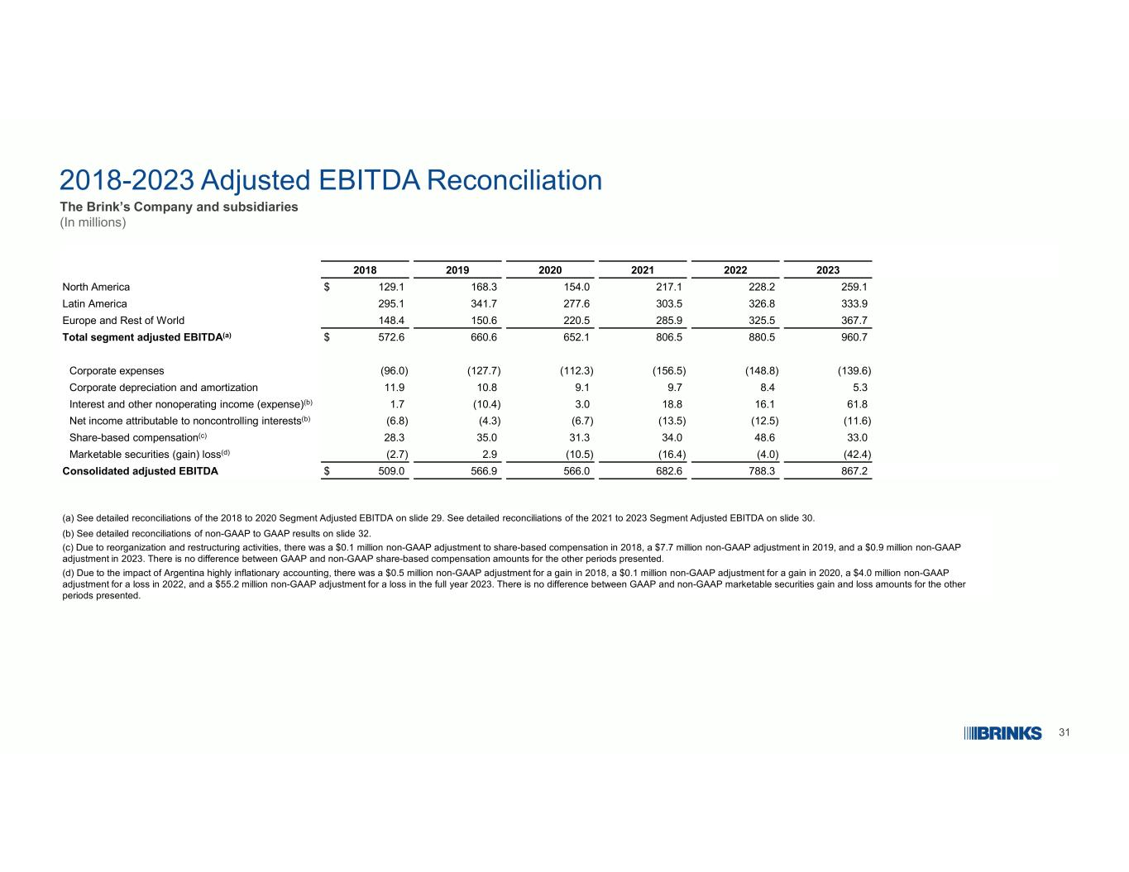
31 2018-2023 Adjusted EBITDA Reconciliation The Brink’s Company and subsidiaries (In millions) (a) See detailed reconciliations of the 2018 to 2020 Segment Adjusted EBITDA on slide 29. See detailed reconciliations of the 2021 to 2023 Segment Adjusted EBITDA on slide 30. (b) See detailed reconciliations of non-GAAP to GAAP results on slide 32. (c) Due to reorganization and restructuring activities, there was a $0.1 million non-GAAP adjustment to share-based compensation in 2018, a $7.7 million non-GAAP adjustment in 2019, and a $0.9 million non-GAAP adjustment in 2023. There is no difference between GAAP and non-GAAP share-based compensation amounts for the other periods presented. (d) Due to the impact of Argentina highly inflationary accounting, there was a $0.5 million non-GAAP adjustment for a gain in 2018, a $0.1 million non-GAAP adjustment for a gain in 2020, a $4.0 million non-GAAP adjustment for a loss in 2022, and a $55.2 million non-GAAP adjustment for a loss in the full year 2023. There is no difference between GAAP and non-GAAP marketable securities gain and loss amounts for the other periods presented. 202320222021202020192018 259.1228.2217.1154.0168.3$ 129.1North America 333.9326.8303.5277.6341.7295.1Latin America 367.7325.5285.9220.5150.6148.4Europe and Rest of World 960.7880.5806.5652.1660.6$ 572.6Total segment adjusted EBITDA(a) (139.6)(148.8)(156.5)(112.3)(127.7)(96.0)Corporate expenses 5.38.49.79.110.811.9Corporate depreciation and amortization 61.816.118.83.0(10.4)1.7Interest and other nonoperating income (expense)(b) (11.6)(12.5)(13.5)(6.7)(4.3)(6.8)Net income attributable to noncontrolling interests(b) 33.048.634.031.335.028.3Share-based compensation(c) (42.4)(4.0)(16.4)(10.5)2.9(2.7)Marketable securities (gain) loss(d) 867.2788.3682.6566.0566.9$ 509.0Consolidated adjusted EBITDA

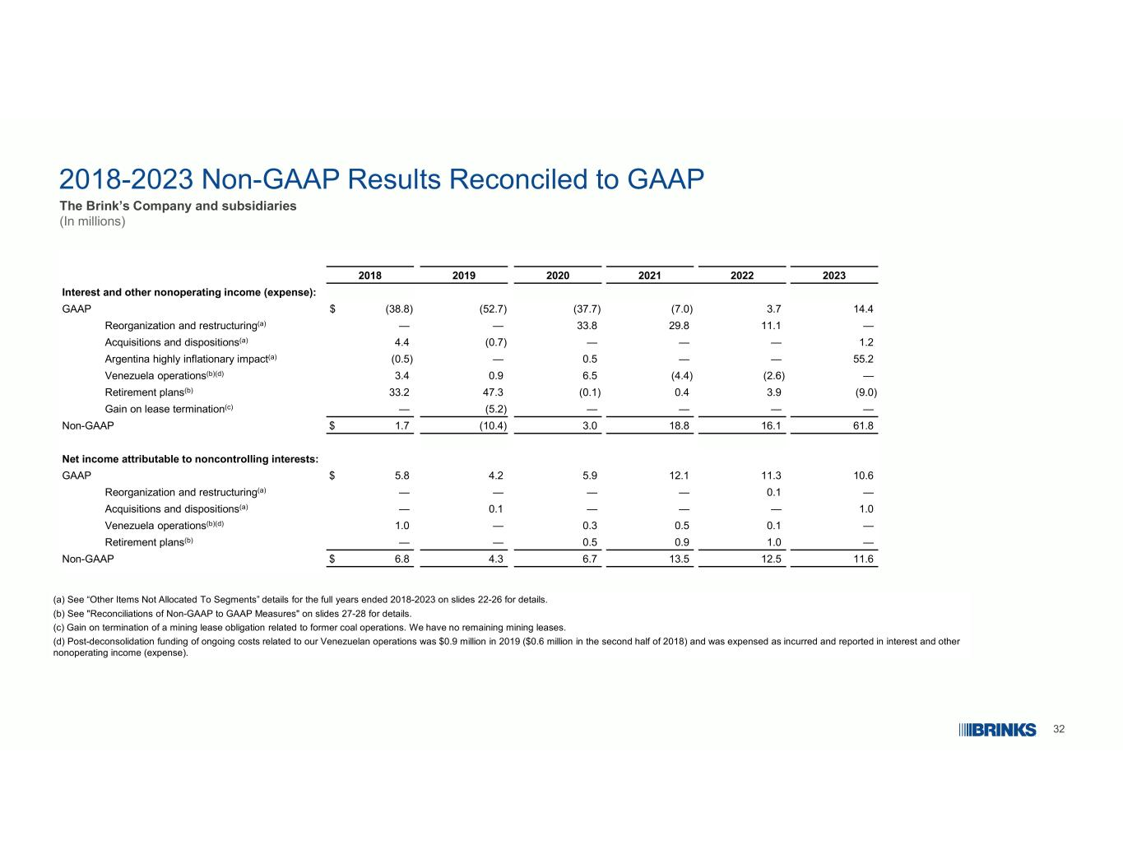
32 2018-2023 Non-GAAP Results Reconciled to GAAP The Brink’s Company and subsidiaries (In millions) (a) See “Other Items Not Allocated To Segments” details for the full years ended 2018-2023 on slides 22-26 for details. (b) See "Reconciliations of Non-GAAP to GAAP Measures" on slides 27-28 for details. (c) Gain on termination of a mining lease obligation related to former coal operations. We have no remaining mining leases. (d) Post-deconsolidation funding of ongoing costs related to our Venezuelan operations was $0.9 million in 2019 ($0.6 million in the second half of 2018) and was expensed as incurred and reported in interest and other nonoperating income (expense). 202320222021202020192018 Interest and other nonoperating income (expense): 14.43.7(7.0)(37.7)(52.7)$ (38.8)GAAP —11.129.833.8——Reorganization and restructuring(a) 1.2———(0.7)4.4Acquisitions and dispositions(a) 55.2——0.5—(0.5)Argentina highly inflationary impact(a) —(2.6)(4.4)6.50.93.4Venezuela operations(b)(d) (9.0)3.90.4(0.1)47.333.2Retirement plans(b) ————(5.2)—Gain on lease termination(c) 61.816.118.83.0(10.4)$ 1.7Non-GAAP Net income attributable to noncontrolling interests: 10.611.312.15.94.2$ 5.8GAAP —0.1————Reorganization and restructuring(a) 1.0———0.1—Acquisitions and dispositions(a) —0.10.50.3—1.0Venezuela operations(b)(d) —1.00.90.5——Retirement plans(b) 11.612.513.56.74.3$ 6.8Non-GAAP

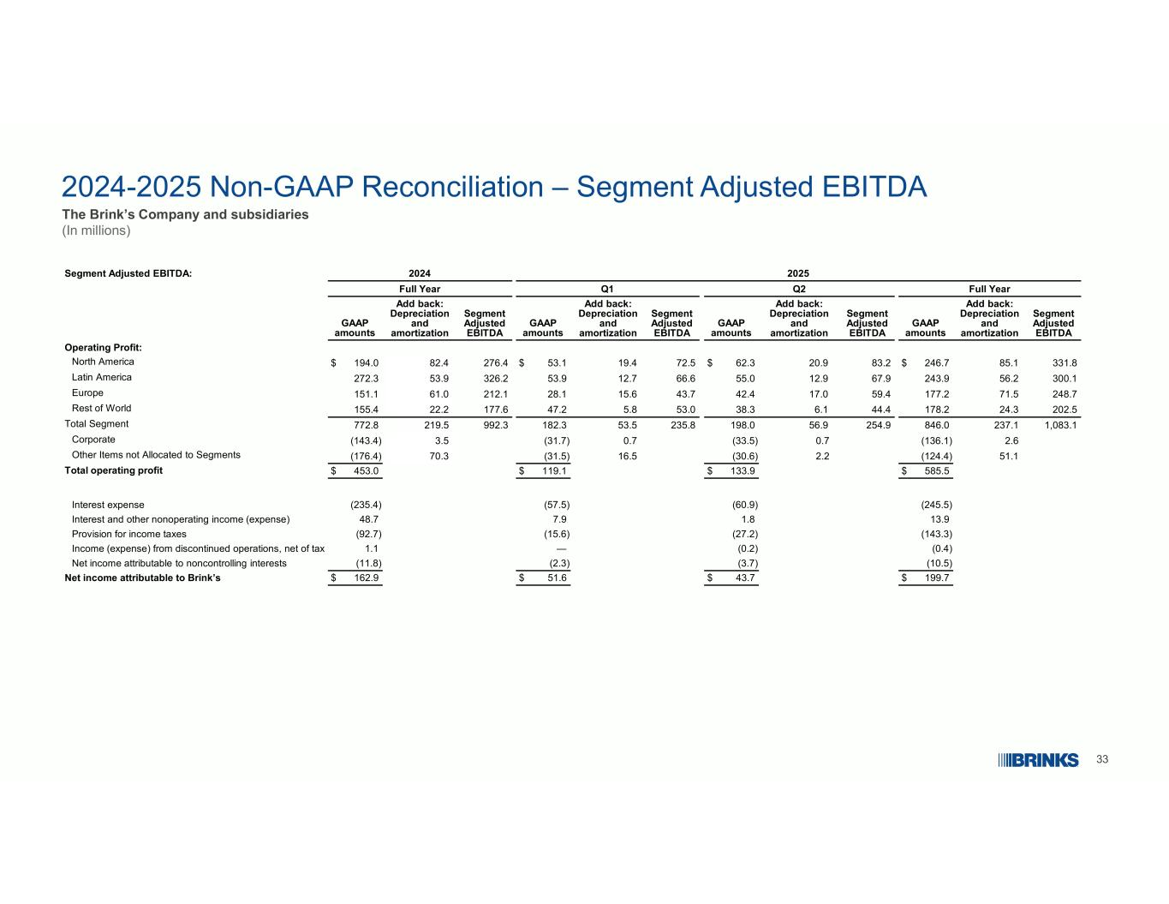
33 2024-2025 Non-GAAP Reconciliation – Segment Adjusted EBITDA The Brink’s Company and subsidiaries (In millions) 20252024Segment Adjusted EBITDA: Full YearQ2Q1Full Year Segment Adjusted EBITDA Add back: Depreciation and amortization GAAP amounts Segment Adjusted EBITDA Add back: Depreciation and amortization GAAP amounts Segment Adjusted EBITDA Add back: Depreciation and amortization GAAP amounts Segment Adjusted EBITDA Add back: Depreciation and amortization GAAP amounts Operating Profit: 331.885.1$ 246.783.220.9$ 62.372.519.4$ 53.1276.482.4$ 194.0North America 300.156.2243.967.912.955.066.612.753.9326.253.9272.3Latin America 248.771.5177.259.417.042.443.715.628.1212.161.0151.1Europe 202.524.3178.244.46.138.353.05.847.2177.622.2155.4Rest of World 1,083.1237.1846.0254.956.9198.0235.853.5182.3992.3219.5772.8Total Segment 2.6(136.1)0.7(33.5)0.7(31.7)3.5(143.4)Corporate 51.1(124.4)2.2(30.6)16.5(31.5)70.3(176.4)Other Items not Allocated to Segments $ 585.5$ 133.9$ 119.1$ 453.0Total operating profit (245.5)(60.9)(57.5)(235.4)Interest expense 13.91.87.948.7Interest and other nonoperating income (expense) (143.3)(27.2)(15.6)(92.7)Provision for income taxes (0.4)(0.2)—1.1Income (expense) from discontinued operations, net of tax (10.5)(3.7)(2.3)(11.8)Net income attributable to noncontrolling interests $ 199.7$ 43.7$ 51.6$ 162.9Net income attributable to Brink’s

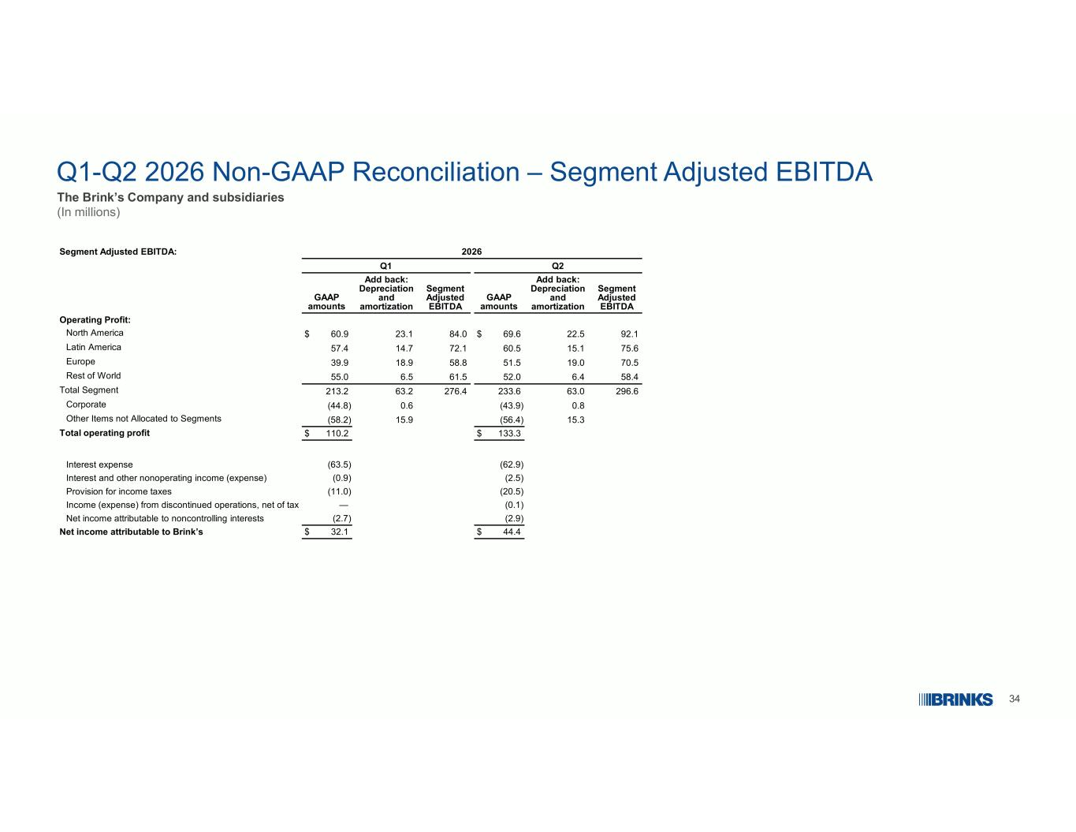
34 Q1-Q2 2026 Non-GAAP Reconciliation – Segment Adjusted EBITDA The Brink’s Company and subsidiaries (In millions) 2026Segment Adjusted EBITDA: Q2Q1 Segment Adjusted EBITDA Add back: Depreciation and amortization GAAP amounts Segment Adjusted EBITDA Add back: Depreciation and amortization GAAP amounts Operating Profit: 92.122.5$ 69.684.023.1$ 60.9North America 75.615.160.572.114.757.4Latin America 70.519.051.558.818.939.9Europe 58.46.452.061.56.555.0Rest of World 296.663.0233.6276.463.2213.2Total Segment 0.8(43.9)0.6(44.8)Corporate 15.3(56.4)15.9(58.2)Other Items not Allocated to Segments $ 133.3$ 110.2Total operating profit (62.9)(63.5)Interest expense (2.5)(0.9)Interest and other nonoperating income (expense) (20.5)(11.0)Provision for income taxes (0.1)—Income (expense) from discontinued operations, net of tax (2.9)(2.7)Net income attributable to noncontrolling interests $ 44.4$ 32.1Net income attributable to Brink’s

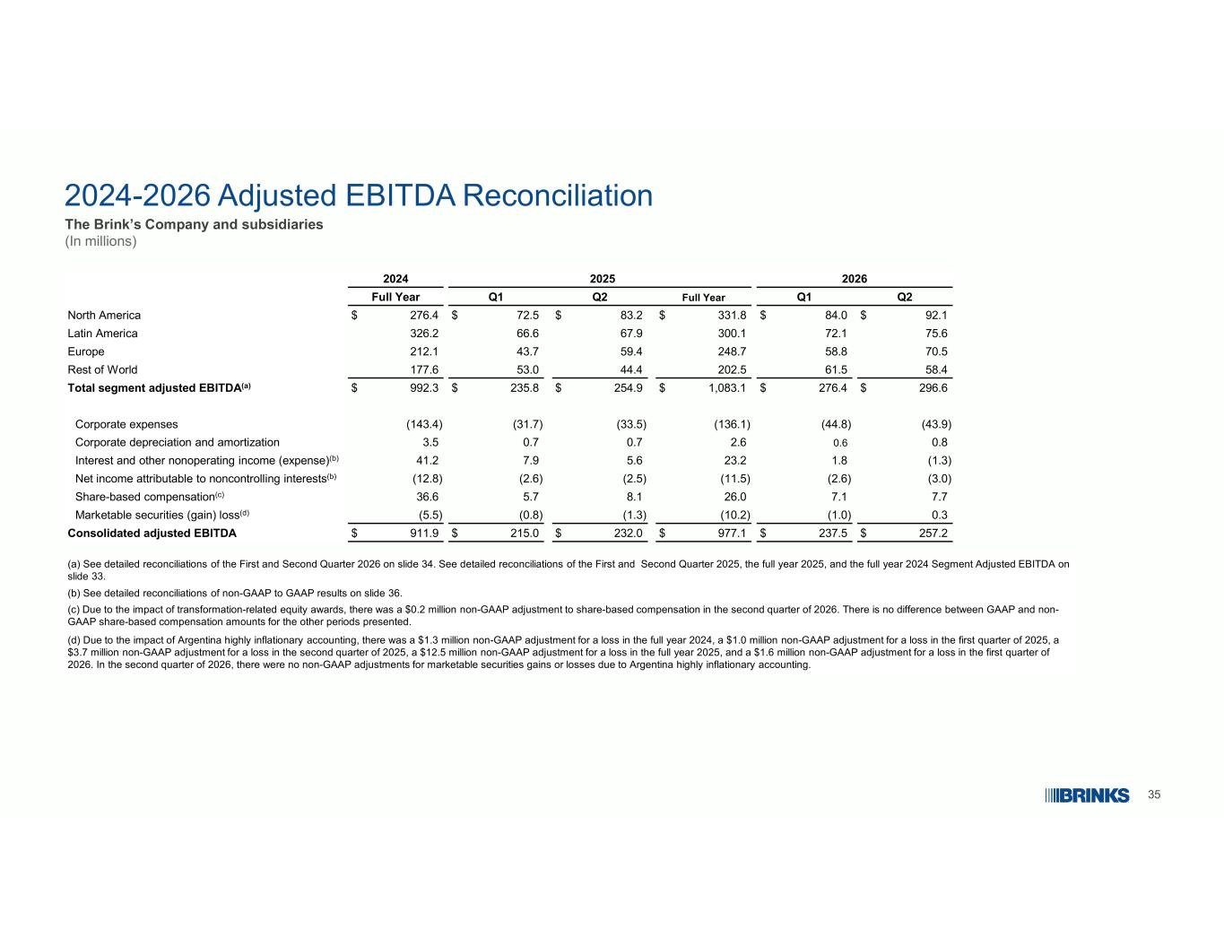
35 2024-2026 Adjusted EBITDA Reconciliation The Brink’s Company and subsidiaries (In millions) (a) See detailed reconciliations of the First and Second Quarter 2026 on slide 34. See detailed reconciliations of the First and Second Quarter 2025, the full year 2025, and the full year 2024 Segment Adjusted EBITDA on slide 33. (b) See detailed reconciliations of non-GAAP to GAAP results on slide 36. (c) Due to the impact of transformation-related equity awards, there was a $0.2 million non-GAAP adjustment to share-based compensation in the second quarter of 2026. There is no difference between GAAP and non- GAAP share-based compensation amounts for the other periods presented. (d) Due to the impact of Argentina highly inflationary accounting, there was a $1.3 million non-GAAP adjustment for a loss in the full year 2024, a $1.0 million non-GAAP adjustment for a loss in the first quarter of 2025, a $3.7 million non-GAAP adjustment for a loss in the second quarter of 2025, a $12.5 million non-GAAP adjustment for a loss in the full year 2025, and a $1.6 million non-GAAP adjustment for a loss in the first quarter of 2026. In the second quarter of 2026, there were no non-GAAP adjustments for marketable securities gains or losses due to Argentina highly inflationary accounting. 202620252024 Q2Q1Full YearQ2Q1Full Year $ 92.1$ 84.0$ 331.8$ 83.2$ 72.5$ 276.4North America 75.672.1300.167.966.6326.2Latin America 70.558.8248.759.443.7212.1Europe 58.461.5202.544.453.0177.6Rest of World $ 296.6$ 276.4$ 1,083.1$ 254.9$ 235.8$ 992.3Total segment adjusted EBITDA(a) (43.9)(44.8)(136.1)(33.5)(31.7)(143.4)Corporate expenses 0.80.62.60.70.73.5Corporate depreciation and amortization (1.3)1.823.25.67.941.2Interest and other nonoperating income (expense)(b) (3.0)(2.6)(11.5)(2.5)(2.6)(12.8)Net income attributable to noncontrolling interests(b) 7.77.126.08.15.736.6Share-based compensation(c) 0.3(1.0)(10.2)(1.3)(0.8)(5.5)Marketable securities (gain) loss(d) $ 257.2$ 237.5$ 977.1$ 232.0$ 215.0$ 911.9Consolidated adjusted EBITDA

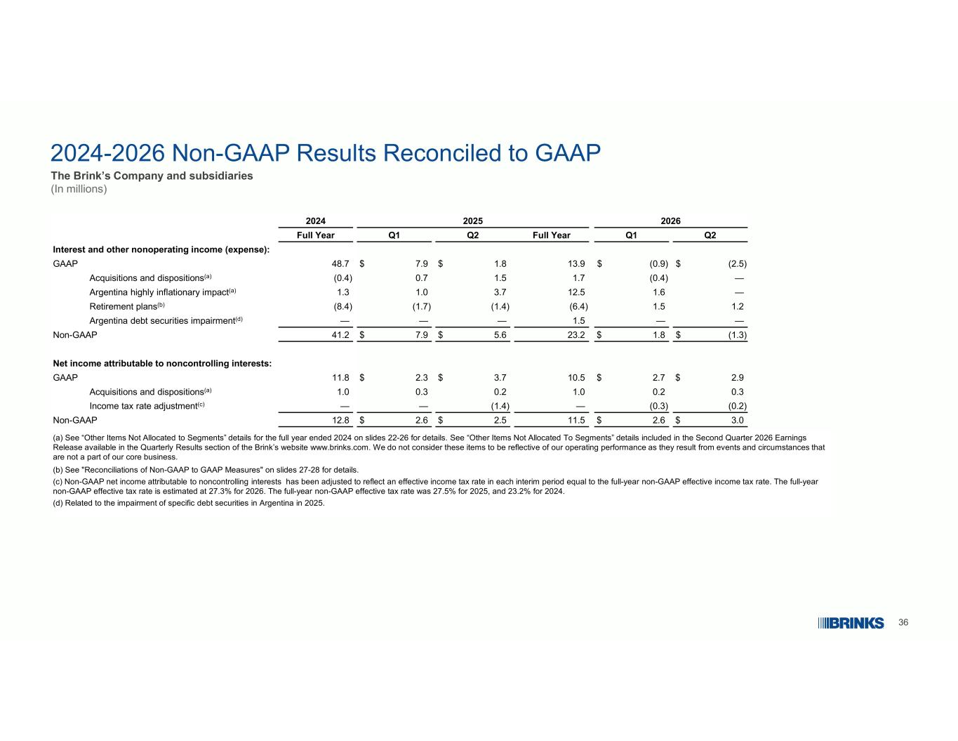
36 2024-2026 Non-GAAP Results Reconciled to GAAP The Brink’s Company and subsidiaries (In millions) (a) See “Other Items Not Allocated to Segments” details for the full year ended 2024 on slides 22-26 for details. See “Other Items Not Allocated To Segments” details included in the Second Quarter 2026 Earnings Release available in the Quarterly Results section of the Brink’s website www.brinks.com. We do not consider these items to be reflective of our operating performance as they result from events and circumstances that are not a part of our core business. (b) See "Reconciliations of Non-GAAP to GAAP Measures" on slides 27-28 for details. (c) Non-GAAP net income attributable to noncontrolling interests has been adjusted to reflect an effective income tax rate in each interim period equal to the full-year non-GAAP effective income tax rate. The full-year non-GAAP effective tax rate is estimated at 27.3% for 2026. The full-year non-GAAP effective tax rate was 27.5% for 2025, and 23.2% for 2024. (d) Related to the impairment of specific debt securities in Argentina in 2025. 202620252024 Q2Q1Full YearQ2Q1Full Year Interest and other nonoperating income (expense): $ (2.5)$ (0.9)13.9$ 1.8$ 7.948.7GAAP —(0.4)1.71.50.7(0.4)Acquisitions and dispositions(a) —1.612.53.71.01.3Argentina highly inflationary impact(a) 1.21.5(6.4)(1.4)(1.7)(8.4)Retirement plans(b) ——1.5———Argentina debt securities impairment(d) $ (1.3)$ 1.823.2$ 5.6$ 7.941.2Non-GAAP Net income attributable to noncontrolling interests: $ 2.9$ 2.710.5$ 3.7$ 2.311.8GAAP 0.30.21.00.20.31.0Acquisitions and dispositions(a) (0.2)(0.3)—(1.4)——Income tax rate adjustment(c) $ 3.0$ 2.611.5$ 2.5$ 2.612.8Non-GAAP

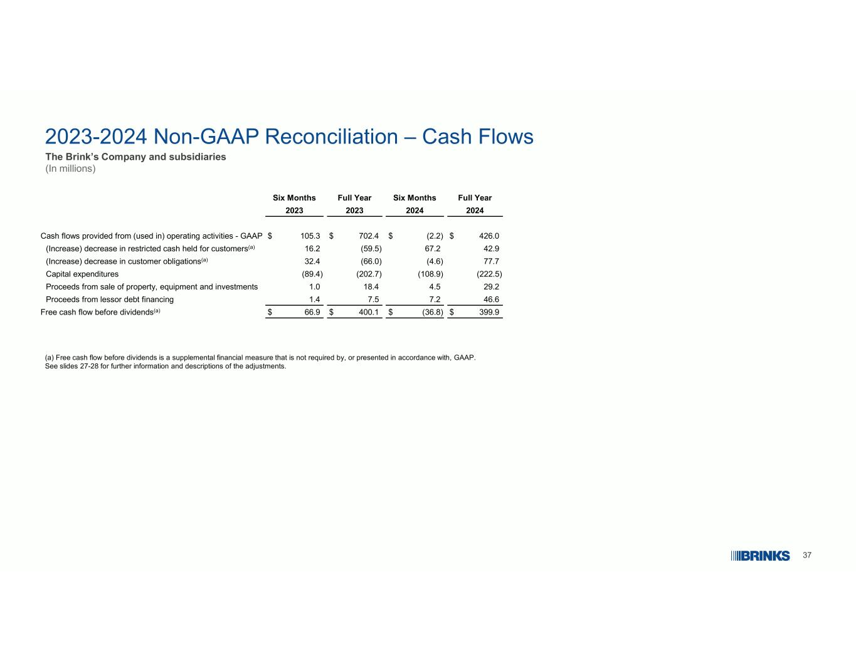
37 2023-2024 Non-GAAP Reconciliation – Cash Flows The Brink’s Company and subsidiaries (In millions) (a) Free cash flow before dividends is a supplemental financial measure that is not required by, or presented in accordance with, GAAP. See slides 27-28 for further information and descriptions of the adjustments. Full YearSix MonthsFull YearSix Months 2024202420232023 $ 426.0$ (2.2)$ 702.4$ 105.3Cash flows provided from (used in) operating activities - GAAP 42.967.2(59.5)16.2(Increase) decrease in restricted cash held for customers(a) 77.7(4.6)(66.0)32.4(Increase) decrease in customer obligations(a) (222.5)(108.9)(202.7)(89.4)Capital expenditures 29.24.518.41.0Proceeds from sale of property, equipment and investments 46.67.27.51.4Proceeds from lessor debt financing $ 399.9$ (36.8)$ 400.1$ 66.9Free cash flow before dividends(a)

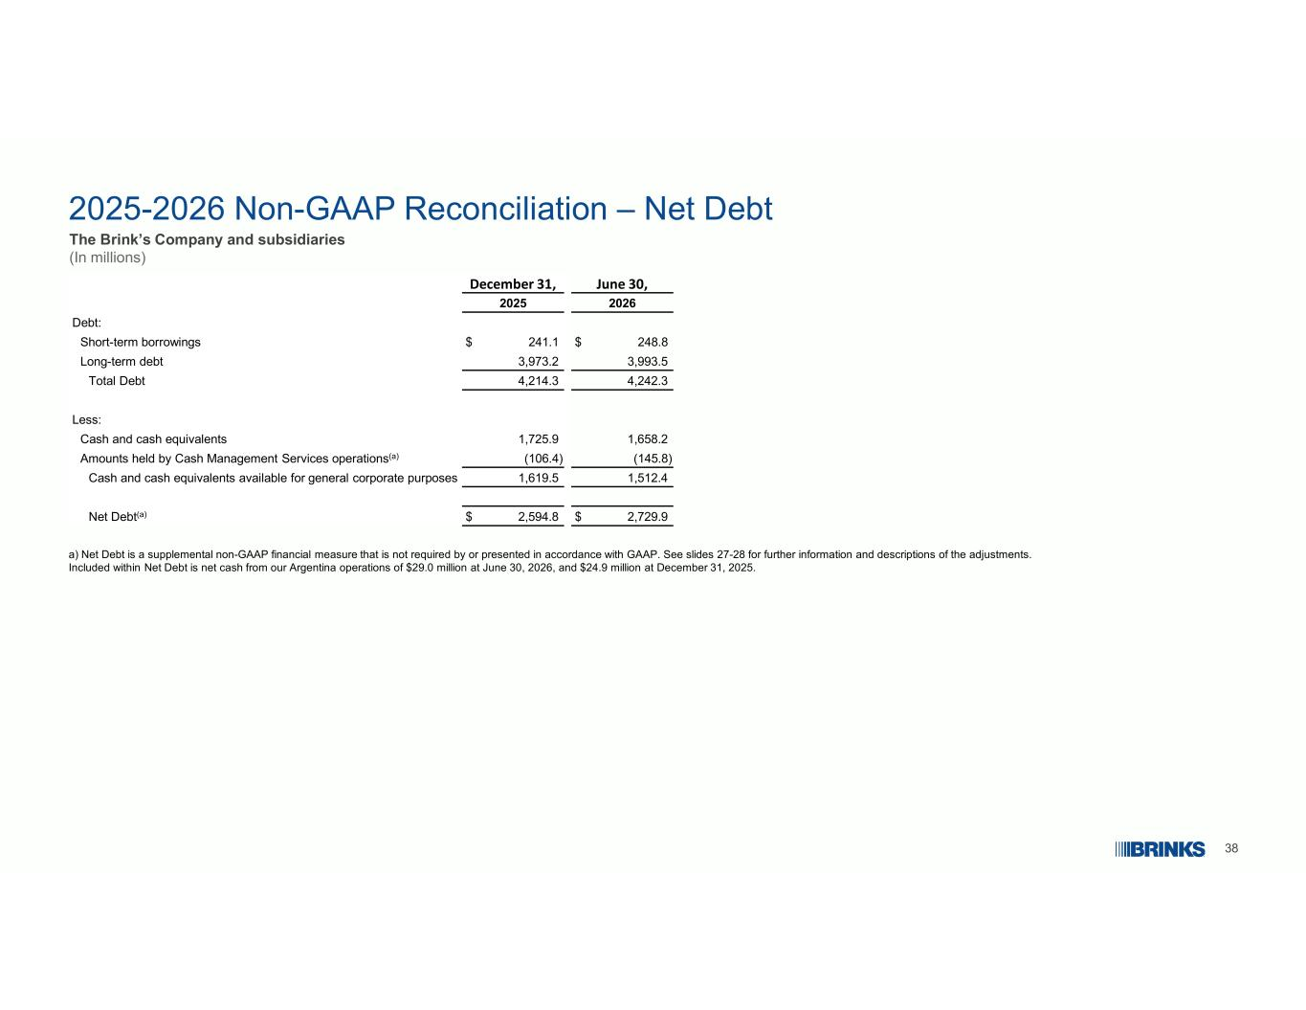
38 2025-2026 Non-GAAP Reconciliation – Net Debt The Brink’s Company and subsidiaries (In millions) a) Net Debt is a supplemental non-GAAP financial measure that is not required by or presented in accordance with GAAP. See slides 27-28 for further information and descriptions of the adjustments. Included within Net Debt is net cash from our Argentina operations of $29.0 million at June 30, 2026, and $24.9 million at December 31, 2025. June 30,December 31, 20262025 Debt: $ 248.8$ 241.1Short-term borrowings 3,993.53,973.2Long-term debt 4,242.34,214.3Total Debt Less: 1,658.21,725.9Cash and cash equivalents (145.8)(106.4)Amounts held by Cash Management Services operations(a) 1,512.41,619.5Cash and cash equivalents available for general corporate purposes $ 2,729.9$ 2,594.8Net Debt(a)

